How to edit subtitles in YouTube

Log In
- Open Chrome or other web browser (Mozilla, Safari, Internet Explorer…)
- Select “new incognito window”
- Go to YouTube.com
- Click on Sign In (top right) and Log in with gwlvolunteers@gmail.com
- Enter password

Open YouTube Studio:
- Click on Volunteers Badge image (top right)
- Select YouTube studio (top right)
- Now on the left hand side below “Your Channel- GWL Volunteers” (Left side, scroll down)
- Select - Subtitles

Subtitle Editing:
- Click on the name of the video you want to subtitle e.g. Lila Clunas
- In the “English (Automatic)” line, under the “Subtitles” heading, to the right of “Published Automatic” click the blue writing that says “DUPLICATE AND EDIT”
- This opens a new window in YouTube with the subtitles on the left and the video on the right, with a section below with chunks of subtitles and the time they take up. This looks like this -
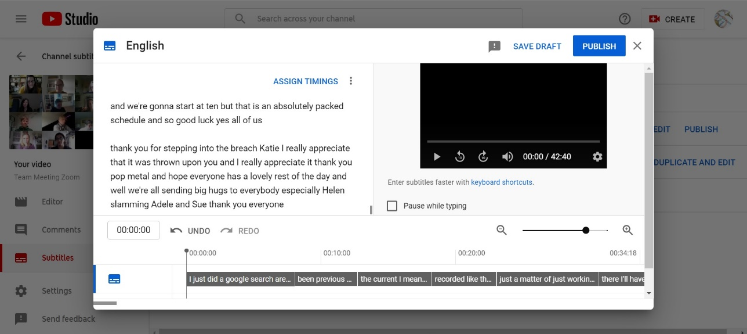

- Click “ASSIGN TIMINGS” in the top right corner of the side with the subtitles. This will divide up the automatic subtitles into relevant chunks of time. These can be adjusted using the bars with the subtitles in the section at the bottom!
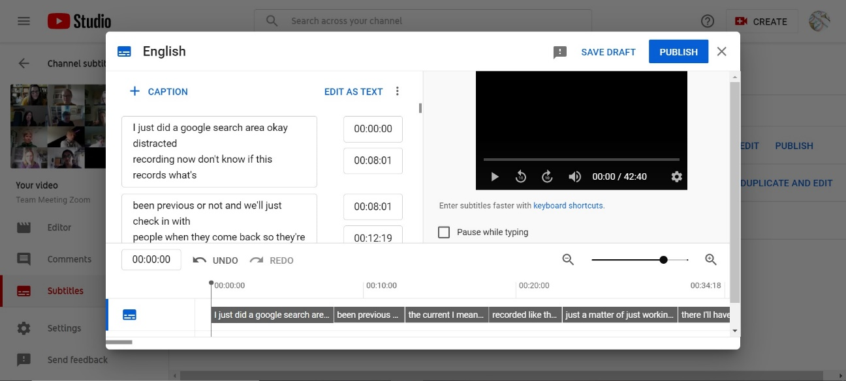

These bars here can be dragged from left to right and stretched!

Editing subtitles:
- Check for spelling mistakes, missing punctuation (commas, full stops etc)
- Shorter subtitles are better (2 short lines of about 4-6 words each). You can split sentences into separate subtitles by clicking Enter.
- Subtitled should be over 2 lines, the top line slightly shorter than the bottom one. You can split up sentences in the one subtitle by using Shift+Enter.
- Make sure the subtitles are in sync with the audio
- Subtitles should be visible for somewhere between 1 and 7 seconds
- To make a Line break use Shift/Return
- In the Subtitling section at the bottom a ‘Hand Hovers’. You can drag the chunks of subtitles from left to right, or if you hover over the line between two chunks you can stretch the chunk to cover more or less time.
- When in subtitle edit mode, there is a cog in the bottom right corner of the video, there is an option to slow down or speed up the video.

Save changes:
Once you’ve finished editing you can save draft or publish (on the top right of the window!)
Don’t worry, if you click publish you can still go back and edit them!

Edit video’s title:

To edit a title: go to Videos (left hand side, below Your Channel GWL Volunteers). Then click on the video you wish to rename. This opens the video details, where you can edit the video title in the title box. Please rename videos to reflect whether it is in the process of being subtitled or if it is subtitled (see below).

To establish when a video is being worked on and so that people don’t work on the same one at the same time:

Before you start editing the subtitles on a video please change the title to include "In Progress". Once you've finished it, edit the title to include "Subtitles"

So, for example, the Sojourner Truth video would be edited as follows:
Sojourner Truth - In Progress

Then edited again when finished to be:
Sojourner Truth - Subtitled

To edit a title: go to Videos (left hand side, below Your Channel GWL Volunteers). Then click on the icon of a pencil to the right of the video. This opens another window in which you can change the title.

Download subtitle files:

You might need to download the subtitle files.
In the ‘Subtitles’ menu when you hover over your subtitles, click the three dots on the right hand side.
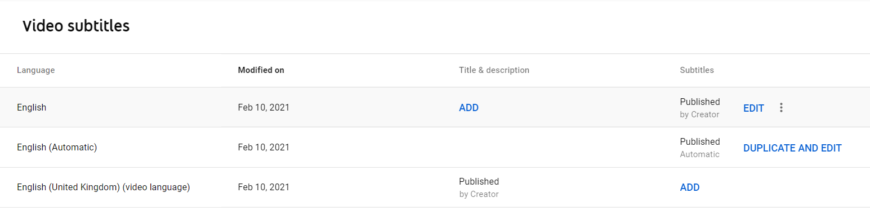Click ‘Download’ and choose the option ‘.srt’. This will then download the file onto your laptop.

