How To: Upload a Blog to Wordpress
Starting your blog
A member of the team will give you a username and login for Wordpress and will send you an access link.

On the dashboard on the left hand side, go to ‘posts’ and click ‘add new’.
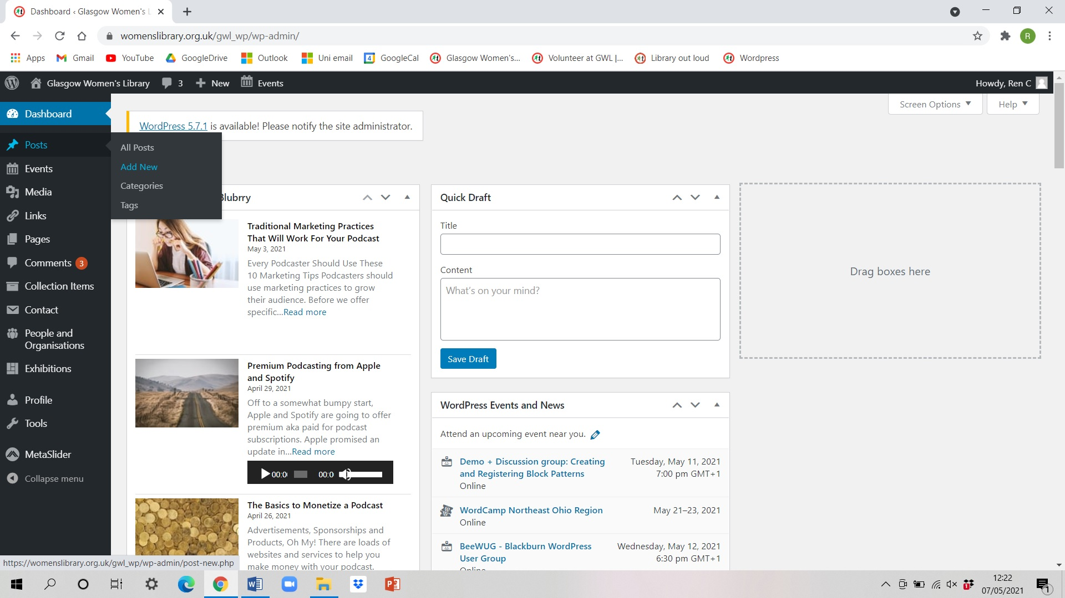

A new post looks like this –
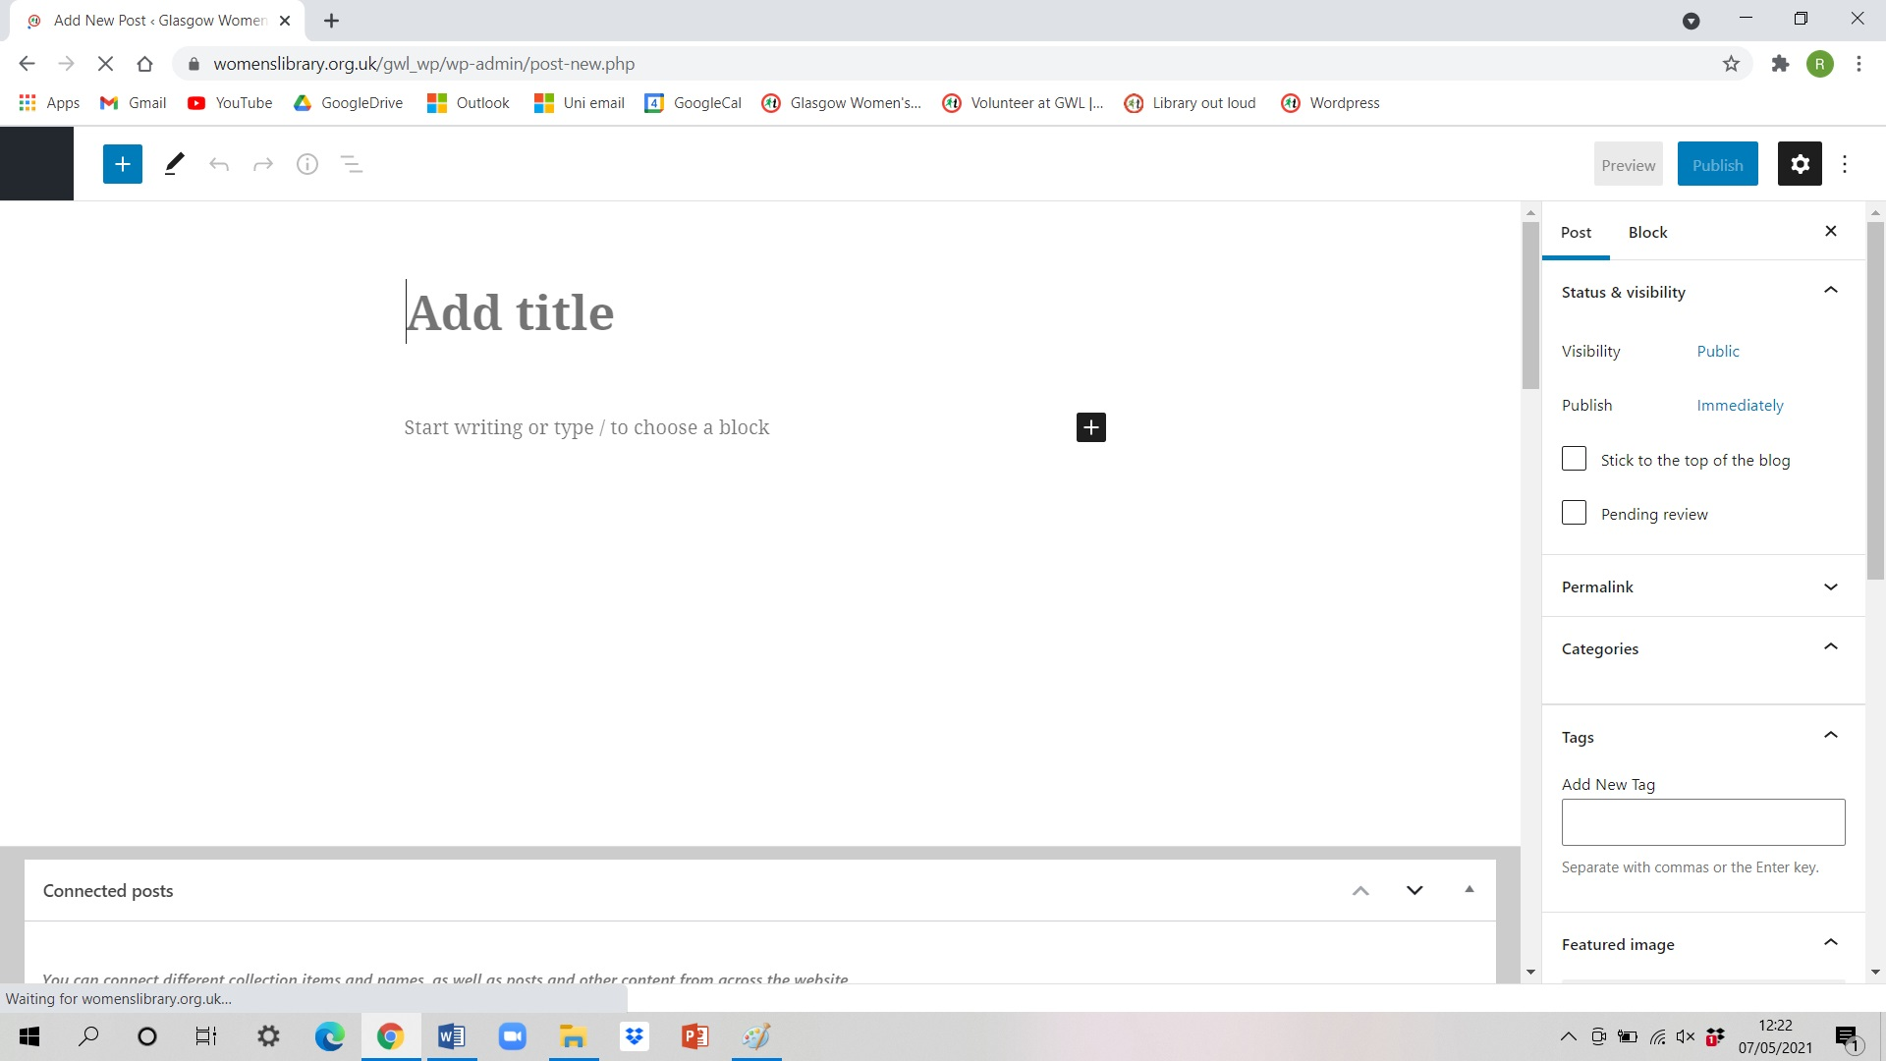

Each post is divided into ‘blocks’. You can think of these as separate sections or paragraphs.
Enter your title and where it says start writing, click here and type in your text from your blog. Each time you click ‘enter’ to start a new paragraph, you create a new ‘block’. Do your text first then photos after.
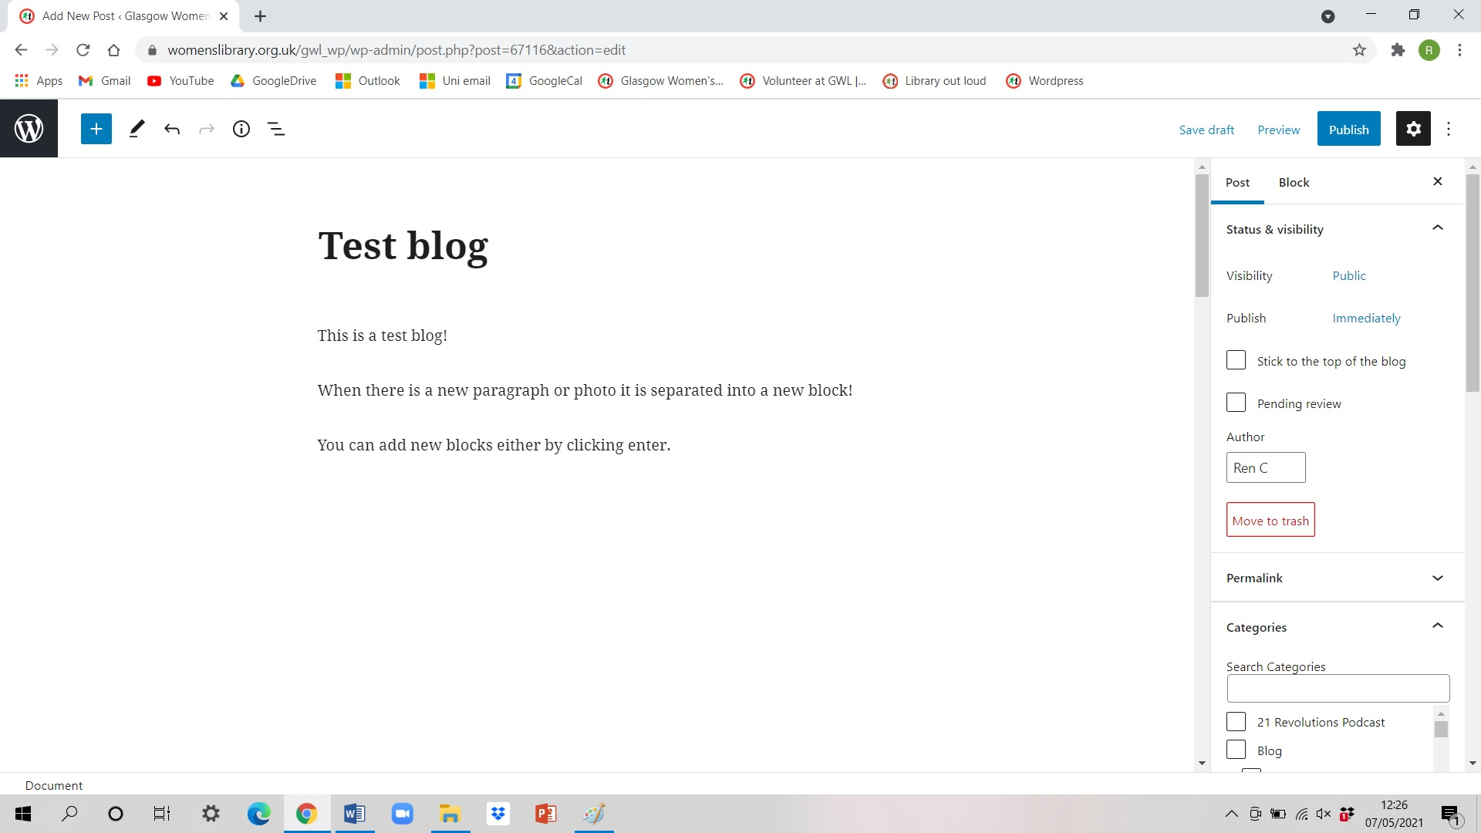
Block 1
Block 2
Block 3
Block 4

When you click on a block there is a menu above and also to the right.
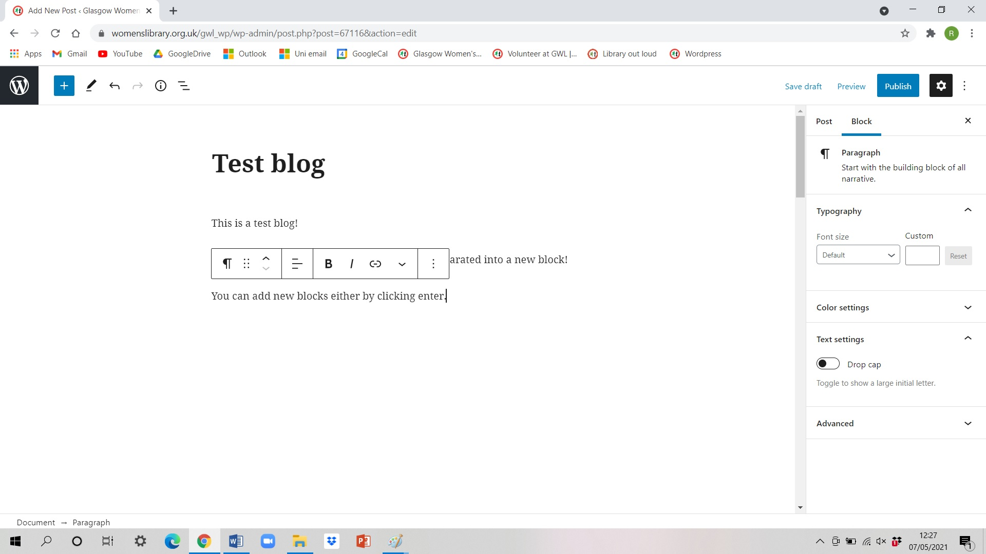

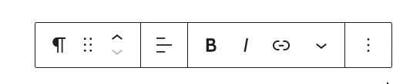
More settings in these menus!
Bold/italics
Changes ‘type’ of block - list, heading, quote etc
Add a link
Click here to drag/move your block around
Changes text alignment (text should always be left aligned!)

Arrows move the block above/below the blocks beside it

Adding images
Before adding images, you need to resize them so they’re appropriate for the website!
Resize the image so that it is maximum 250KB (as close to 200KB as possible). This is approximately equivalent to 1280 pixels (long) by 1024 pixels (wide).
Open image – if using a GWL laptop, use the app IrfanView.
In File, select Save for Web. A dialogue box might open. If it does click Yes.
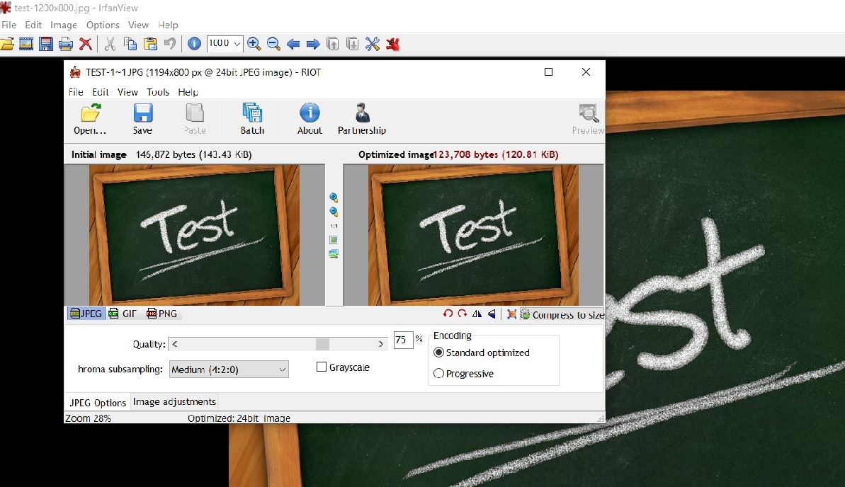
Another box might open that looks like this –

Click the button circled in the photo above.
You can then readjust the size. Enter 1280 pixels in the longest side (either length or width depending on the image’s orientation). The other side will automatically adjust.
Click OK. And Save image to Pictures.
Your picture is now ready to be inserted into your blog!

To add an image into your blog you can start a new block by pressing enter. If you hover over your new block a black square with a cross in it will appear, and when you click on it there will be a menu (see below).
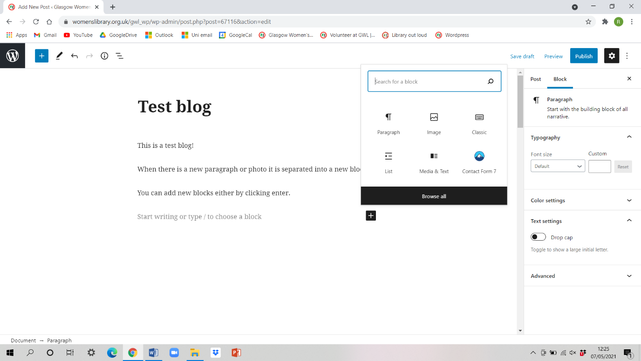
Click image, and then click Media Library.
On the top left of the box that comes up, click on ‘Upload files’, and choose your relevant image to upload.
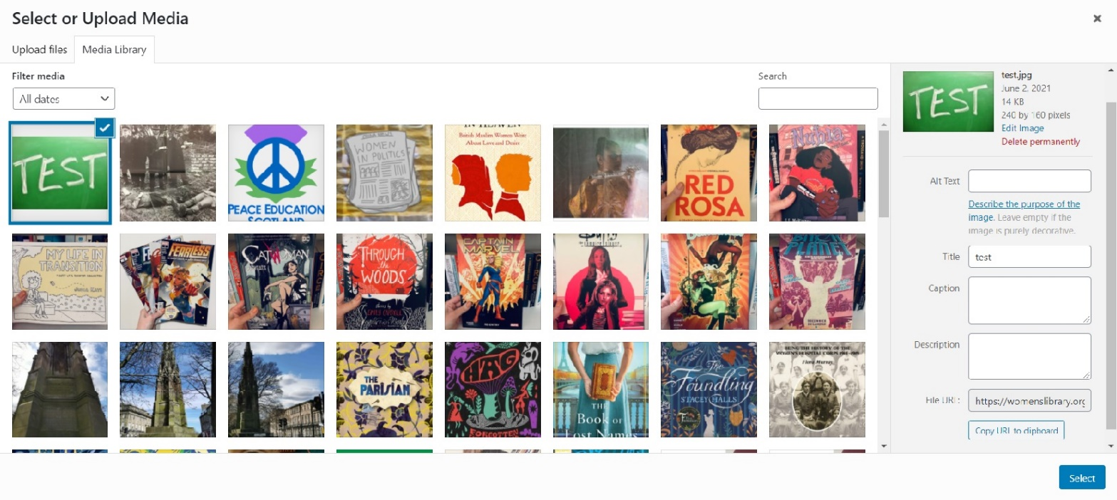
You will then see the media library with your uploaded image (see below!)

You need to input some information into the menu on the right.
Alternative text – this is for people who have a visual impairment and is really important for accessibility so please don’t skip this! Please describe the image here. For example, the above would be ‘The words ‘test’ written in all caps in white chalk on a green chalkboard’.
Title – the name of your image. Make this simple and concise so you can search for it in the future if you need to!
Caption – This is what is displayed under the image on the blog. This is where you would put credits for the image if necessary.
Once you’ve entered this info, click Select at the bottom of the menu on the right!

Once your photo is uploaded onto your blog, you can adjust the image using the menu that appears when you click on it.
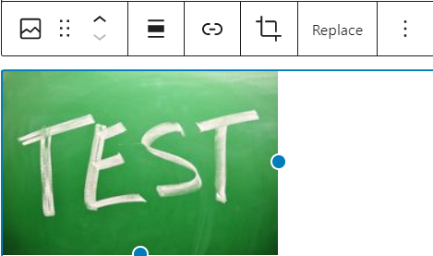

The button in the orange circle adjusts the alignment of the image -
For blogs with big pictures
Alignment: None
For blogs with small pictures
Alignment: Right
You can also change the size of the image at the bottom of the menu on the right by choosing thumbnail, medium, large, or full size. Please don’t adjust the image dimensions as it will leave us with inconsistent image sizes!

Creative Commons Licence:
We are required by one of our funders (National Heritage Lottery Fund) to make all digital materials created by volunteers available under Creative Commons International Licence 4.0. This means anyone can share and adapt the content and makes it more widely available to more people.
To let people know the blog is available under this licence:
- Click to add a new block and “browse all”
- From Reusable Blocks, select Creative Commons HTML
The text will automatically be added. You can see what it will look like once published by going to Preview (top right).

Getting ready to publish
When you are finished inserting your blog and are ready to publish, click the ‘post’ tab on the top of the menu at the right (next to where it says ‘block’!).
A few settings need adjusted in this menu so you are ready to publish!
Visibility – public
Publish – choose the date you want your blog to be published. Check this with a staff team member!
Author – this should already be set as your username for your Wordpress account! If you would like to change this or stay anonymous, let a member of the GWL staff know.
Categories – this defines where the blog shows up on the website. The default is news, make sure to untick this if not necessary!
Always tick blog and the ‘placement and volunteers’ category.
If event related – tick blog and other related categories such as lifelong learning, our history, past events
If news related (i.e. updated opening hours) – tick Blog, News, and other related categories
Search through and choose the relevant other categories such as the book review and archives categories!
Tags – these are buzzwords so users can find related content. Type in related tags separated by a comma.
The most used ones on the website are – ALN, Archives, Art, BME project, Books, Creative writing, Events, Feminism, Fiction, Glasgow, History, Learning at GWL, Library, Lifelong Learning, Literacy & Numeracy, Poetry, Scotland, Scottish writers, Women’s history, Workshops.
Featured image – this is what will be shown on the website before you click on the blog. Not all blogs have one so far but please do add one! Either choose an image from your blog, or upload a separate image to the Media Library.
Excerpt – this is the text that will be shown on the website as a ‘blurb’ before you click on the blog. This is normally around 2 sentences. If you don’t write one, Wordpress automatically chooses the first 50 words of your blog.
Discussion - Almost always allow comments, unless controversial! And allow pingbacks & trackbacks.

You can now preview your blog to make sure it looks okay! Always check with a team member before publishing it. You can save your blogpost as a draft – Wordpress saves as it goes but it’s always good to make sure!

