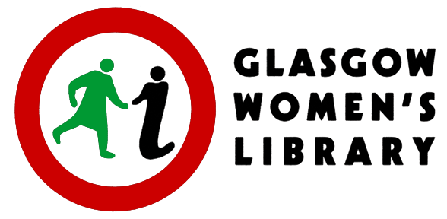
Candidate Number _______________
APPLICATION FORM - PART ONE

Engagement and Outreach Development Worker

14 hours per week; £29,819 pro rata (actual salary is £11,928 gross) plus 6% Employer’s Pension Contribution

The details on this page will be detached from the rest of your application (Part Two) for the purposes of short-listing for interview.

Glasgow Women’s Library processes your personal data safely in accordance with the General Data Protection Regulation 2018. For more information on your rights and how your data is used and stored, please visit womenslibrary.org.uk/privacy

PERSONAL DETAILS

Name
Address
Postcode
Telephone number(s)
Email address

Please email the completed application form, Parts 1 and 2, to apply@womenslibrary.org.uk

CLOSING DATE FOR APPLICATIONS: 12 noon on Monday 10th October 2022

Interviews will take place on Wednesday 9th November 2022

Applications will be accepted from women only under Schedule 9, part 1 of the Equality Act 2010.

This post is supported by the Scottish Government

