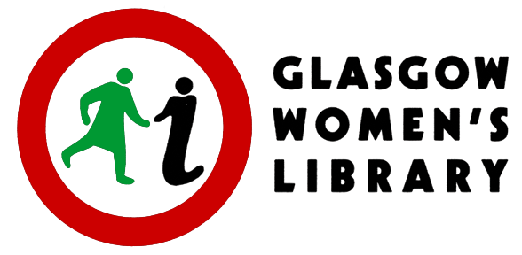
Job Description: Project Archivist: Three Decades of Changing Minds,
Glasgow Women’s Library (GWL)

This is a Fixed Term Contract for a period of 18 months

Hours of work: 35 hours per week (full-time)

Salary: £28,950, plus 6% Employer's Pension Contribution

Holidays: 25 days per annum plus 12 public holidays

Reporting to: Director of Operations, Resources and Enterprise

Main Purpose: To lead in appraising, cataloguing, digitising and making accessible GWL’s organisational records

Main Duties and Responsibilities:

- To work closely with colleagues to make GWL’s records accessible and available digitally where appropriate

- To work with colleagues towards a Digital Management Plan for GWL’s born digital records

- To inspire, motivate, educate and inform a broad range of people in the care, interpretation and use of GWL’s organisational collection

- To train and support groups of volunteers (with a range of lived experiences and needs) in archive related skills with due respect to the sensitivity and safe handling of records and international cataloguing standards

- To work with the GWL staff team in developing and delivering public learning and training activities, displays and events related to the project and GWL’s organisational collection

- To contribute to Accreditation processes in relation to GWL’s Accredited Museum status and its designated status as a Recognised Collection of National Significance

- To network with relevant individuals and organisations in order to recruit volunteers, and to promote the collection and GWL as a safe and appropriate place of deposit for future donations relevant to the project

- To respond to telephone, written, social media and email enquiries regarding the collection and donations, and promote the heritage of GWL through social media platforms

- To attend and contribute to regular staff team meetings and supervision sessions

- To undertake appropriate training and staff development

- To undertake any other reasonable duties, appropriate with the job title, as may be determined by Glasgow Women’s Library, and work within its policies and procedures

Applications will be accepted from women only under Schedule 9, part 1 of the Equality Act 2010.
Person Specification: Project Archivist: Three Decades of Changing Minds, Glasgow Women’s Library

The Person Specification is designed to let applicants know what is required in relation to the attributes of a successful candidate. The Person Specification is divided between 'essential' and 'desirable' attributes. In order to convince the selection panel that you should be short-listed for interview, you must be able to show that you meet all the essential requirements. If you can also meet some or all of the desirable requirements, then you will have further advanced your case for a successful application. Please try to structure your own answers on the application form to show the panel how you meet these requirements, especially the essential ones. If you are called for interview, the panel will ask you questions specifically designed to confirm your ability to meet such requirements.

Skills and Abilities | Essential | Desirable
An ability and enthusiasm to motivate, educate and inspire a broad range of people | √
Skills required to train groups of volunteers in archive related work with due respect to the sensitive and safe handling of records and international cataloguing standards | √
Ability to lead group learning activities and training with confidence, patience and sensitivity | √
Excellent organisational skills, with the ability to manage a wide range of tasks and meet deadlines | √
Ability to think creatively | √
Ability to work as part of a team | √
Ability to use own initiative and organise own workload | √
Excellent communication, presentation and interpersonal skills, both written and verbal | √
Good IT skills including word processing and database management | √
Ability to work flexibly including evenings and occasional weekends if required |  | √
Experience
Experience of working as an Archivist | √
Experience and knowledge of digitisation standards and practices | √
Experience of using evaluation and monitoring tools and techniques |  | √
Experience of liaising with and working effectively in partnership with other organisations |  | √
Knowledge
Hands-on knowledge and experience of online archive management systems | √
Sound background in ISAD(G) standards for archival collections | √
A knowledge and understanding of intersectional equalities issues | √
Training and Qualifications
A relevant professional qualification | √
Other
Interest in women’s history and achievements |  | √

CLOSING DATE FOR APPLICATIONS: 12 noon on Monday 24th January 2022

Please email the completed application form, Parts 1 and 2, to apply@womenslibrary.org.uk

Interviews will take place on Tuesday 8th February 2022

This post is supported by the National Lottery Heritage Fund

