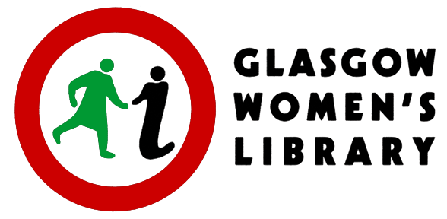
Candidate Number _______________

APPLICATION FORM - PART ONE

Project Archivist: Three Decades of Changing Minds, Glasgow Women’s Library

35 hours per week (full-time): £28,950, plus 6% Employer's Pension Contribution

This is a Fixed Term Contract for a period of 18 months

The details on this page will be detached from the rest of your application (Part Two) for the purposes of short-listing for interview.

Glasgow Women’s Library processes your personal data safely in accordance with the General Data Protection Regulation 2018. For more information on your rights and how your data is used and stored, please visit womenslibrary.org.uk/privacy

PERSONAL DETAILS

Name
Address
Postcode
Telephone number(s)
Email address

CLOSING DATE FOR APPLICATIONS: 12 noon on Monday 24th January 2022

Interviews will take place on Tuesday 8th February 2022

Please email the completed application form, Part One and Part Two, to apply@womenslibrary.org.uk

Applications will be accepted from women only under Schedule 9, part 1 of the Equality Act 2010.

This post is supported by the National Lottery Heritage Fund

