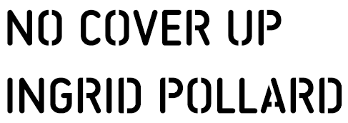

Friday 28th May 2021 to Friday 23rd July 2021
Glasgow Women’s Library
Open: Tuesday, Wednesday, & Friday: 11am to 4pm // Thursday 2pm to 7pm // Saturday 12pm to 4pm

Following a residency in 2019, Ingrid Pollard presents new work in response to the Lesbian Archive held within Glasgow Women’s Library (GWL). Having worked with Ingrid over this period, it is an honour to write this text for No Cover Up.
The Bradford 12. Colin Roach. Section 28. Hands Off Grenada. Newham 8. Lenthall Road Workshop. Lesbian Line. Black Lives Matter.
By pulling together these various strands of history, Ingrid’s work demonstrates the ways in which social movements are necessarily interconnected, and the futility of trying to separate them. Interviews on bookshelves, fabric prints draped on walls, books with hidden recesses, posters and prints across both floors of the library highlight the way in which connectivity abounds.
The voices that you hear are individuals who are included within, or connected to, the archive. These include Claudette Johnson, Pam Isherwood, Pragna Patel, and Adele Patrick. A microcosm of the women’s liberation movement during the 80’s, alongside various other protests and demonstrations adorning GWL’s walls, the archive connects all.
Echoing the architecture and materiality of the library, Ingrid’s work is analogue in a digital world. Dealing directly with the ‘sweetness of the place,’ and the context of the library itself, the visitors and the archive, it’s an old style rejuvenated by the new. Though many contemporary exhibitions work to fit within a white cube, these works depend upon and speak to their surroundings. It is integral therefore to place you, the viewer, in your current context.

You stand within a women’s library which has been fought and cared for, fiercely, by women and non-binary people; its consistent aim to preserve and celebrate women’s history, creativity and cultures. Within the library sits a relatively young archive – we can assume that amongst those represented in it are people who are very much alive. The interconnectedness of the archive, the communities it represents and the links to our current context are repeatedly highlighted throughout the exhibition.
The Lesbian Archive began in London, a collection of various personal and community archives, ephemera, literature, objects, letters, posters. But the archive is not inextricably linked to London – its contents represent lesbian lives and activism across much of the UK and beyond. What links the materials in the archive is not solely what they represent, but the groups of people, who have cared enough to collect and protect these records.
However, you would be forgiven for asking the question most regularly asked in relation to the archive – ‘Why Glasgow?’.
In the 1990’s, the Lesbian Archive and Information Centre (its proper title) lost their funding and could no longer safeguard the materials. This evokes concerns that persists today for the endurance and safeguarding of counter cultural spaces and records – what should happen to a community or personal archive, particularly one which represented marginalised or oppressed peoples? Which institutions can be trusted to hold these archives in perpetuity? How do we protect such important materials from this precarity? Which institutions have the resources and the motivation to do so, and which may be influenced by funding, patrons, politics?
At the time, LAIC put an urgent call out for a new home via the ‘gay press’ and it was the volunteer led Glasgow Women’s Library that responded. Constituting the largest of the collections housed by GWL the archive continues to accumulate records and welcomes researchers and visitors. At intervals, the perpetual relevance of its collections are brought into sharp focus through the agency of creatives. This is abundantly the case with Ingrid Pollard’s No Cover Up.

Text by Freya Monk-McGowan and GWL

Ingrid Pollard:
Ingrid Pollard is a multi-media artist, photographer, researcher and lecturer. Pollard has developed a social practice concerned with representation, history and landscape with reference to race, difference and the materiality of lens-based media. Her work is included in numerous collections including the UK Arts Council and the Victoria and Albert Museum. Recent works include a re-examination of the UK and international archives to decolonise ethnographic and state-sponsored imagery of the former colonised countries.
In 2020 Ingrid Pollard and MK Gallery were awarded the Freelands Foundation Award to host a major exhibit of Ingrid’s work in 2022. In 2019 Ingrid Pollard was a recipient of the Paul Hamlyn Foundation Award for Artists, and in 2018 was the inaugural Stuart Hall Associate Fellow at the University of Sussex.
Freya Monk-McGowan:
Freya Monk-McGowan is a freelance curator and coordinator. Having studied Curation (MFA) at Goldsmiths and History, Literature and Culture (BA Hons) at Brighton University, she has a focus on marginalised and community histories. Freya previously worked as Assistant Curator for Glasgow International 2018, and designed and curated the Lesbian Lives project, of which No Cover Up is an integral part.
The Lesbian Archive:
The Lesbian Archive at GWL is the only one of its kind in the UK and is a valuable resource documenting the lives of lesbians, bi and queer women from the 1920s to the present day. Although it is called the Lesbian Archive – due to the majority of the collections originating from the Lesbian Archive and Information Centre in London (LAIC) – it covers a wide range of LGBTQ movements, with materials relating to key political campaigns, events and groups across the broader community.

Online Resources:
All exhibition text materials, and a list of website references selected by Ingrid Pollard, are available to download from the exhibition page on GWL’s website.
Public Programme:
In Conversation: Ingrid Pollard & Mason Leaver-Yap, Thursday 24th June, 6.30pm to 8pm, Online, 16+
Join Ingrid Pollard and Mason Leaver-Yap in conversation as they discuss Ingrid’s recent residency and commission with Glasgow Women’s Library, and the process of working within a relatively young archive.
Please book your free place on GWL’s website.

Ingrid Pollard, Freya Monk-McGowan and Glasgow Women’s Library would like to thank:
Lenthall Road Workshop Collective, Suzanne Bonnar, Lesley Climpson, Sue Frumin, Patricia Gonzales, Pam Isherwood, Claudette Johnson, Femi Otitoju, Pragna Patel, Adele Patrick, Alice Andrews, Lubaina Himid, Laura Guy, Charlotte Keenan, Mason Leaver-Yap, Sonia Chand, Ren Clark, Doreen Kelly, Lauren Kelly, Gillian Murray, Stacy Wallace, Ru Yorke, GWL volunteers

Ingrid Pollard, No Cover Up, is selected for and supported by Glasgow International 2021 Across the City Programme. Funded by Esmée Fairbairn Collections Fund which is run by the Museums Association.

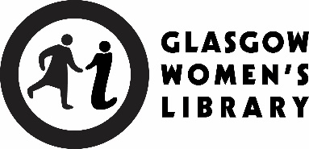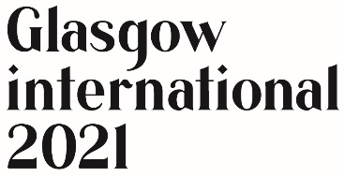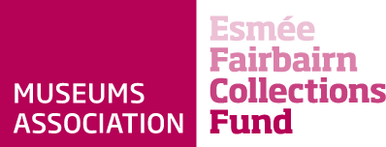

Large print formats of all exhibition text materials are available at Front of House.
All exhibition text materials are available to download from the exhibition page on GWL’s website: womenslibrary.org.uk/event/ingrid-pollard-2/

