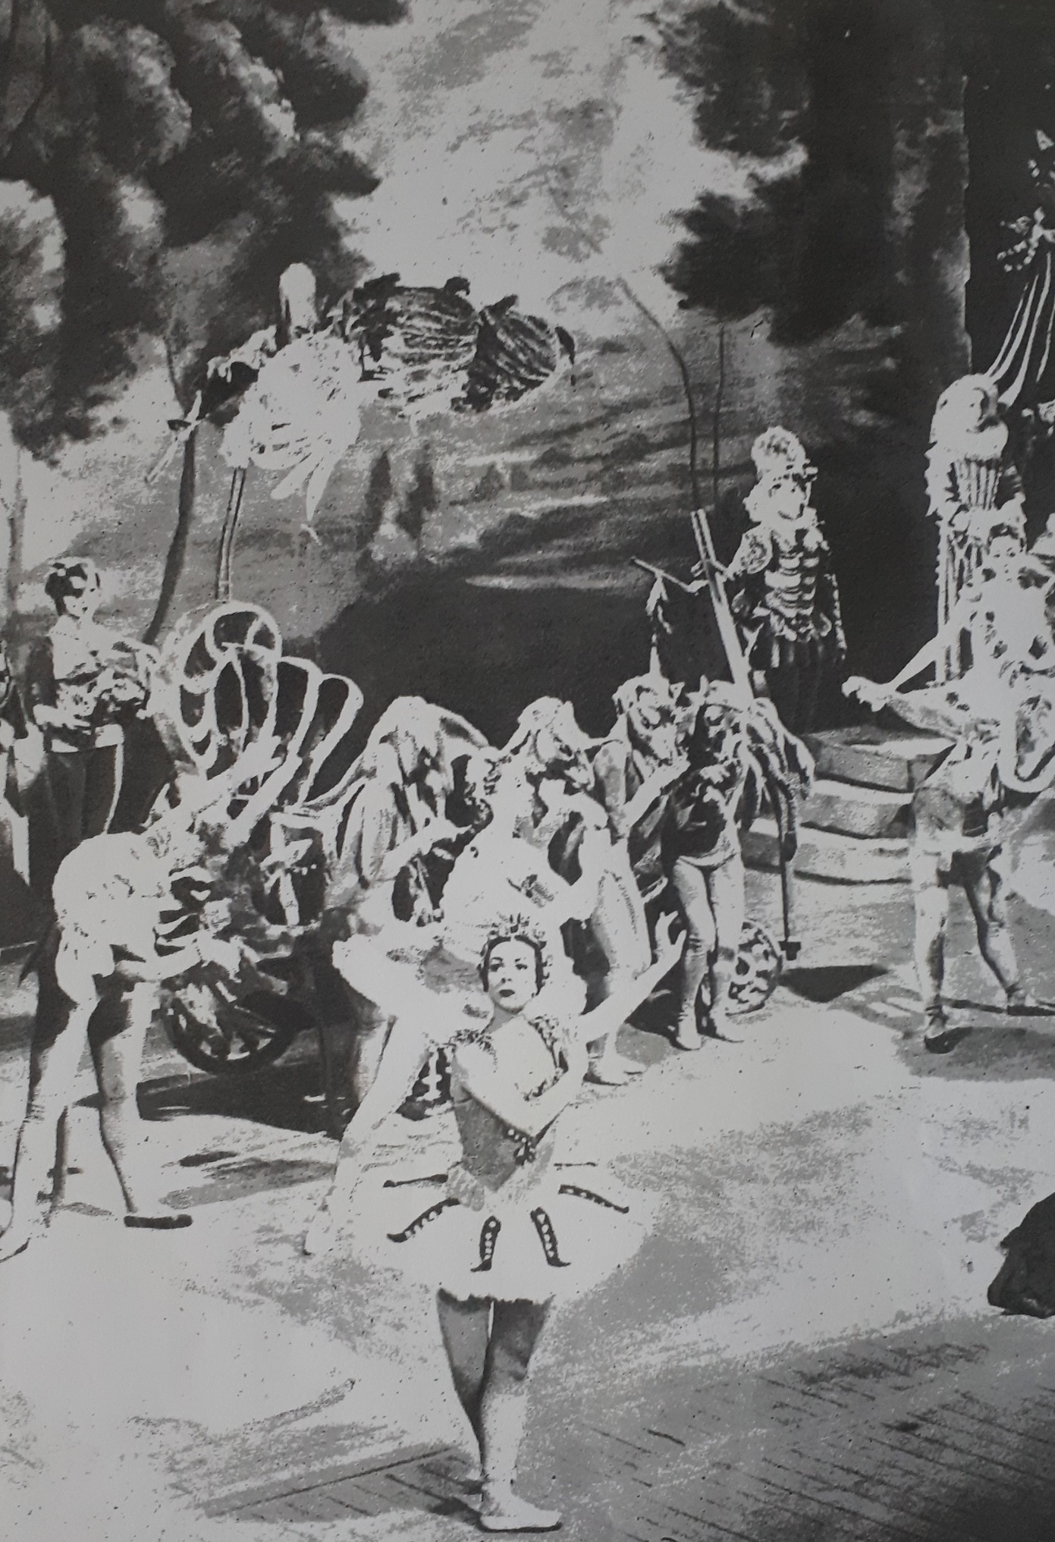
Succession

Succession is a e-zine made by Glasgow Women’s Library’s Autumn/Winter Create and Connect group 2019-20, and first shared online in January 2020. Each piece is a found poem or short story/ flash fiction created in response to items held in the Glasgow Women’s Library archive: a ‘Christmas Decorations’ page in Girl Annual no.6 (approx. 1955) and a short story by Elizabeth Benson, illustrated by John Chamberlain, titled ‘3 Fateful Words’ in Girl Annual no.3 (approx. 1952). ‘On Snails’ by Lauren Ross is from Girl Annual no.6 (approx. 1955).

Image sources: Cover image from Girl Annual no.3 (approx. 1952), Christmas Decorations image from Girl Annual no.5 (approx.. 1955), the Skating figures image is from Girl Annual no.9 (approx. 1961) and the 3 Fateful Words image is from Girl Annual no.3 (approx. 1952).

Glasgow Women’s Library does not take responsibility for the content of writing produced by the group, and all rights are reserved to the authors of each piece.

To find out more about the Glasgow Women’s Library, visit www.womenslibrary.org.uk.

Contents

Succession by Lesa Ng
Christmas Decorations by Lauren Ross
Two Equal Parts: the angel and the boy by Amy B Moreno

Three Fateful Words by Lauren Ross
It’s Not Much by Kirsty Lewin
Three Fateful Words: by Clare Jane Hewitt

On Snails by Lauren Ross
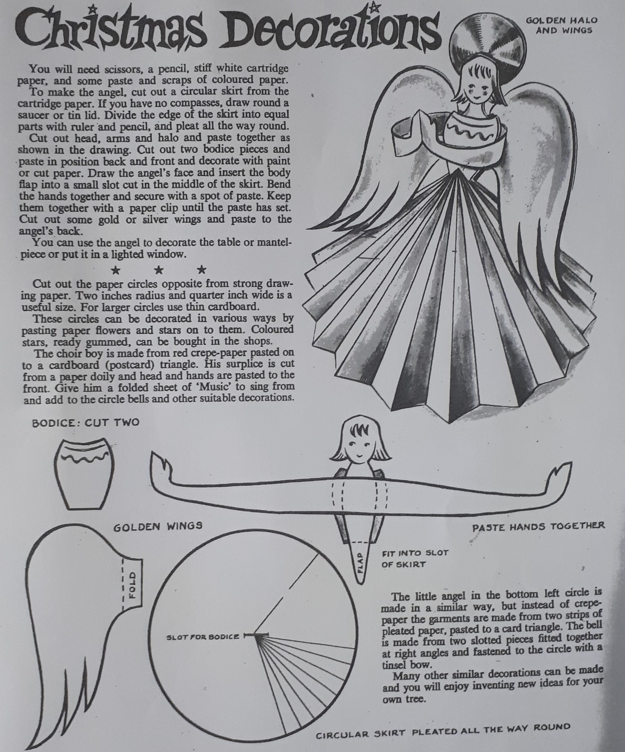
Succession

a ruler
equal parts
boy and skirt
his face stiff, white
hands folded together
the golden circle
secure on little head
bells sing

by Lesa Ng

Christmas Decorations

You will need

To make the angel
have no

halo

decorate
the angel’s face

with a spot of

gold

in a lighted window.

flowers and stars
can be bought in the shops

by Lauren Ross

Two Equal Parts: the angel and the boy
To make the angel,
thin is a suitable size
Pleat, divide and fold; fitted small
Paste a doily skirt with coloured cut out flowers, all the way round
Decorate the face with paint, and draw a red edge
Secure a halo
Cut and insert the wings
Bend the hands back and secure them together with a clip
Give scraps
You can use the angel to decorate the mantel piece

To make the boy,
Use a tin lid
A larger size; back and front
Add:
wide arms
golden hands
strong head
With parts and pieces slotted together,
he is useful in various ways
Give him stiff paper and right angles,
And he will enjoy inventing new ideas
Enjoy your similar decorations, and put them together in a lighted window.
Amy B. Moreno

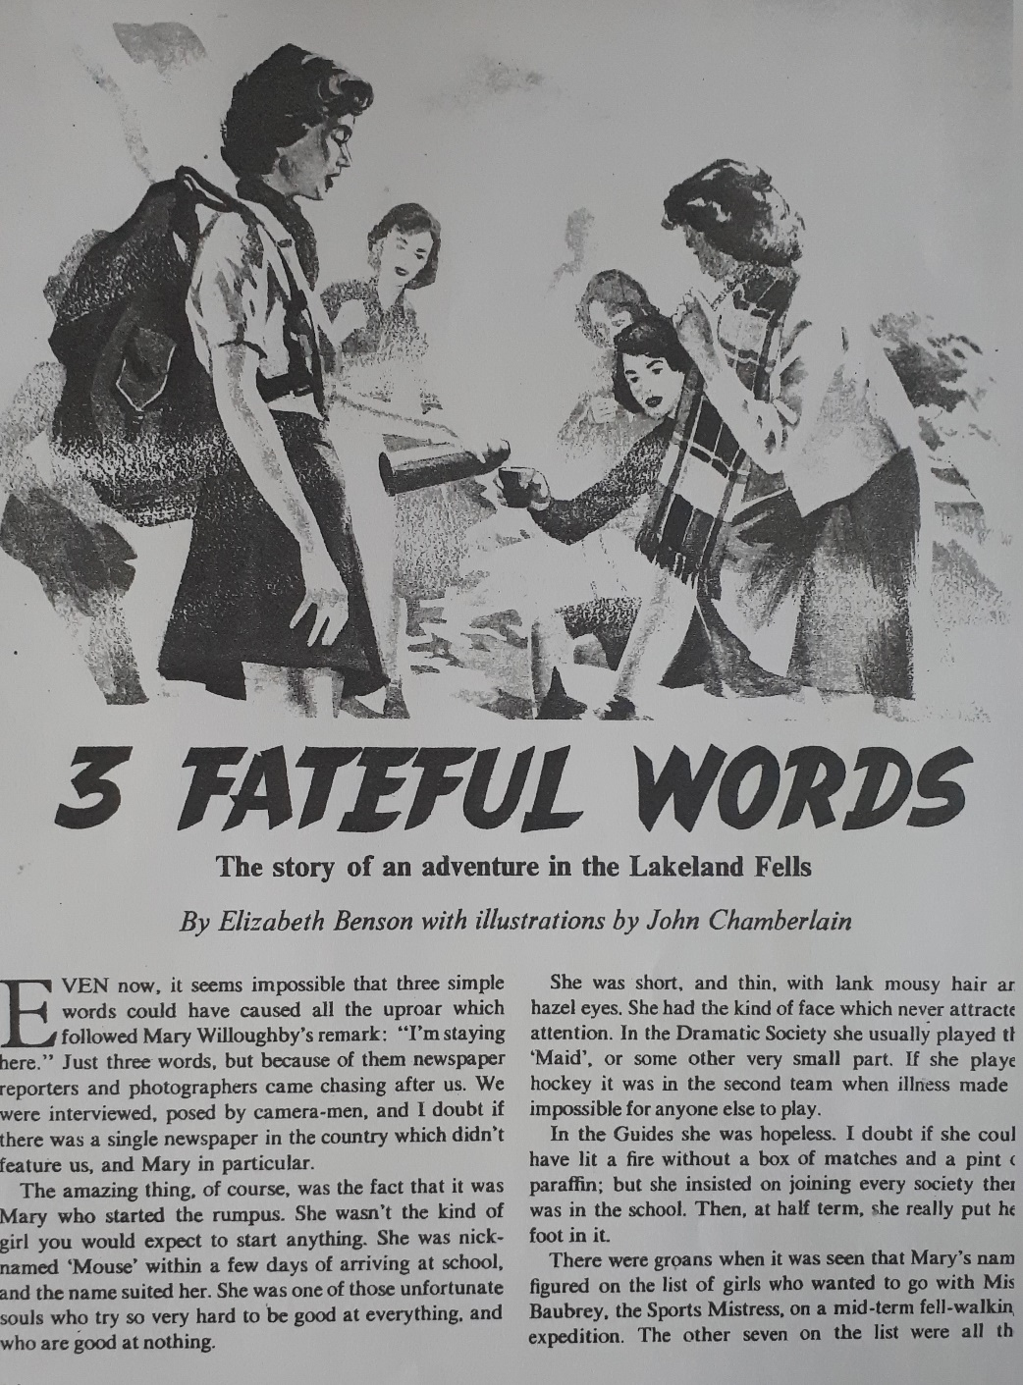

Three Fateful Words

On her way back from the village bakery, Alice felt in her coat pocket for the waxy paper folded around her package of half-dozen gingerbread biscuits. She unfolded an end to retrieve a piece, her eyes shifting in their sockets to check no-one was watching, and as
she pulled one out, a flash of white caught her eye. A small slice of card slid out of the wrapping with the biscuit. She stopped and blinked at it, scowling.

Meanwhile, back in the village, Max was racing out of the bakery leaving bemused customers at the counter and kicking up dust on the road. With each stride and gasping breath he prayed that Alice hadn’t discovered the note yet. ‘The wrong package, the wrong
package, the wrong package,’ spun through his mind as he sprinted, weaving around a postbox and pedestrians with prams.

He turned off the main road and saw her blue coat in the distance.

‘Alice!’ he called down the length of Church Street. She stood stock still with her back to him, head bent and forearms raised. He ran the rest of the way towards her. ‘I can explain,’ he pleaded in a long, trembling breath before reaching her.

She turned to him, then, a look of shock frozen over her face, the tiny card perched between her thumb and finger. ‘It wasn’t meant for you,’ Max continued, ‘it was meant for—’ He couldn’t let the
name pass through his lips.

Alice looked down again at the lines of ink scribbled on one side of the note, back up into Max’s bulging eyes, then offered him the slip of paper. ‘I can’t read.’

By Lauren Ross

It’s not much

‘It’s not much,’ she says, dropping the pound coin into my hat.
‘Bless you,’ I say. Alien words, chosen for their dissociation. She doesn’t move. Just stands there blocking my cardboard sign. The guts of my new life spelt out in angry felt-tipped capitals.
‘It’s better than nothing,’ she says. She’s smiling down in her thick camel coat. My neck hurts from looking up. She stares at my hands. Ten neat finger nails stumped by grime. I fold their shame into the sleeves of my sweater. Her hands jiggle in a cottontail muff. The straps of her shoes plough bare flesh into thin cultivated lines.

She squats down. Dosing me with her foxy cloying scent. I rub my nose. Her eyes meet mine. I shuffle backwards, sliding on the damp plastic bag.
‘The thing is,’ she says, leaning backwards on her heels, her cream trousers dipping in the wet, ‘I don’t carry cash.’ Her eyes probe. I blink her away.
‘It’s okay,’ I say.
‘It’s all cards now,’ she says. ‘My daughter says it’s safer.’ She’s blocking my sign. My chances. So many legs and bags hurrying past.
‘It’s cards that put me here,’ I say. She looks at my stack. Backpack, bedroll, bottle of water.
‘I couldn’t do it,’ she says, ‘what you do.’
‘I can’t either,’ I say.
‘I have so much,’ she says, ‘and you, you make me feel guilty.’ She takes a hand out of the muff, pats the hard shine of her pewter hair.
‘We’re all made to feel that,’ I reply. I pick at the scab on my lip. Taste the coppery salt. Watch the freed red scrap of skin float into my lap. ‘You couldn’t get me a cup of coffee?’ I ask. ‘I could do with something hot.’ She frowns.
‘There isn’t anywhere close,’ she says.
‘McDonalds,’ I say, motioning to the other side of the street.
‘Oh, I don’t really…’
‘Or a lip salve?’ I look at her bag. Brown leather with a horse-bit buckle. She glances at my boots. The quality chunky soles. The red laces, double knotted. Remnants of what was and now isn’t.
‘The thing is,’ she says, ‘you’ve got something I’ll never have’. Her breath is acetic. Liquor sweet.
‘What’s that then?’ I ask, distracted by a young bloke in white trainers with his wallet out. He drops a two pound coin into the hat.
‘Thanks,’ I say.
‘No worries, mate,’ he smiles. ‘Tough times. You look after yourself.’

‘Freedom,’ she says. ‘You have your freedom.’ She levers herself up. My mouth opens. Her heel slides on the pavement.
‘Careful,’ I say. Her hands fly out of the cottontail. The muff swings loose from her neck on its gold chain. She steadies herself. Slots her hands back into the pelt.
‘It’s not much,’ she says, pointing the muff at the coins in my hat. She looks down at me again. ‘But I enjoyed our chat.’

By Kirsty Lewin

Three Fateful Words:

People milling around in sound like a wash of waves, and words are as indistinguishable from one another as drops of water. Sound moves through the air and you struggle to tune into the frequency of the conversation you're meant to be in. Words burst through like static on a radio dial. Leave. Weather. Flood. Normal words. Apocalyptic words. Words which change a life because of who says them, and who hears them. You're looking for the connection between these words, to allow their meaning to take shape. But they continue to bounce around your head like stones in a rolling barrel and their sense is as vacant as the air around them. You try to change the subject, but find there's nothing left to say.

Clare Jane Hewitt

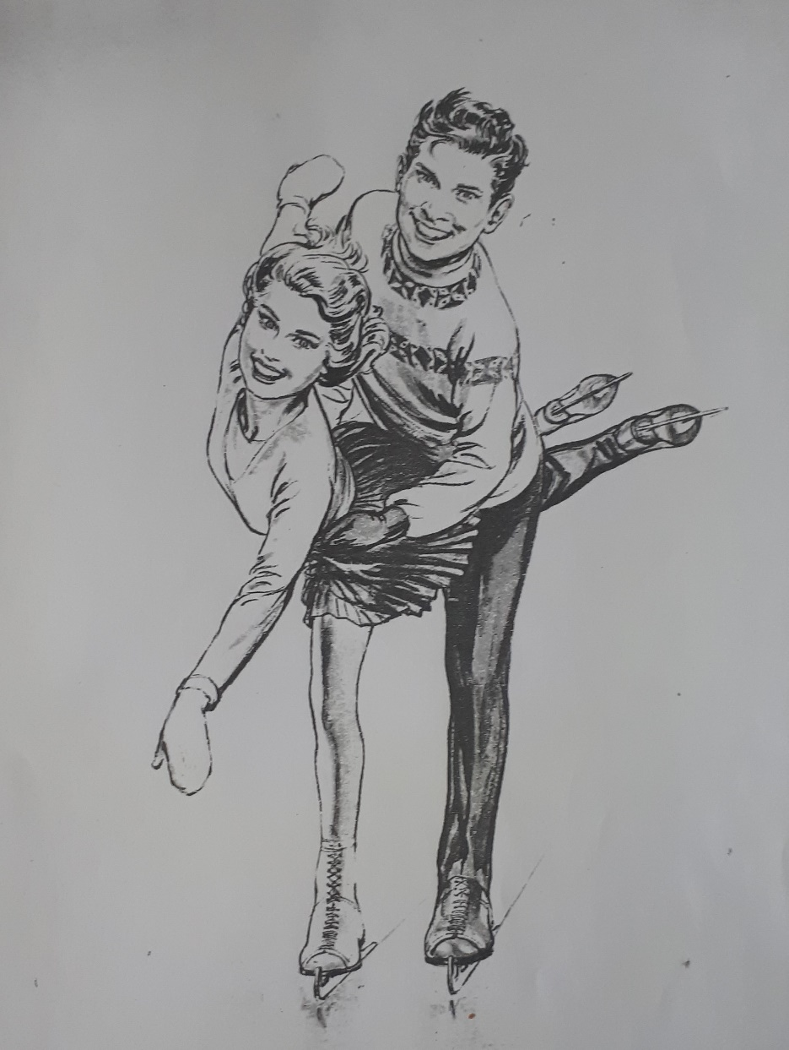

On Snails

Inspiration: ‘Someone once took some snails out of a glass case in a museum where they had been kept for fifteen years, and found they were still alive.’

* * *

But what made it even stranger was the fact these were no ordinary snails, not that they were as large as those from Africa or had pink-spotted shells or blue bodies. No, these had been buried deep into the soil of a plain old back garden in Shropshire. And yet, when their shells were analysed, they were found to be over 150 years old.
Mr Patterson, a recent doctoral graduate of paleontology, had recently joined the museum as an archivist. One night, only weeks into his new employment, he took three of the snails in question from their show cabinet, without having gained prior permission, in order to perform his own study of them in the privacy of his office. He failed, however, to return the snails, falling asleep at his desk where the snails sat. When he awoke, he found that they had disappeared. He thought that perhaps another employee had discovered his misconduct and returned them straightaway. Then, on opening the blinds, Mr Patterson noticed the light catching a thin, sparkling trail, which wound off of his desk and through a gap in his office door.

By Lauren Ross

