Information for attending the Seeing the Unseen event at Glasgow Women’s Library

- The timings of the event
- Getting to Glasgow Women’s Library
- Arriving at the Library
- The layout of the building
- The spaces the event takes place in
- How to get in touch

Event Timings

5pm - Help yourself to tea or coffee
- 5.15 pm - Catriona Stewart from the Scottish Women’s Autism Network will introduce the screening
- 5.30pm - The screening will start
- 6.50pm – 10 minute break
- 7pm - Q & A session with Catriona Stewart from the Scottish Women’s Autism Network. If you don’t feel comfortable shouting out questions there will be a box where you can write down a question and leave it for Catriona to answer

- Please feel free to take breaks during the screening

Travel to GWL
The Library is just around the corner from Bridgeton Cross – you can reach the Library on Landressy Street on foot from London Road, or from James Street.

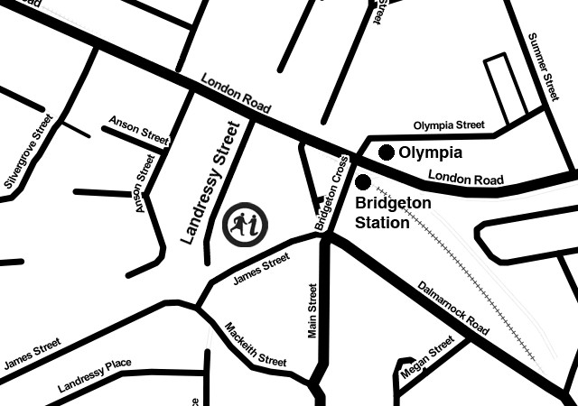
Get directions to Glasgow Women’s
Library on Google Maps.

Getting to us by bus
Take the 18, 43, 46, 64, 65, 164, 263 or 2
to London Road/Bridgeton Cross For information on bus services call: FirstGlasgow: 0141 423 6600
Glasgow Citybus: 0141 954 2255
Scottish Citylink Coaches: 08705 505050

Getting to us by train
The closest railway station to the Library is Bridgeton station – take the low-level train from Glasgow Central. Please note that Bridgeton Station is not wheelchair-accessible, and the platforms are accessed by a long flight of stairs. The closest wheelchair-accessible station is Dalmarnock Station, which is approximately 3/4 mile (1.2 km) from the Library.
To find GWL from the train station, turn left onto the main road (London Road), walk past the bandstand (Bridgeton Umbrella) and shops on the left, then turn left into Landressy Street (across from Greggs). GWL is on the left further up Landressy Street.

Getting to us by bicycle
Cycling Route 75 follows the Clyde to Glasgow Green which is a 3 minute ride from Landressy Street along cycle paths. We suggest using CycleStreets.net to plan your journey to and from GWL.
There are bike racks in the small square on James Street as well as our very own bike shelter which is available
for visitors. It is locked but please ask our front of house team if you would like to use it.

Parking at GWL
We always encourage our visitors to use greener methods of transport when visiting GWL but we understand that sometimes using a car is unavoidable. To ensure that our neighbours can park on the street without any problems, we ask visitors to please park in the car park opposite our building. There’s plenty of space and there are no charges for parking your car there.
Please contact the Library if you have any questions about access.

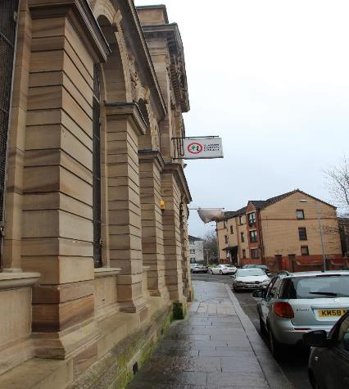
Arriving at the Library

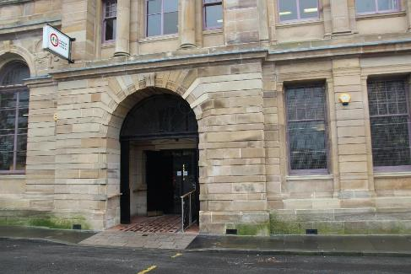

The entrance is sloping, step-free and wheelchair accessible.

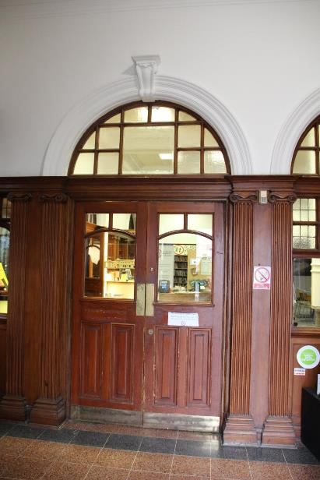
Entrance foyer

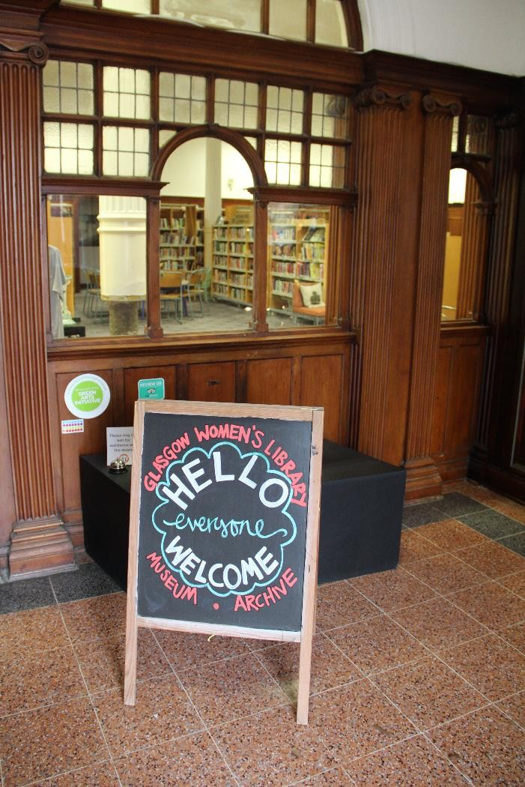
There is a bell to ring if help is needed with the doors, as they are quite heavy and not automated.

Once you are through the main doors, you will find:

The reception area The lending library
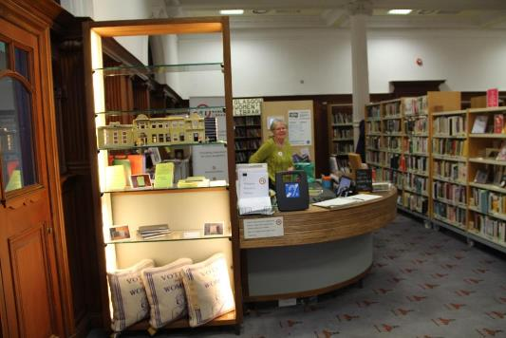
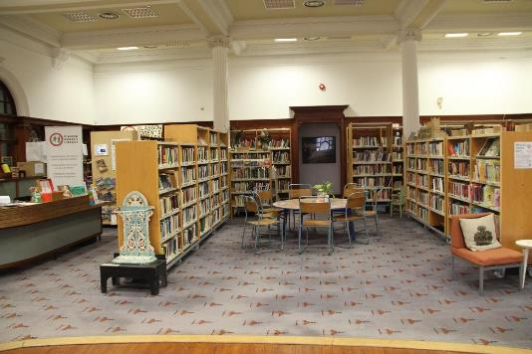

A volunteer will welcome you. There are comfy seats around the library if you would like to wait downstairs. The accessible toilet is next to reception (all toilets are gender neutral).

When you arrive at GWL, let the volunteer on reception know you are here for the film screening.

If you are early, you can either wait in the main library area, or in one of the quiet areas of the library. These are listed on a sign to the left of the reception desk (next to the lego model of the library). There is overhead fluorescent lighting in the main library area and throughout the library.

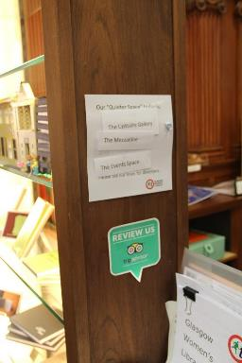
A GWL volunteer will show you up to the Community Room, where the screening is taking place.

The Upstairs Gallery is next to the Community Room. You can make use of this room if you need a break in a quieter space during the screening. There are two toilets off this room including a disabled access toilet.

A GWL volunteer will show you upstairs through this door

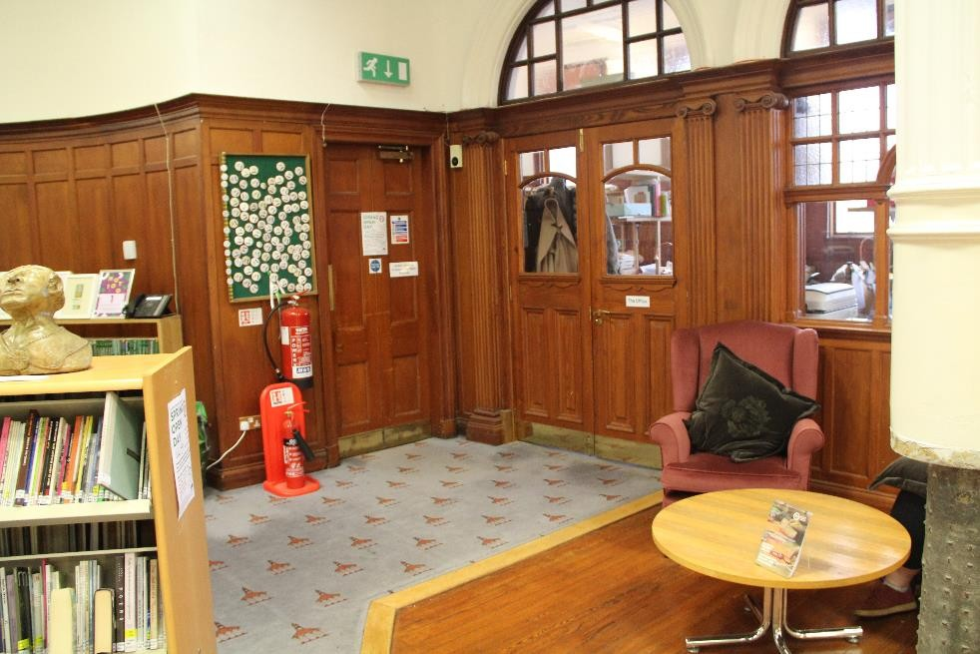
Door up to the Community Room

Once you go through the door to the Community Room, there is a door to your right at the end of a short corridor, also signposted for the Community Room. There is a set of stairs and also a lift which you can use. The lift will take you up to the Upstairs Gallery which is next to the Community Room. If you go up the stairs you will see the Community Room straight ahead of you.

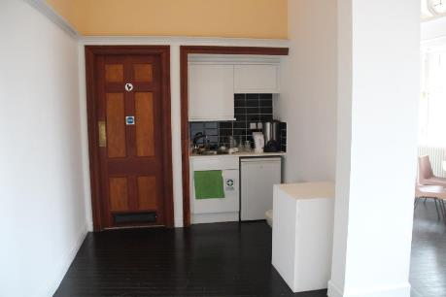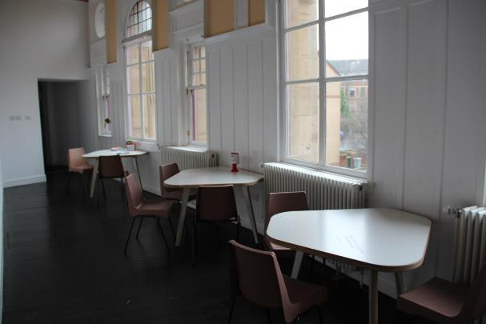

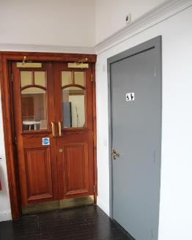
Upstairs Gallery
Kitchen area, toilets, seating area and lift.

There will be teas, coffees and refreshments in this
area and space to sit before and during the screening.

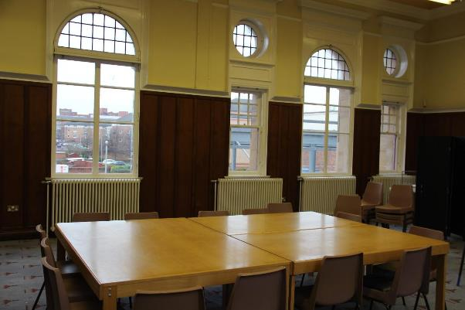
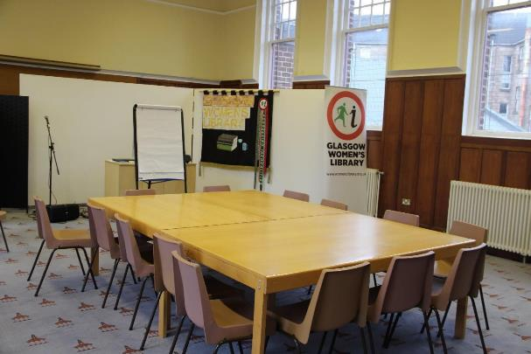

The Community Room – Screening Space
The Community Room is where the screening is taking place. The chairs are cushioned and will be laid out in rows. The room has fluorescent lighting which will be turned off during the screening.

If you have any concerns or questions about access, please get in touch with us on 0141 550 2267 or email emily.ilett@womenslibrary.org.uk

https://womenslibrary.org.uk/about-us/accessibility/

