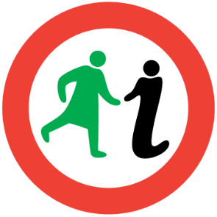
WOMEN’S
WEST END
HERITAGE WALK

1.6km/1mile
The terrain is mostly flat with a gradual hill on University Avenue and the route follows pavements throughout.

Introduction
Determined, committed and inspiring women have shaped Glasgow’s history from its beginnings, but their story is not often told. Glasgow Women’s Library made history itself by creating this guided walking tour in 2007; the first one to focus on the pioneering women of the city. Join us on a journey to celebrate some of their achievements.

This walk offers a unique and inspiring insight into the hitherto unsung women who made the West End. Walk in the footsteps of protesting activists, rent strikers, and the first female students of the University of Glasgow.

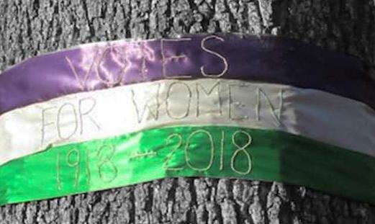
Image: Votes for Women banner, created by Valerie Gauld, on the Suffrage Oak, 2018, Photography by Rebecca Jones.

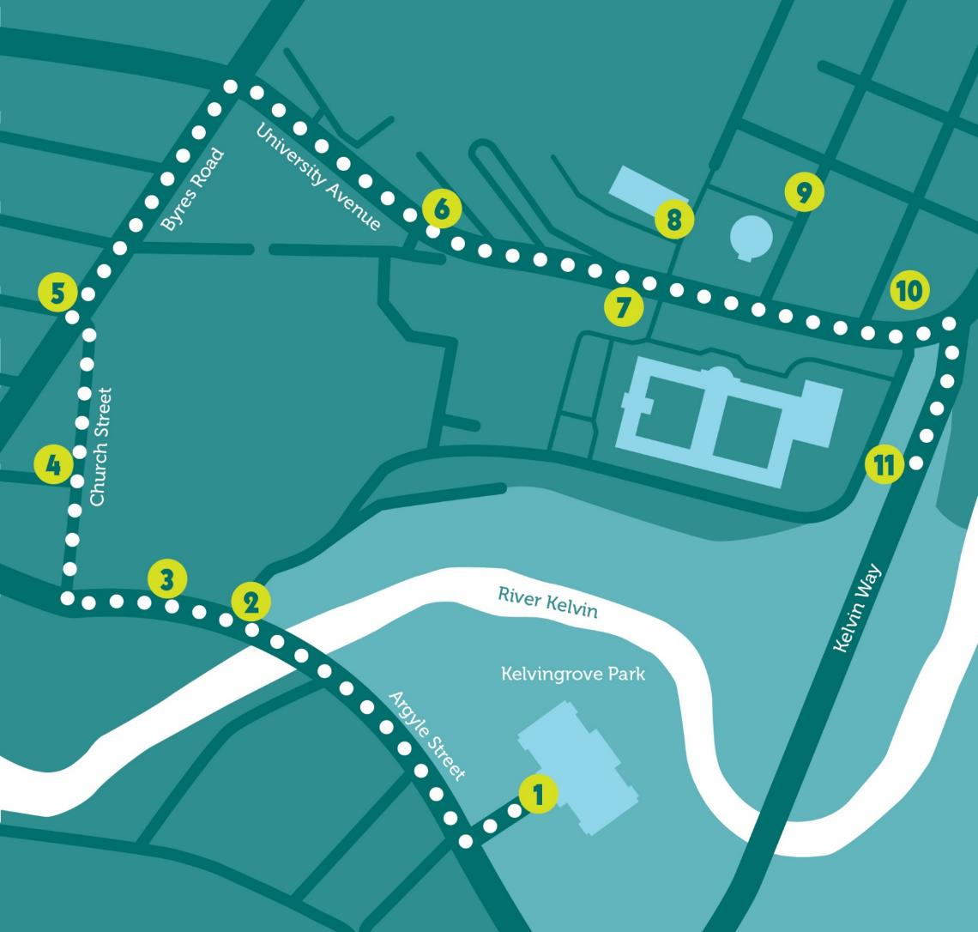
Our walk begins in the shadow of Kelvingrove Museum and Art Gallery (1).
The museum houses works by the Glasgow Girls, women working in art and design between 1880 and 1920. If you complete the loop, you can return to the museum and look inside.

For now though, let’s walk from here along Argyle Street with the tower of Glasgow University on your right.

Use your imagination to go back in time when the red trams rumbled their way along this street. Glasgow was the first city in Britain to recruit female conductors and drivers in the place of men during World War I.
Women provided a flexible and cheap workforce in a time of austerity.
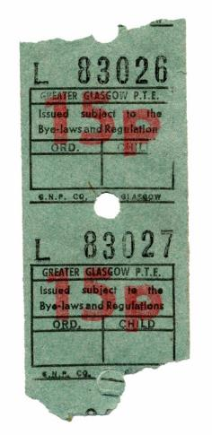
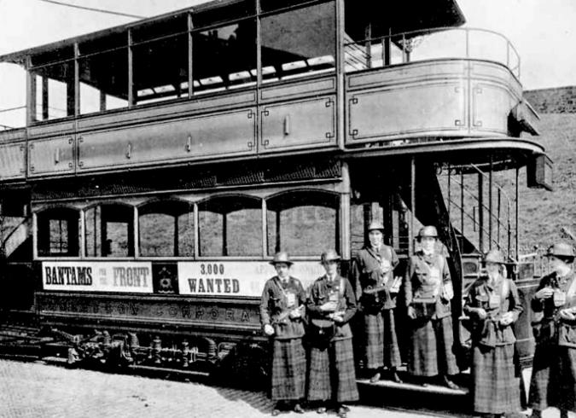
Image: Tram Drivers, Glasgow Museums Photo Library.

Image: Tram Ticket, Glasgow Museums.
These women were the forerunners of the inimitable force that was the Glasgow ‘Clippie’.
Let’s wander on and look at some significant buildings on our route.

Firstly, you’ll pass the Maggie’s Centre (2) on your right. When Maggie Jencks suffered a recurrence of breast cancer in 1993, she was given a short time to live. In her remaining months, she realised how important it was for people to have an environment where they would be seen as individuals rather than cancer patients.

She put all her energy into making such a place happen. The first Maggie’s Centre opened in Edinburgh in 1996. This one opened in 2002, and since then has had tens of thousands of visitors.

Continue past the former Western Infirmary on your right, after which you’ll come across a set of gates. If they are open, use the opportunity to get away from the bustling road. Look above the modern glass entrance and you’ll see faded lettering. You can almost make out the name – Anderson College (3). The Anderson was initially founded to rival Glasgow University with the aims of making education more accessible. In the first 3 years of the college almost half of the 1000 students were women.
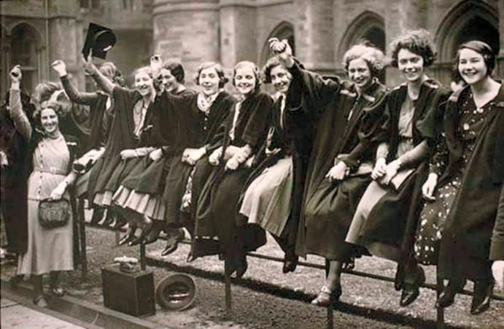
Image: University Women, Glasgow University Archives.

The 1870s was when educational opportunities for girls and women started to open up. In 1876 parliament passed an act which allowed universities to grant degrees to women. The University of London was the first to act upon it but the Scottish universities were very slow. Professor Milligan, of the University of Aberdeen thought that women were biologically too weak to take the strain of constant study! Women were not allowed to matriculate at any Scottish university until 1892, some 400 years after Glasgow University was founded.

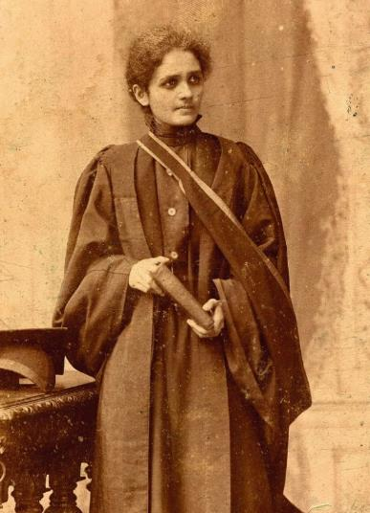
Trailblazing Marion Gilchrist was the first woman to graduate from Glasgow, doing so in 1894 with a high commendation in medicine. Marbai Ardesir Vakil was the first Asian woman to graduate from the University in 1897; she was also a doctor.
Image: Marbai Ardesir Vakil, Courtesy of Glasgow University Archives.
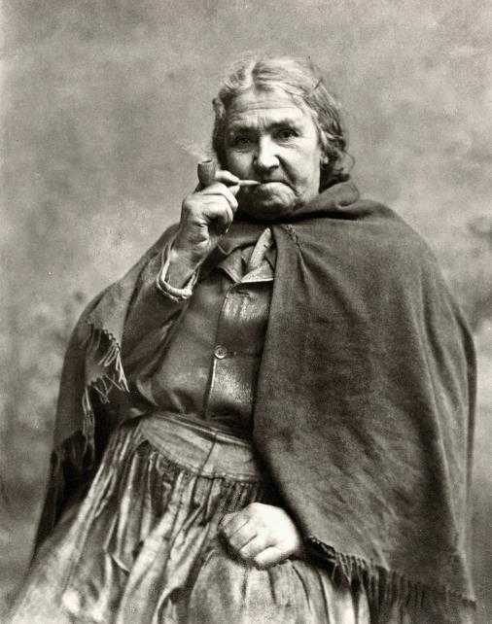
Return to Dumbarton Road. Even the noise of today’s buses bumping along the road wouldn’t have drowned out the sounds coming from the shipyards. In peacetime the yards were generally a male domain, with one unforgettable exception.
Image: Rachel Hamilton, Glasgow Museums Photo Library.

Pipe smoking Rachel Hamilton was a well kent face in Partick. Rachel Hamilton was 6 feet 4 inches, weighed 17 stone and smoked a pipe. She broke boundaries by working as a labourer in the shipyards and helped police as a special constable during the riots here in Partick in 1875.

Partick saw more dissent during the Great War. Not only against the war itself, but also against unscrupulous landlords trying to squeeze more money out their tenants.

Helen Crawfurd played a major role in both protest movements. As Secretary of the Glasgow Women’s Housing Association she was instrumental in rallying and coordinating support for those who were at risk from eviction because of rent increases.
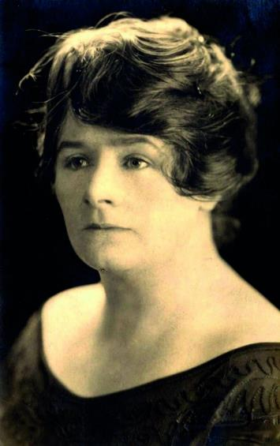
Image: Helen Crawfurd, Gallacher Memorial Library, Glasgow Caledonian University Archives.

She made a rousing speech on the issue, and described how “the fight was essentially a women’s fight”.

Turn right up Church Street. The red sandstone building on your left is one of the many monuments to education in the West End (4). Church Street Primary opened in 1903. In the same year, Laurel Bank, a private school for girls, was established on nearby Great George Street.

In addition to the ‘three Rs’, (reading, writing and ‘rithmetic’) which were taught at both schools, Church Street expected girls to learn domestic skills such as laundering, sewing and cookery, while Laurel Bank offered Art, Music and French.

Let’s continue up Byres Road (5).

Whilst researching for this walk we looked at businesses owned by women on this West End thoroughfare around 1900. Mrs McHoul ran a laundry at number 83; Miss Robson was a stationer and tobacconist at 101; and Mrs and Miss Simpson had a dressmakers at 115. This is interesting not only in showing the examples of businesses that women ran, but also in demonstrating how the type of business changed as you went up Byres Road.

Bear right along University Avenue and stop opposite the Boyd Orr Building (6).
On International Women’s Day 2000, the Student’s Representative Council Women’s Group were up early to change the names on University buildings to honour past women graduates.

The Boyd Orr Building was renamed after Mary
Hamilton, a politician and active member of the National Union of Women Suffrage Societies who argued strongly in favour of equal pay for men and women. Many other dedicated suffragettes were honoured including Dr Dorothea Chalmers Smith.

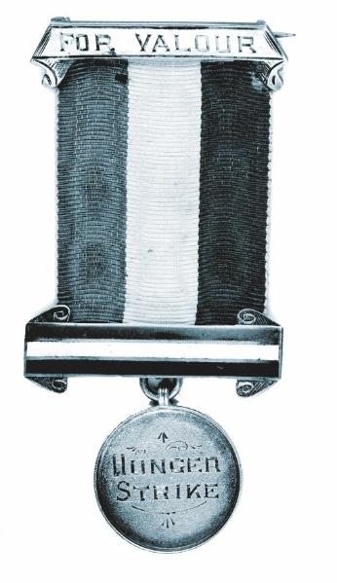
Dr Dorothea Chalmers Smith was one of the first women to graduate from Glasgow in medicine in 1894, after which she worked at Glasgow’s Royal Samaritan Hospital for women where she did pioneering work in child care. She became involved with the militant suffragettes in 1912, and in 1913 was caught red-handed trying to set fire to a house in Park Gardens. She was sentenced to 8 months in Duke Street Prison where she went on hunger strike.
Image: Hunger Strike Medal, Glasgow Museums Photo Library.

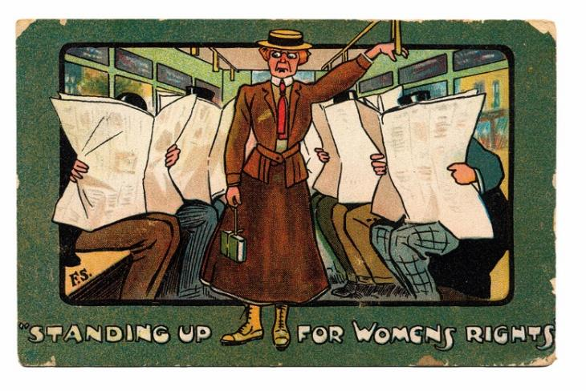
Dorothea’s husband was the minister of Calton Church in the East End and the church demanded that he should control his wife or divorce her. In the end, Dorothea left him and they divorced, but as a consequence she wasn’t allowed to see her sons. Dorothea’s story speaks of the many sacrifices suffragettes were forced to make in their fight for the vote.
Image: Anti-Suffragette Postcard, circa 1908, GWL Collections.

In the campaign for suffrage, hunger striking became common amongst suffragettes across the country, and in September 1909 the British Government introduced force feeding in prisons.

After imprisonment in Holloway, sisters Frances and Margaret McPhun were awarded hunger strike medals by the Women’s Social and Political Union. These sisters were also honoured on University buildings on International Women’s Day 2000, alongside suffragettes Flora Drummond and Marion Dunlop.

Continue up University Avenue until you are outside the University gates (7).

Isabella Elder is the only woman commemorated on these gates. She was one of a trio of women who contributed to opportunities for Higher Education in Glasgow. Along with Jessie Campbell and Janet Galloway, Isabella helped found Queen Margaret College, by donating North Park House in Queen Margaret Drive in 1883.

All three women are commemorated on the memorial window in Bute Hall, and in 2015 the University named a building after Isabella.

Opposite the gates, you can see the round reading room.
Interestingly, parts of it were still gender segregated until the 1950s. The street to the right of the reading room is Southpark Avenue. Number 78 (the Mackintosh House) is recreated in the Hunterian Art Gallery (8). It was the home of Margaret Macdonald Mackintosh (9). An incredible artistic force in her own right, her talents have often been overshadowed by those of her husband Charles. It is well worth visiting the Mackintosh House to see her wonderful interiors.

Continue down University Avenue and make your way to the bottom of the hill.
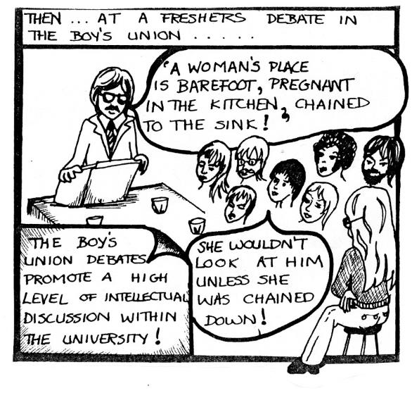
Across the road is the Glasgow University Union (10), which was the last union in the UK to have single sex membership. It was not until 1979 when students from the Queen Margaret Union voted to accept men that the men’s union reluctantly reciprocated, but only after the University had threatened to withdraw funding in fear they would be liable for a breach of the Sex Discrimination Act of 1975.
Image: Cartoon from Awful Mag (student
magazine), Glasgow University Archives.
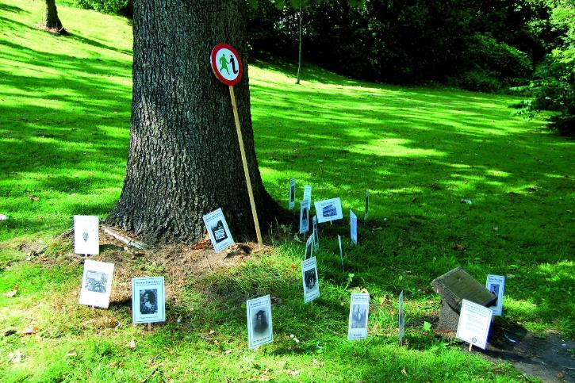
Now, onto our final stop. Turn right onto the leafy Kelvin Way, and continue for 50 yards or so. On your right you will see a mighty oak (11). This is the Suffrage Oak, planted by suffrage organisations in 1918 to celebrate some women’s first opportunity to vote in a general election. Women over 30 who owned property were given the vote in 1918, and in 1928 the vote was extended to women on the same terms as men.
Image: The Suffrage Oak, Photography by GWL.
In a city with only a handful of statues to women, it’s nice to also have the Suffrage Oak to commemorate the granting of the vote, and in 2015, Glasgow Women’s Library put the tree more firmly on the map. We nominated it as Scotland’s Tree of the Year – and it won! Staff and volunteers from the Library were invited to go to the Scottish Parliament to receive their trophy and a plaque has been added to the tree to commemorate the event. Surely the suffragettes would be proud!

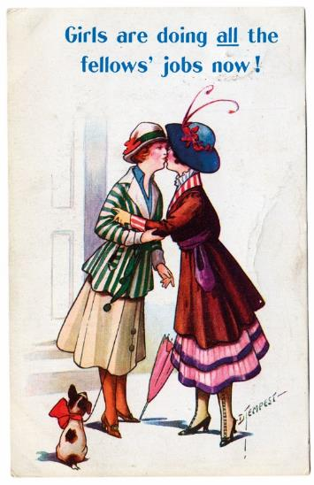
Image: Anti-Suffragette Postcard, GWL Collections.

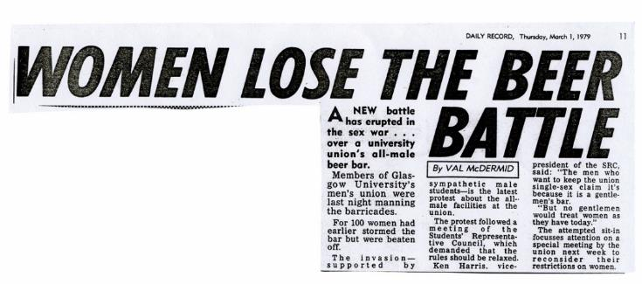
The first women’s suffrage society in the city was formed around 1870, and a large openair women’s suffrage meeting was held two years later on Glasgow Green. By 1907 there were three main groups in Scotland: The Scottish Liberal Women’s Federation who wanted suffrage through debate and discussions; The Women’s Freedom League who believed in militancy, but not violence; and The Women’s Social and Political Union, led by the Pankhursts, who used violence against property as a means of attracting attention to their cause.
Image: Newspaper clipping, Glasgow University Archives.

The West End was rocked on the morning of 24th January 1914. Twenty seven panes of glass from the Kibble Palace in the Botanic Gardens (at the top of Byres Road) were broken by a bomb, allegedly planted by suffragette militants.

Evidence of this being the impression of high-heeled ladies shoes in the soft ground and a lady’s black silk scarf found nearby!

And just through Kelvingrove Park, Dorothea Chalmers Smith was caught red handed trying to set fire to an empty house at 6 Park Gardens.

Militant campaign tactics, including window smashing, hunger striking, attacking post boxes and fire raising were not the practice of all who wanted the vote, but the approach certainly drew attention to the cause.

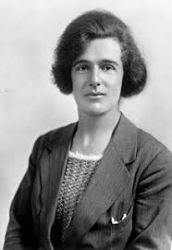
The suffrage movement wasn’t only the preserve of university graduates – Jessie Stephen, a domestic servant and trade unionist, perpetrated acid attacks on post boxes, but was never caught.
Image: Jessie Stephen, Creative Commons.

Perhaps Helen Crawfurd, Dorothea Chalmers Smith, Jessie Stephen and Frances McPhun stood here and watched as the acorn was planted. Let’s stop to reflect on the remarkable women of the
West End and to think about how their achievements affect us today.
We hope you’ve enjoyed your journey of discovery around the West End. We’ve only just scratched the surface of women’s heritage in the area. We’d love to think we’ve inspired you to find out more.

For further reading, visit the Women Make History pages at the website address below. For more insight into women’s history contact Glasgow Women’s Library to find out when our two hour guided walks of Garnethill and other areas of Glasgow take place. You can also download our maps and audio tours from our website.

About Glasgow Women’s Library

Glasgow Women’s Library is no ordinary library. It is the only Accredited Museum dedicated to women’s history in the UK, and also a designated Recognised Collection of National Significance. A place for browsing, borrowing and being inspired, GWL is welcoming, free and open to all, with programmes of events and activities that offer something for everyone: from film screenings to literacy support; from talks to supported volunteering opportunities; and from exhibitions to workshops.
About Women Make History

Women Make History is GWL’s women’s history project. Volunteers research and deliver pioneering Women’s Heritage Walking tours in Glasgow and produce related maps and audio tours. Other activities include talks, workshops, recording the histories of living heroines, exhibition curation, tour guiding, training and ongoing women’s history detective work. For more details contact GWL.

How to get involved

Glasgow’s women’s history is still largely hidden from the general public. There are many ways to get involved to address this. Why not join our women’s history detective or tour guide teams? You may have information you think could be added to this tour or suggestions of how it could be improved. If so, we want to hear from you. You can also support GWL by becoming a Friend. This is an invaluable way of ensuring that our work is sustainable for future generations. Visit friends.womenslibrary.org.uk to become a Friend.
Contact us

To find out more about GWL, Women Make History, our guided tour dates and maps and audio tours of other routes please visit our website: www.womenslibrary.org.uk, or email us at info@womenslibrary.org.uk

Thanks to: Dr Anne Cameron, University of Strathclyde; Deborah Haase; Scottish Jewish Archives Centre; Stephen Hosey, Glasgow City Council; Fiona Frank, hannahfrank.org; Garnethill Multicultural Centre; Fiona Hayes, Glasgow Museums; Gary Nisbet, glasgowsculpture.com; Public Catalogue Foundation; Public Monuments and Sculpture Association. Designed by Kirsty McBride. Edited and compiled by Heather Middleton. © GWL 2019

Glasgow Women’s Library, 23 Landressy Street, Bridgeton, Glasgow G40 1BP, 0141 550 2267 info@womenslibrary.org.uk womenslibrary.org.uk @womenslibrary
Registered Company No: 178507
Glasgow Women’s Library is a Scottish Charity SC029881, regulated by the Scottish Charity Regulator (OSCR)

