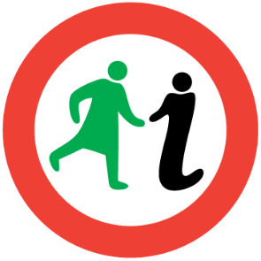
WOMEN’S
GLASGOW
NECROPOLIS HERITAGE WALK

1.6km/1mile
The terrain is very hilly with some steps and grassy paths.

Introduction
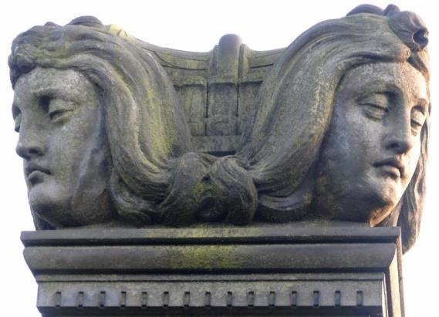
Some 50,000 souls are buried in Glasgow’s Necropolis: the 3,500 visible tombs commemorate the great and the good, with the majority buried in unmarked communal graves. The headstones of most women’s graves acknowledge only their role as wives and daughters, but there are a few notable exceptions, from a gypsy queen to a clutch of benefactresses.
Image: ‘Two headed’ statue. Robert Miller of Belvidere and his wife Margaret Steele, Photography by Jeane Trend-Hill.
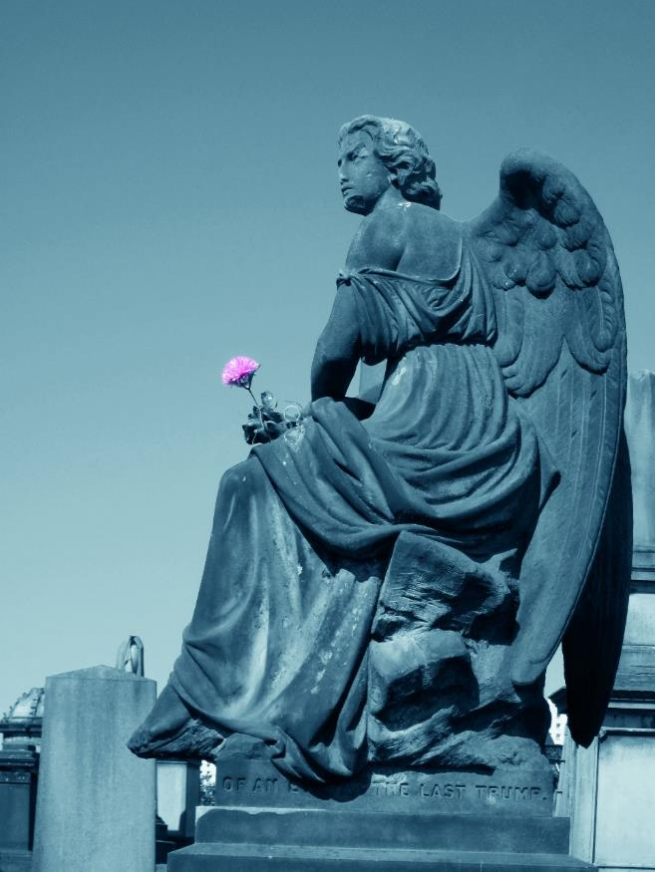
Image: Mourning Angel, Photography by Heather Middleton.

Glasgow’s city of the dead is the earliest Scottish garden cemetery. Existing urban graveyards were not places to linger, let alone take the family on a Sunday stroll.
Horror stories abound of noxious fumes and shallow graves with bones (or worse!) protruding. When the Necropolis opened for business in 1833, death was rendered both hygienic and picturesque, and it rapidly became a must-see visitor attraction. Parts of it are crumbling these days though, so take care – and be prepared for steep slopes and steps.

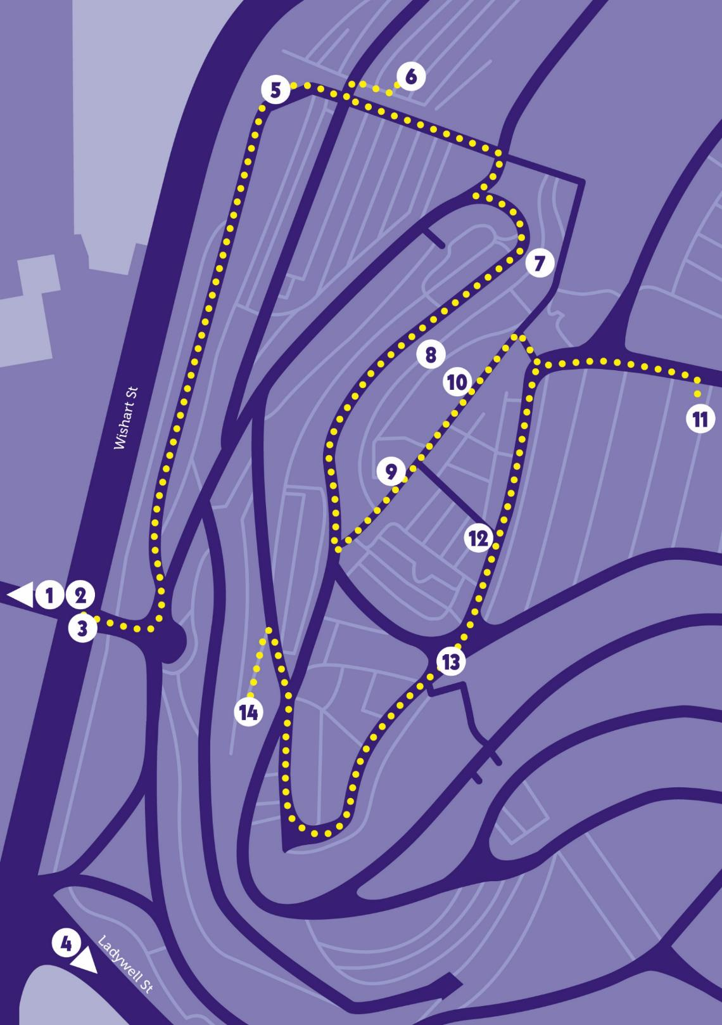
Our walk begins in the square before Glasgow Cathedral where a monument (1) marks the position where the medieval Bishops’ Palace once stood.

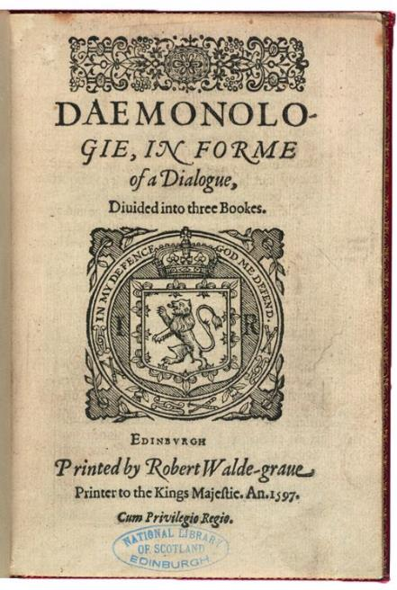
Women accused of witchcraft were imprisoned here in the post-Reformation period when the Castle was used on occasion to hold political and religious off enders. When King James VI of Scotland published his Daemonologie in late 1597, witchcraft was breaking news. That year Margaret Aitken, “The Great Witch of Balwearie” of Fife, claimed under torture that she could identify other witches by looking into their eyes and a commission took her from town to town. When she reached Glasgow, Minister John Cowper condemned many innocent women to death on her evidence. Finally someone thought to test Margaret herself by presenting her with people she’d previously accused – this time she found them innocent. The resulting outcry prompted an inquiry into the reliability of witches’ testimony and Scotland would not see another panic for three decades.
Image: Cover of Daemonologie, The Trustees of the National Library of Scotland.

Now follow the Cathedral wall to the right to find the entrance gate of the Necropolis. (If the entrance is closed, follow the gates round the corner to enter at 52 Cathedral Square.) Just inside the gates is the Stillbirth Memorial (1999) (2).

Until the 1970s, it was common for bereaved parents not to see their babies or arrange their funerals. There are no burials here, though unmarked communal graves of stillborn children exist across the city’s cemeteries.

Follow the road to the Bridge of Sighs (1833–4) (3). The Molendinar Burn once flowed below, and to your right, Ladywell Street curves around the bottom slope of the Necropolis. One of the oldest streets in Glasgow, the site of the 13th century well (4) from which it takes its name is worth a visit on your way back.
Image: Bridge of Sighs, The Mitchell Library, Glasgow City Council.

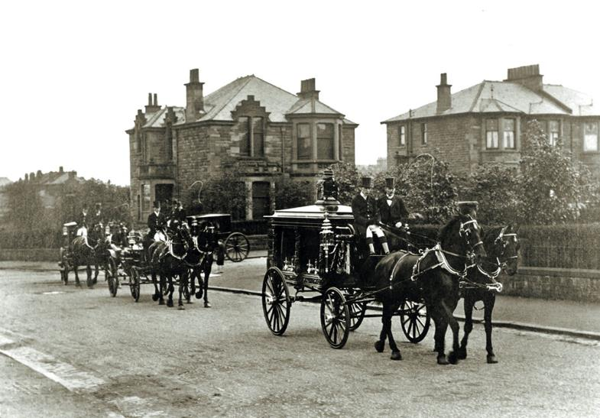
The space before the entrance façade allowed room for horse-drawn hearses to turn. There were funerals to suit every pocket in the 19th century: the cheapest cost one pound, but for five, a massive hearse resembling a “circus band chariot” could be had.
Image: A Funeral Procession in the 1890s, Culture and Sport Glasgow (Museums).

As for mourning dress, this was rigidly codified for women. Widowed Queen Victoria, whose strict insistence on mourning etiquette extended down to babies, was greatly influential. For middle-class widows, full mourning lasted a year and a day (all black covered with crepe); second mourning 21 months (all black, less crepe); ordinary mourning a minimum of three months (black silk, trimmings of ribbon and jet permitted). Half-mourning could last from six months to a lifetime, during which a widow could follow the fashions of the day, but in soft, subdued colours. Only after WWI, when full mourning was considered bad for morale, did this gloomy tide of black recede.

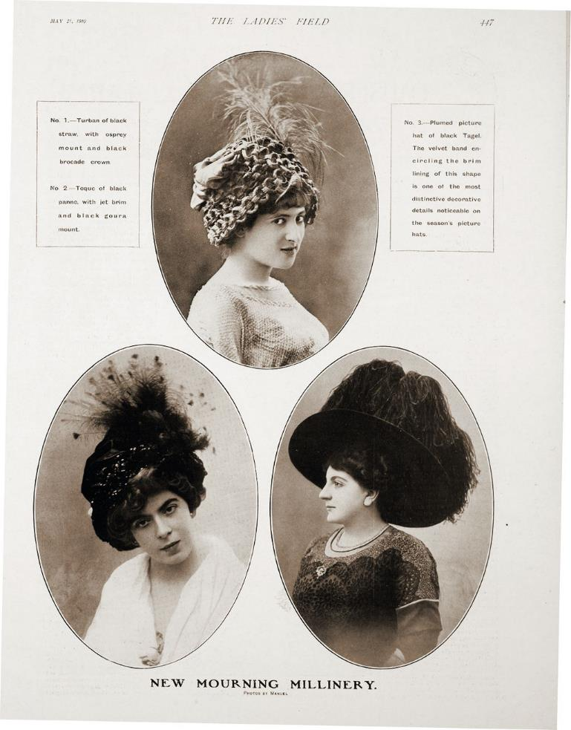
Image: Mourning millinery for Edward VII, from the Ladies Field, 21 May 1910, The Trustees of the National Library of Scotland.

At the façade, turn left down the lower of the two paths. At the end of the avenue, you will come to a pillar and an ornamental archway decorated with a Star of David.

This was the Jewish cemetery (5), the only area that is not interdenominational. The land was bought by the Jewish community and first used in 1832, before the Necropolis officially opened, to bury Joseph Levi, a jeweller who died of cholera. Previously, Glaswegian Jews buried their dead in Edinburgh.

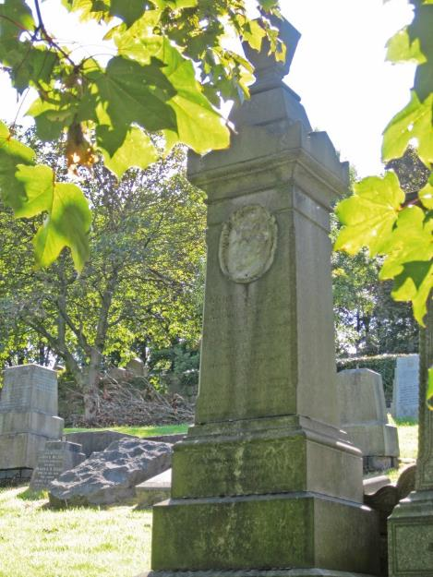
Jewish practice involved the ritual washing of bodies and a special bath house adjacent to the Molendinar Burn was used. With bodies customarily buried one per grave, by 1851 the plot was full and a memorial plaque lists all 57 people buried here including one for Deborah Ascherson, (d. 1847), who was “in dispute” with the leaders of the Jewish community for reasons unknown.
Image: Memorial to Corlinda Lee, Photography by Heather Middleton.
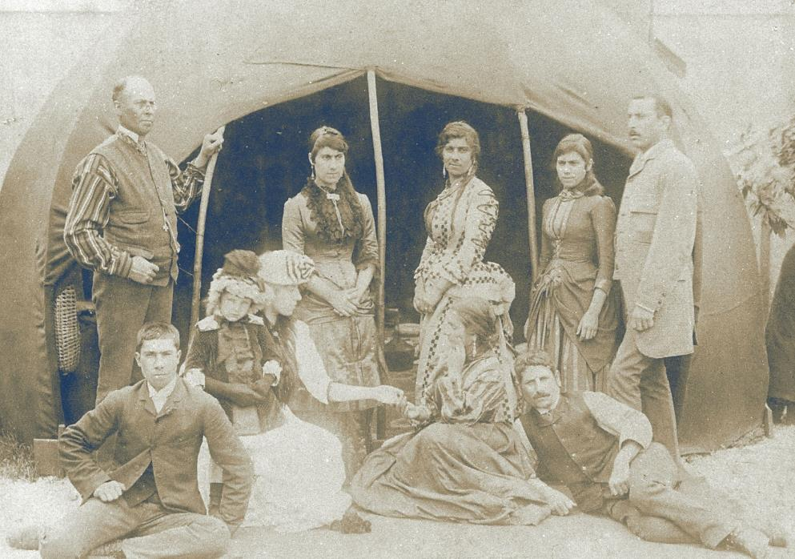
Go up the very steep steps to your right, up two further small flights of steps, then up another set hidden behind the low wall to your left. Take the second grassy path on your left and just after the tree, up on your right, is the memorial to the Queen of the Gypsies, Corlinda Lee (6).
Image: Corlinda Lee and Family, Liverpool University Library SMGC.K42.15.32.
Her bronze plaque is gone, leaving only a ghostly portrait behind. The memorial often has coin tributes pressed between the stones. Born in 1831, Corlinda merged two important gypsy dynasties when she married horse trainer George Smith and they became king and queen of their extended family. George capitalised on the Victorian fascination with gypsy life by taking his clan on tour, hosting “gypsy balls”. Queen Victoria visited, and it is alleged that Corlinda read her palm.

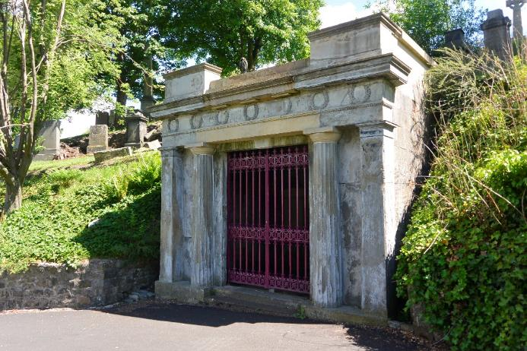
From here, return to the main steps and continue to ascend until you reach a path. Turn right, and, where the path splits in two, take the upper to Robert Black’s Grecian mausoleum (7).
Image: Robert Black’s Grecian Mausoleum for his daughter, Catherine, Photography by John Marsh.

The first mausoleum to be erected in the Necropolis, this was commissioned in 1837 by merchant Robert Black for his daughter Catherine, who died aged 12.
The tomb would ultimately hold five of his children, all dead before 21. Victorian families lost children at an unfathomable rate.

The Necropolis internment book reveals an appalling record of child mortality, with measles often the cause. For poor families the situation was worse, their very living conditions often proving fatal.

Continue to the next but one tomb, decorated with two draped Grecian urns, built for the Misses Buchanan of Bellfield (8), three unsung heroines of Victorian Glasgow.
Image: Jane and Elizabeth Buchanan, The Bellfield Trust/East Ayrshire Council.

Jane, Elizabeth and Margaret were the daughters of George Buchanan of Woodlands, a cotton baron. All outlived their male siblings and none married. The sisters felt a deep responsibility for Glasgow and their will bequeathed £10,000 to the Merchants’ House, on the condition that their tomb be properly maintained in perpetuity. (It has been restored by the Friends of Glasgow Necropolis). A bequest of £30,000 founded a hospital for the infirm of Glasgow aged 60 or above. With all that free-flowing charity, we’ll forgive the preferential terms to those named Buchanan. They left money to many other institutions, amounting to a legacy of some £4m in today’s money.

Now go up the grassy hill to the summit, the most sought-after place for burials, although you and your tomb had to cut the mustard to make it up here.
The monument to John Knox (9) was erected in 1825 on what was then Fir Hill. A preacher and instrument of the Reformation in Scotland, Knox was also the author of The First Blast of the Trumpet against the Monstrous Regimen of Women (1558) which he wrote in response to the reign of “Bloody” Mary Tudor. Queen Elizabeth took exception to his views on female rule and refused him passage through England the next year.
Stand back to back with Knox, turn a couple of degrees left and head along the wide grassy path. A tall obelisk almost immediately on your right (10) bears a relief of four children mourning their “Beloved Mother” but, unusually, no family name.
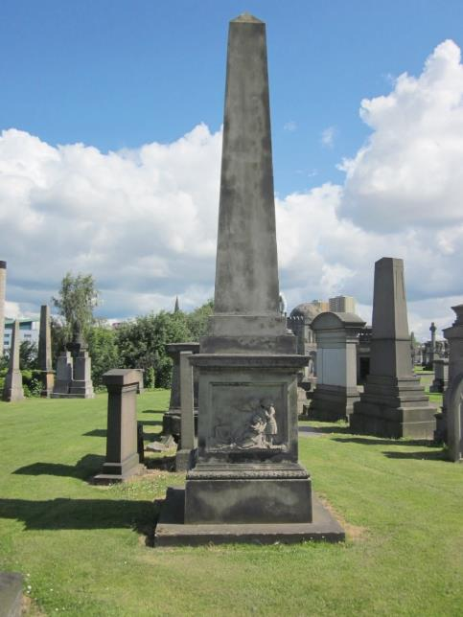
Image: ‘Beloved Mother’ Obelisk, Photography by Heather Middleton.

For years the mother’s identity was unknown, until researcher Diana Burns announced she had found her. She looked for clues in the position of the sculpture – a prestigious spot – and searched burial records, until she found Agnes Strang, wife of Allan Gilmour, a wealthy ship owner and merchant.
She died in childbirth in 1849 aged 33, leaving behind three young children plus her new baby. Around this time, five of every thousand births resulted in the death of the mother. With contraception primitive, a married woman had little choice but to become a mother and raise a family.

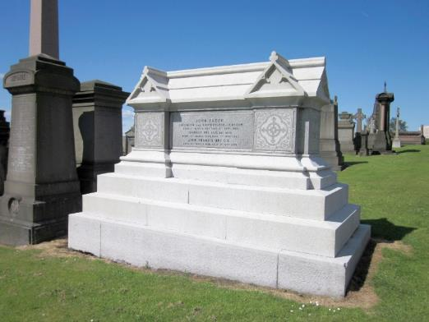
At the end of the path, turn right past a pale octagonal kiosk to spot the striking white tomb of Isabella Ure Elder (1828–1905) (11) straight ahead.
Image: Tomb of Isabella Elder, Photography by Heather Middleton.
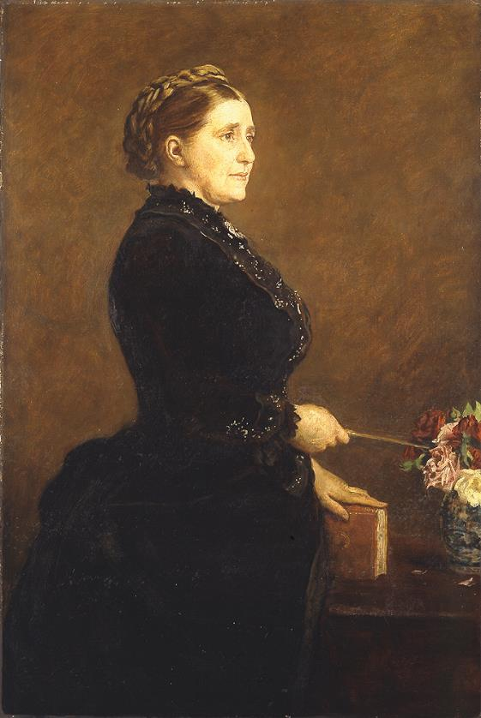
Isabella is one of the few historical women commemorated as statues around Glasgow. She is dressed in her academic robes within the Elder Park she founded in Govan.

Image: Portrait of Isabella Elder by Sir John Everett Millais, Culture and Sport Glasgow (Museums).

A wealthy philanthropist, she was instrumental in promoting higher education for women in Scotland. After her husband died she devoted her life to good works, which included providing premises and financial support to Queen Margaret College, the first in Glasgow to provide comprehensive higher education for women. After it merged with Glasgow University, she maintained pressure to ensure female students did not receive an inferior education. In Govan, she established a School of Domestic Economy, a library and a cottage hospital. Fittingly, when Isabella died, it was Dr Marion Gilchrist, the first woman to graduate in medicine from Queen Margaret College in 1894, who signed her death certificate.
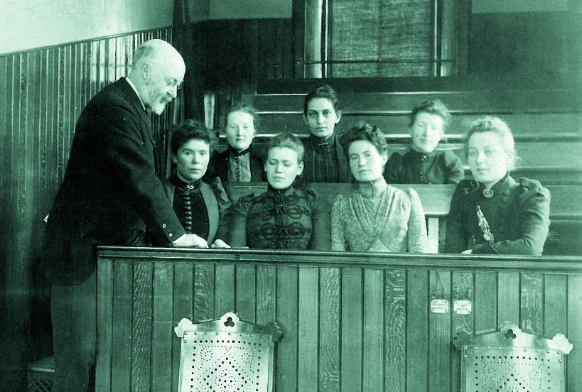
Image: Dr William James Fleming’s class of clinical surgery at Queen Margaret College including Marion Gilchrist, Lily Cumming, and Dorothy Lyness, University of Glasgow Archive Services, Queen Margaret College collection, GB0248 DC233/2/22/2/82.

Across the path from Isabella is an area of unmarked graves. Many will be women, for example, unclaimed bodies from Duke Street Prison or Lock Hospital.

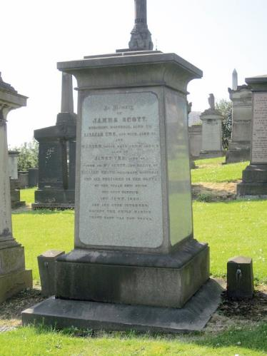
Return to the octagonal tomb junction and go left. Halfway along is a stone kerb on the right of the path: go in two rows deep and four graves along, to find a stone marked James Scott (12).
Image: Gravestone of James Scott and Lillias Ure Scott, Photography by Heather Middleton.

In 1850, Lillias Ure Scott was returning to Glasgow from Canada aboard the steamship Orion with husband, sister and daughter when the ship struck rocks.
The passengers were asleep below deck, and around one quarter of those aboard lost their lives. The captain was imprisoned for 18 months. Lillias’ reasons for emigration are unknown, but many Scotswomen, considered hard-working and God fearing, were encouraged to move to Canada from the 1830s, mainly to work as domestics in rich Canadian homes, or to marry and help populate the new world.

Regain the path and continue to a junction – turn left until you reach a gap in the trees where you can enjoy a panorama over southeast Glasgow (13).

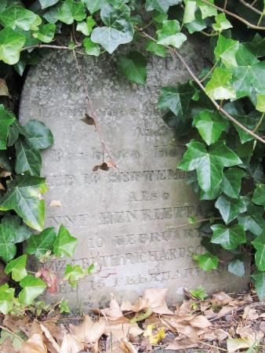
Return to the junction, taking the left fork down the hill, and follow the loop round to another fork. Take the left fork, with the Cathedral on your left, then almost immediately take a path that backtracks to your left. In the grassy terraced clearing at its end is Barbara Hopkirk’s monument (14), partly hidden by ivy, to the right of the large pink granite monument of her husband, Laurence Hill, a Necropolis founder, and his second wife.
Image: Barbara Hopkirk’s monument, Photography by John Marsh.

By the time she died in 1833 aged 40, Barbara had lived a life of continual pregnancy, giving birth to 13 children. In an early guidebook, she is described as ‘the first Christian lady, moving in the upper or respectable ranks, whose remains were deposited in the cemetery.’ In fact, Elizabeth Miles was the first Christian burial but as mere stepmother to the Necropolis superintendent and head gardener, she was invisible because she lacked the status of a wealthy and successful husband.

So, as the Bridge of Sighs comes back into view below, we hope you have enjoyed this introduction to the women of the Necropolis.

For further reading, visit the Women Make History pages at the website address below. For more insight into women’s history contact Glasgow Women’s Library to find out when our two hour guided walks of Garnethill and other areas of Glasgow take place. You can also download our maps and audio tours from our website.
About Glasgow Women’s Library

Glasgow Women’s Library is no ordinary library. It is the only Accredited Museum dedicated to women’s history in the UK, and also a designated Recognised Collection of National Significance. A place for browsing, borrowing and being inspired, GWL is welcoming, free and open to all, with programmes of events and activities that offer something for everyone: from film screenings to literacy support; from talks to supported volunteering opportunities; and from exhibitions to workshops.

About Women Make History

Women Make History is GWL’s women’s history project. Volunteers research and deliver pioneering Women’s Heritage Walking tours in Glasgow and produce related maps and audio tours. Other activities include talks, workshops, recording the histories of living heroines, exhibition curation, tour guiding, training and ongoing women’s history detective work. For more details contact GWL.
How to get involved

Glasgow’s women’s history is still largely hidden from the general public. There are many ways to get involved to address this. Why not join our women’s history detective or tour guide teams? You may have information you think could be added to this tour or suggestions of how it could be improved. If so, we want to hear from you. You can also support GWL by becoming a Friend. This is an invaluable way of ensuring that our work is sustainable for future generations. Visit friends.womenslibrary.org.uk to become a Friend.

Contact us

To find out more about GWL, Women Make History, our guided tour dates and maps and audio tours of other routes please visit our website: www.womenslibrary.org.uk, or email us at info@womenslibrary.org.uk

Thanks to: Dr Anne Cameron, University of Strathclyde; Deborah Haase; Scottish Jewish Archives Centre; Stephen Hosey, Glasgow City Council; Fiona Frank, hannahfrank.org; Garnethill Multicultural Centre; Fiona Hayes, Glasgow Museums; Gary Nisbet, glasgowsculpture.com; Public Catalogue Foundation; Public Monuments and Sculpture Association. Designed by Kirsty McBride. Edited and compiled by Heather Middleton. © GWL 2019

Glasgow Women’s Library, 23 Landressy Street, Bridgeton, Glasgow G40 1BP, 0141 550 2267 info@womenslibrary.org.uk womenslibrary.org.uk @womenslibrary
Registered Company No: 178507
Glasgow Women’s Library is a Scottish Charity SC029881, regulated by the Scottish Charity Regulator (OSCR)

