WOMEN’S
MERCHANT CITY HERITAGE WALK

1.1km/0.7 miles
The walk begins on a steep hill then moves downhill, with some steps, to flat terrain.

Introduction

A portrait hangs in Glasgow’s People’s Palace. Infamous as damning evidence of the city’s role in the transatlantic slave trade, the Glassford Family portrait holds another secret. The face of the wealthy merchant’s wife has been painted over that of his former spouse. This piece of
18th century editing deems women to be replaceable, almost ghostly: there in spirit, but not important to the story.

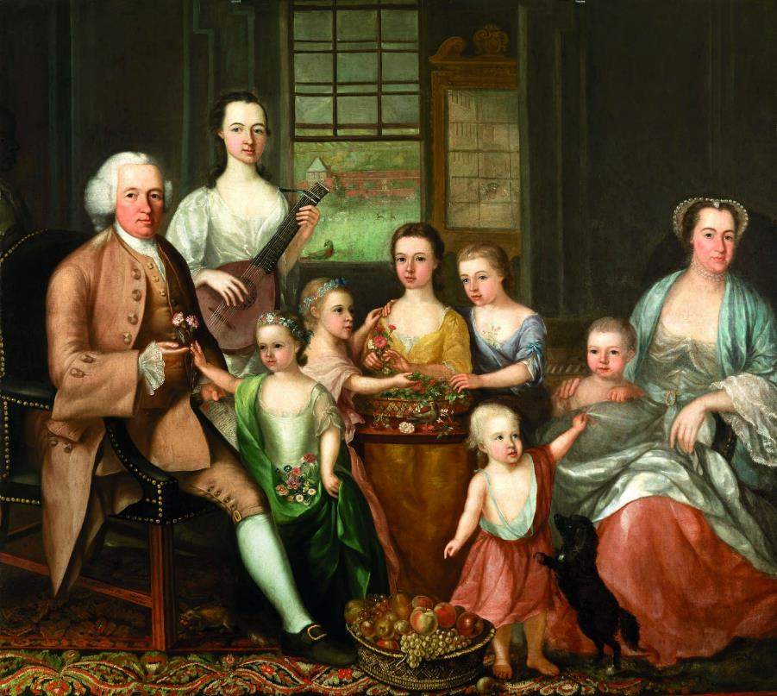
This map aims to redress that view and to shout about, share and celebrate the achievements of women in this regenerated and thriving quarter of Glasgow. Women have played a part in this area from its dear green beginnings, through its darker days, to its recent resurgence.
Image: Glassford Portrait, Glasgow Museums.

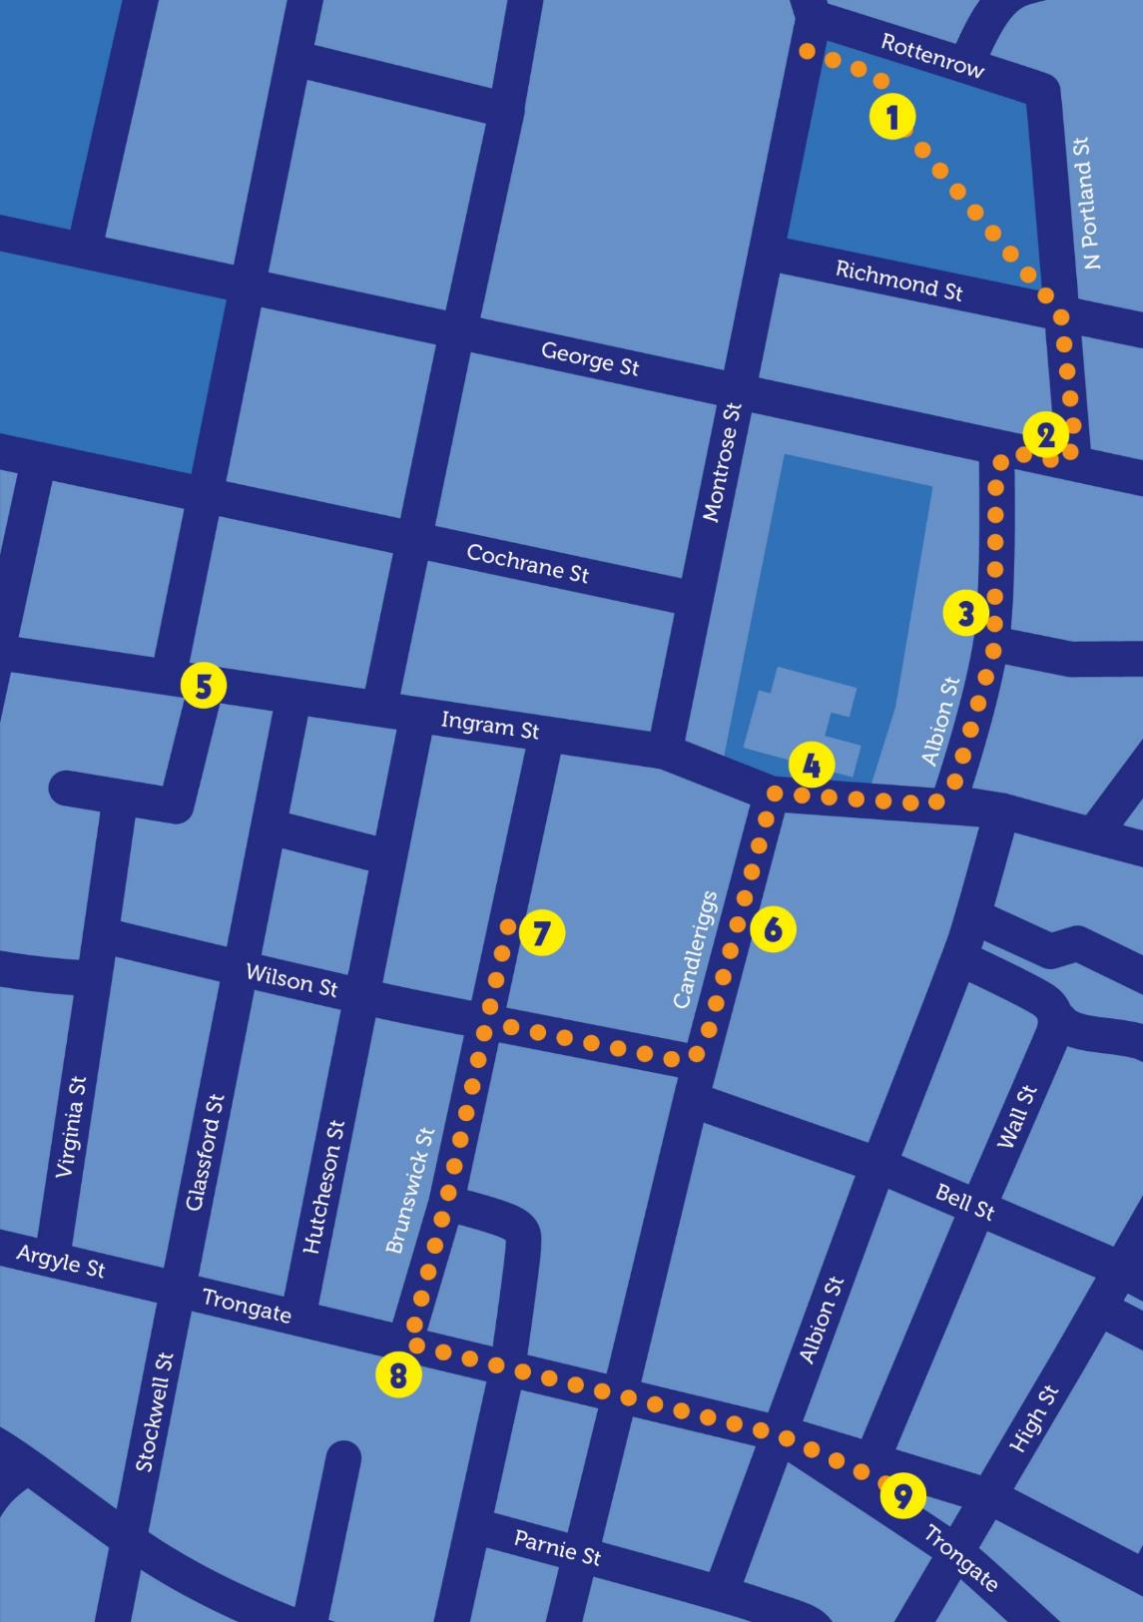
We begin our tour by walking to the upper edges of the Merchant City. Stride up the Montrose Street hill to savour the gardens behind Strathclyde University.

A campus now, formerly these streets were crowded with ramshackle four and five storied sandstone tenements, wynds and vennels. Throughout the late 18th and 19th centuries this area was congested, full of shebeens and brothels.

Despite its poverty, one artist took inspiration from the area and the children who played in its streets.

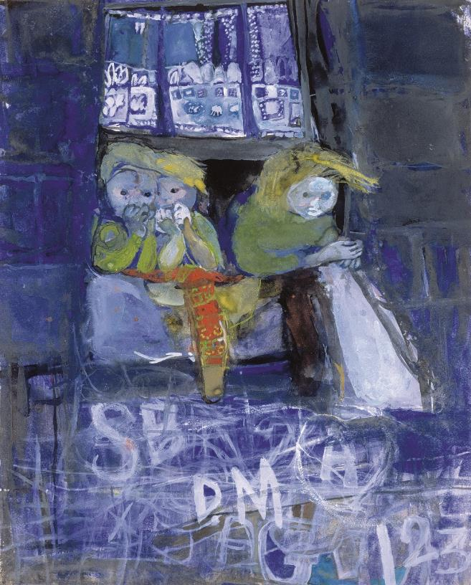
Joan Eardley (1921–1963) had studios close to here, and was often seen using a pram to transport her easel and paints. The Samson family who stayed further along Rottenrow had a particular impact on Joan.
Image: Three Children at a Tenement Window by Joan Eardley, Eardley Editions.

Her resulting pictures of Glasgow children express her understanding of tenement life in the 1950s. Joan herself said: “I like the friendliness of the back streets, life is at its most uninhibited here.”

If you look up and along Rottenrow you will see a portico on the crest of the hill. This was the original entrance to Glasgow Royal Maternity Hospital (1). (If you hiked up, try to imagine doing it whilst nearly 9 months pregnant; the incline was known by some as Induction Brae or Hill).

The Royal Maternity Hospital moved to this site in 1860 before eventually moving to the Royal Infirmary in 2001. The gardens now occupy the site where generations of Glaswegian weans entered the world. This was not its only achievement. The hospital had an international reputation as a quality midwifery training centre.

In addition, remarkable advancements in pre- and neonatal care were piloted and developed at the Rottenrow. Risky caesarean sections were performed successfully in the 1880s; a significant development in an unhealthy city where many women found it difficult to give birth naturally due to developing rickets in their youth.

Ultrasound was also developed at Rottenrow and tested on expectant mothers. A doctor who assisted on these pilots commented, “Glasgow women are wonderful and they accepted all this without demur”.
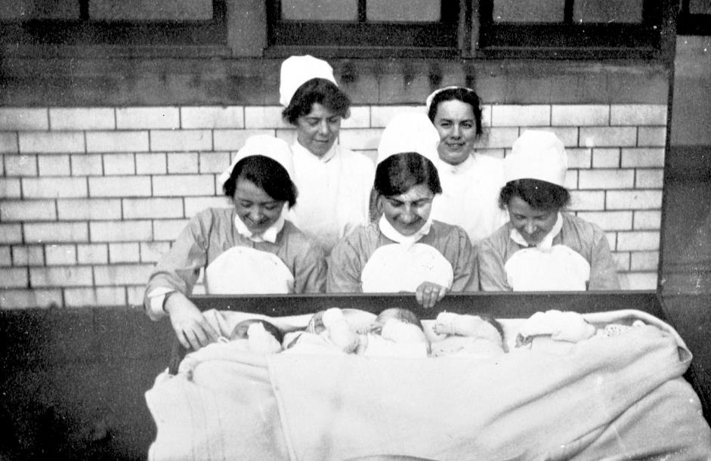
Image: Nurses at Glasgow Royal Maternity Hospital, Glasgow Museums.

When the building was demolished, paperweights were made from the rubble. They sold like hotcakes, evidence of the affection that people had for the building.

The giant nappy pin in the middle of the garden pays homage to Maternity. It’s a poignant stopping point to reflect on all that was achieved at Rottenrow.

The notorious but secretive Lock Hospital for Unfortunate Females treated women and children with venereal diseases in Glasgow for 150 years from 1805.

A purpose-built hospital was opened in Rottenrow in 1845–46. Curiously, it was constructed to look like the tenements around it, but had beds and wards, a laundry and a mortuary. The objectives of the Lock were to “effect the moral reformation of the patients and help them quit their evil courses…”.

Treatments were harsh and often dangerous involving disinfectant and mercury cures which rarely cured and often killed.

Walk down towards the left, through the garden and onto North Portland Street; continue downhill till you reach George
Street (2). The shop to your right stands close to the former home of the Strickland Press, where the Socialist paper The Word was printed from 1938 until 1962.

Two women, Jenny Patrick (1884–1971) and Ethel Macdonald (1909–1960) were instrumental in its production. The Word published articles on topics such as family planning, peace and equality. Both women travelled to Spain at the height of the civil war and Ethel was to achieve particular prominence.
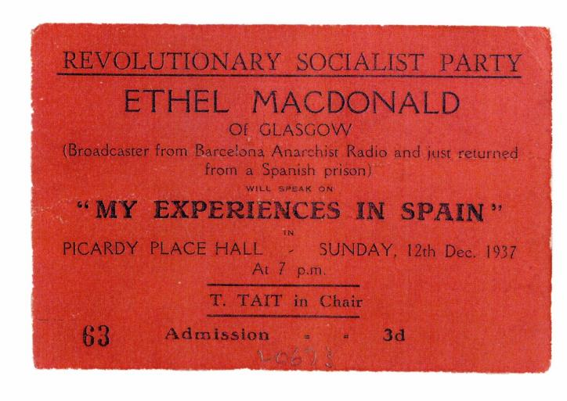
Whilst in Barcelona she worked in an anarchist radio station and regularly broadcasted rousing reports on the conflict around the world. She smuggled food and letters to anarchist comrades in prison and relayed information and messages back out. The 28-year-old woman from Bellshill went on to assist in the escape of prisoners out of the country.
Image: Ethel Macdonald ticket, Mitchell Library Archives.
Her rebellious actions led to her imprisonment, her position as a “thorn in the flesh of Barcelona authorities” and the moniker “The Scots Scarlet Pimpernel”. She returned home to a rapturous welcome in November 1937. A newspaper reported on her speech to the crowd of 300: “I went to Spain full of hopes and dreams. It promised to be Utopia realised. I return full of sadness, dulled by the tragedy I have seen”.

Let’s move on to consider more women who have been involved in media and journalism.

Cross George Street and walk down the wide street in front of you. On your right you’ll see a formidable black building (3).
In this A-listed vitrolite monolith the Daily Express was produced for 38 years, but in April 1974 the presses fell silent. The publishers planned to move the production of the paper elsewhere.
Journalists and other workers were stirred to action and produced a paper, funded by their redundancy money, which highlighted workers views and rights: The Scottish Daily News. Its slogan was “Read the people’s paper and keep 500 in jobs.” Dorothy Grace Elder was initially a features editor within the workers co-operative that created the paper. By her own admission she was “one of the very few women on the editorial floor – but that was true of all papers then.”
Underfunding and dwindling sales forced the publication to fold. However, some of the workers remained, staging a work in and “turning out a rebel ‘emergency edition’ to which [Dorothy] was elected as editor.”
Workers sold the paper in the streets of the city. “The people of Glasgow rallied when we were at our lowest points – cold, often downright hungry but still producing a paper for nothing. They turned up with donations, they marched, they bought the paper… We worked seven days. I can never forget the mighty roar of the presses starting up at night or the bonding and comradeship we felt.” Financial pressures eventually ended the work six months after it began.
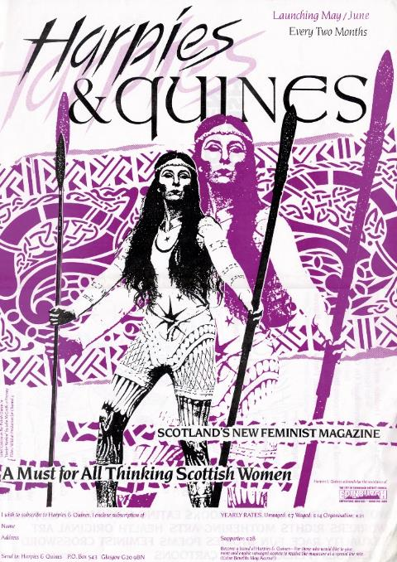
The Albion Street building went on to house the Glasgow Herald where a number of prominent female journalists made their mark and continue to do so. One of them, Lesley Riddoch, went on to co-found and edit the feminist magazine Harpies & Quines, which was published from 1992 until 1994.
Image: Harpies & Quines Cover, GWL Collections.

Continue south down the road then turn right on Ingram Street until you reach St David’s Ramshorn Church (4). Walk into the graveyard through the gate furthest to the right. Just beyond half way in is lair five.

Resting here, in the Fleming family tomb lie the remains of Pierre Emile L’Angelier. When his remains were exhumed two days after his death in 1857 he was found to be riddled with enough arsenic to kill 20 men. Love letters, at first gushing, and then increasingly distant, found in his apartment were traced back to a Miss Madeleine Smith (1835–1928) of Blythswood Square.

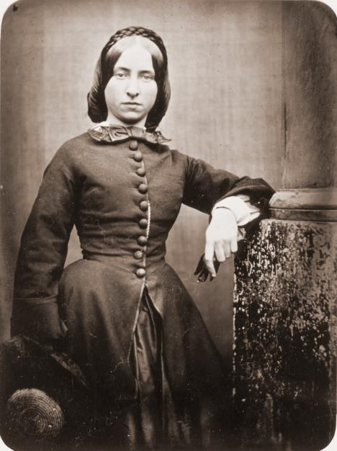
Image: Madeleine Smith, Mitchell Library.

The same Miss Smith who signed for arsenic in a local druggist for beauty purposes. The subsequent sensational murder trial was a
Victorian scandal of the highest order, with the story being reported as far afield as New York. Madeleine’s dignity and coolness during the trial won and lost her admirers in equal measure. No conclusive evidence emerged to convict Madeleine and the peculiarly Scottish verdict of “not proven” left her free to see out her days in London and America.

Further along Ingram Street and on the left at number 205–207 stood the remarkable tearooms of proprietor Miss Kate Cranston
(1849–1934) (5).

With a unique interior designed by Margaret Macdonald Mackintosh (1865–1933) and her famous husband, the Ladies Room was advertised specifically for business ladies to lunch in.
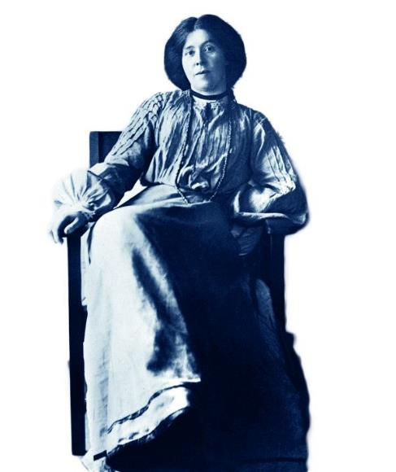
Image: Margaret Macdonald Mackintosh, James Craig Annan.

Margaret’s gesso panel, the May Queen can be found in Kelvingrove Museum in the west end of the city. Tearooms provided an alcohol free space to meet at a time when the temperance movement was flourishing.

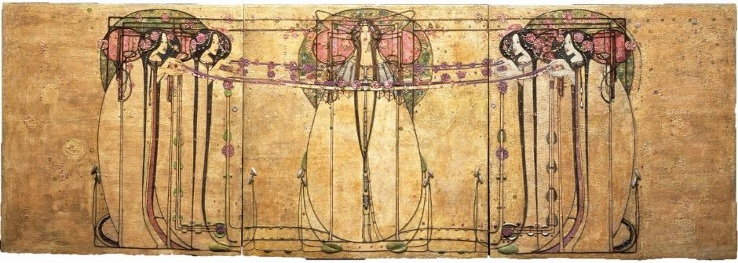
Image: The May Queen by Margaret Macdonald,
Glasgow Museums.

Temperance campaigns had gained popularity in the 19th century in a city where it was felt that many of its problems were perpetuated by the “demon drink”.

From the entrance to Ramshorn Church, walk right across the road and then left down Candleriggs where you will come to the City Halls (6).
A particularly vocal campaigner for prohibition came to speak to a rapt Glaswegian audience here in 1908.

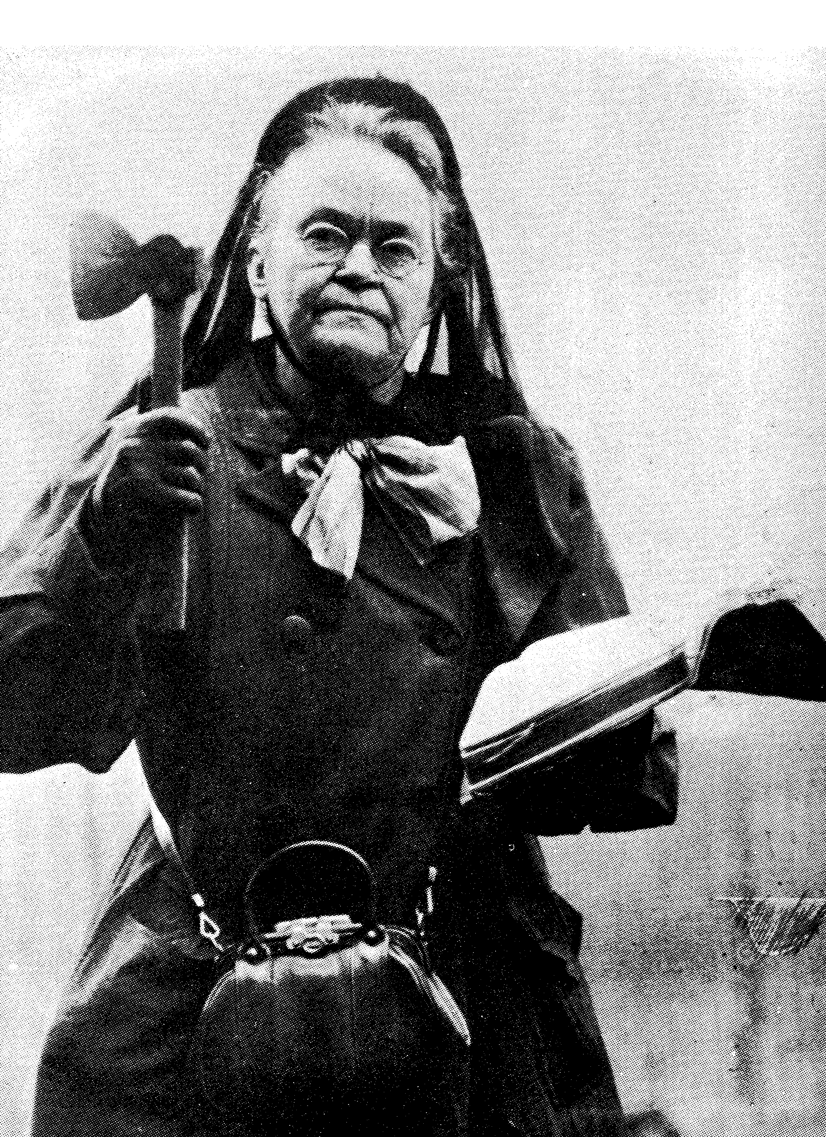
Carrie A Nation, known as “the bar-room smasher” came from Kentucky, hatchet in hand, to spread the word. Her bar smashing campaign wasn’t her only barnstorming message: she was outspoken too in her call for the enfranchisement of women.
Image: Carrie A Nation, Glasgow Museums.
The Temperance movement in Glasgow was instrumental in politicising women and garnering support for the suffragette movement. Links were made too between domestic abuse and alcohol with the effects on the family being vocalised in this dramatic lament written by “Stella” with the music by a certain Miss E Pankhurst:s E Pankhurst:
We were so happy till Father drank rum,
Then all our sorrow and trouble begun;
Mother grew paler, and wept ev’ry day,
Baby and I were hungry to play.
Slowly they faded, and one Summer’s night
Found their dear faces all silent and white;
Then with big tears slowly dropping, I said:
‘Father’s a Drunkard, and Mother is dead!’
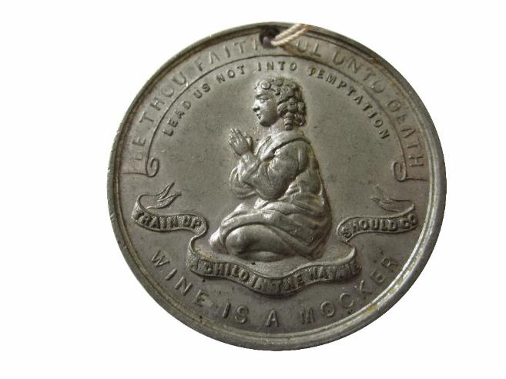
Image: Temperance Coin, Glasgow Museums.

For 70 years until the 1940’s the City Halls hosted Temperance Music nights every Saturday night. It doesn’t take much to imagine even today this area living up to its former reputation of “a den of sin and a citadel of vice”. A number of shebeens and houses of questionable repute peppered this area back in the Victorian era.

Turning right from Candleriggs we reach Brunswick Street and a very different Merchant City emerges with bars and cafes but the vennels and buildings still hint at their past of mills, factories and sweat shops cheek by jowl with markets and stalls, mainly worked by women.

Working in factories was tough and often dangerous and behind the gates at number 102 was one of several clothes factories owned by Samuel Moorov (7).

In 1930, he was charged with sexually assaulting 19 female employees over a number of years. Two policewomen, Ellen Scollay and Ellen Webster, investigated the assaults and obtained a conviction against Moorov. Samuel Moorov appealed on the grounds that the alleged assaults were uncorroborated, as there were no witnesses. He lost his appeal in what is known as the “Moorov Doctrine of mutual corroboration”, still in use in Scotland today.

Retrace your steps and walk down Brunswick Street until you reach Trongate.
Turn left and you’ll soon see a fantastic symbol of the area’s regeneration (8).

The front of the Britannia Panopticon Theatre has been restored to its former glory.

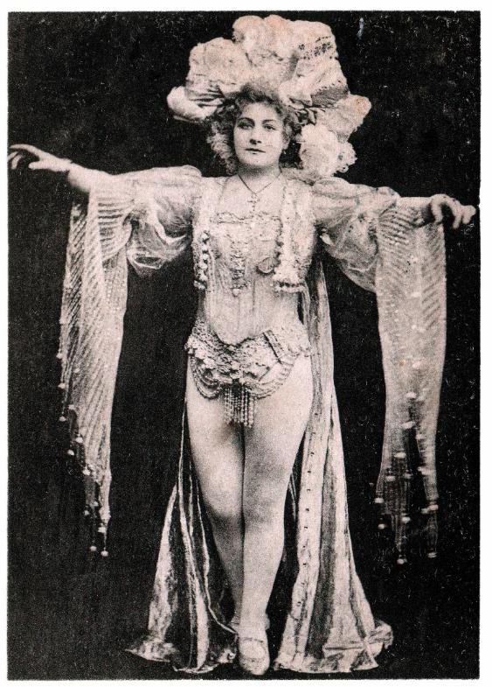
Marie Loftus (1857–1940), a local luminary born on Stockwell Street, trod the boards here. Her talents and fame took her to London and beyond and on her return to Glasgow, fans queued round Trongate to catch a glimpse of the hometown star.
Image: Marie Loftus, Paul Maloney.

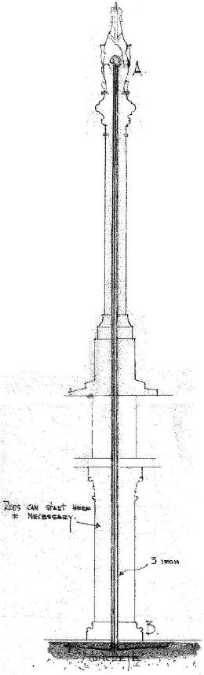
Continue left along the street, beyond the Tron clock tower, until you come to the medieval-looking Mercat Cross (9).
Image: Sketch of the Mercat Cross building by Edith Burnett Hughes, Mitchell Library Archives.

Designed by Edith Burnett-Hughes (1888–1971), the first practising female architect in Scotland, it is a fitting point to finish our tour. Edith tended to specialise in domestic architecture, but in the late 1920s she was commissioned to design the cross, working with the sculptor Margaret Cross Primrose Findlay who modelled the unicorn on top. Solid, strong and at the heart of the city, the building acts as a fine metaphor for the remarkable achievements of the women that we’ve celebrated during our walk.

We hope you’ve enjoyed your wander around the Merchant City and discovering the remarkable achievements of the women we have celebrated on our walk.

This provides a flavour of what we have uncovered about the hidden history of women, but there’s always more to be discovered at Glasgow Women’s Library and on our other Heritage Walks.

For further reading, visit the Women Make History pages at the website address below. For more insight into women’s history contact Glasgow Women’s Library to find out when our two hour guided walks of Garnethill and other areas of Glasgow take place. You can also download our maps and audio tours from our website.

About Glasgow Women’s Library

Glasgow Women’s Library is no ordinary library. It is the only Accredited Museum dedicated to women’s history in the UK, and also a designated Recognised Collection of National Significance. A place for browsing, borrowing and being inspired, GWL is welcoming, free and open to all, with programmes of events and activities that offer something for everyone: from film screenings to literacy support; from talks to supported volunteering opportunities; and from exhibitions to workshops.
About Women Make History

Women Make History is GWL’s women’s history project. Volunteers research and deliver pioneering Women’s Heritage Walking tours in Glasgow and produce related maps and audio tours. Other activities include talks, workshops, recording the histories of living heroines, exhibition curation, tour guiding, training and ongoing women’s history detective work. For more details contact GWL.

How to get involved

Glasgow’s women’s history is still largely hidden from the general public. There are many ways to get involved to address this. Why not join our women’s history detective or tour guide teams? You may have information you think could be added to this tour or suggestions of how it could be improved. If so, we want to hear from you. You can also support GWL by becoming a Friend. This is an invaluable way of ensuring that our work is sustainable for future generations. Visit friends.womenslibrary.org.uk to become a Friend.
Contact us

To find out more about GWL, Women Make History, our guided tour dates and maps and audio tours of other routes please visit our website: www.womenslibrary.org.uk, or email us at info@womenslibrary.org.uk

Thanks to: Dr Anne Cameron, University of Strathclyde; Deborah Haase; Scottish Jewish Archives Centre; Stephen Hosey, Glasgow City Council; Fiona Frank, hannahfrank.org; Garnethill Multicultural Centre; Fiona Hayes, Glasgow Museums; Gary Nisbet, glasgowsculpture.com; Public Catalogue Foundation; Public Monuments and Sculpture Association. Designed by Kirsty McBride. Edited and compiled by Heather Middleton. © GWL 2019

Glasgow Women’s Library, 23 Landressy Street, Bridgeton, Glasgow G40 1BP, 0141 550 2267 info@womenslibrary.org.uk womenslibrary.org.uk @womenslibrary
Registered Company No: 178507
Glasgow Women’s Library is a Scottish Charity SC029881, regulated by the Scottish Charity Regulator (OSCR)

