WOMEN’S
GARNETHILL HERITAGE WALK

2.9km/1.8miles
The terrain is hilly and the route follows paths and pavements with steps through Garnethill Park.

Introduction
As 19th century Glasgow prospered, it expanded west. The wealthy middle-classes built detached residences on the drumlin of Garnethill, attracted by its fresh air and hilltop vistas. A century on from those sedate beginnings, Garnethill had grown into a bohemian enclave, home to theatre people, incomers, artists and activists... and some remarkable women who shaped this corner of the city.

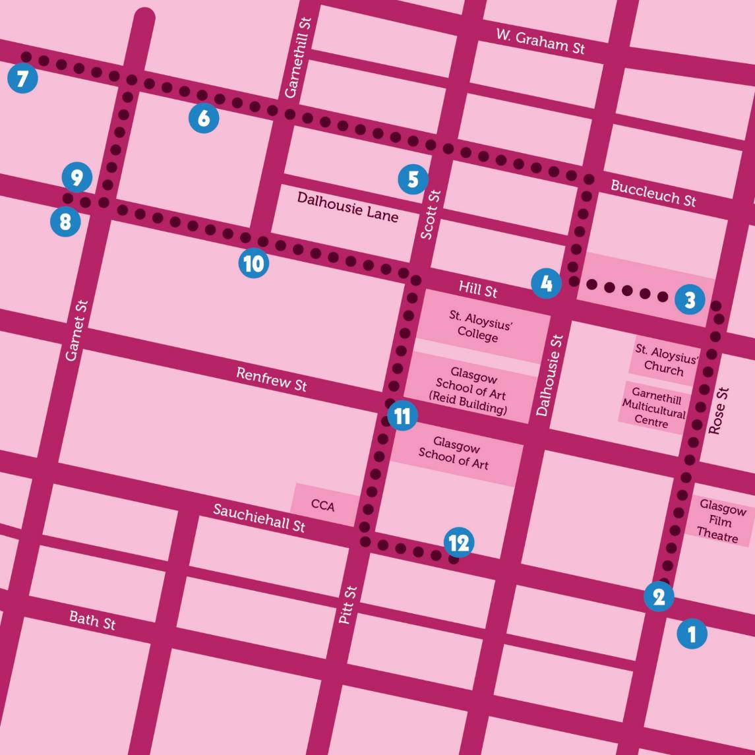

Our walk begins at the junction of Sauchiehall Street and Rose Street (1). Imagine Sauchiehall Street around the turn of the century. Glasgow was the Second City of the Empire. Upmarket department stores competed in the splendour of their displays, tearooms and even orchestras to entice female patrons, for whom shopping was no longer solely about necessity but also pleasure. Copland and Lye at 165 offered the latest Paris fashions. Palatial Pettigrew and Stephens next door was Scotland’s largest department store. Both are now demolished. Daly’s, at 199, was “the Harrods of the North” and the former McLellan Galleries housed Trerons’ Magasin des Tuileries, promising “Paris in Glasgow”.

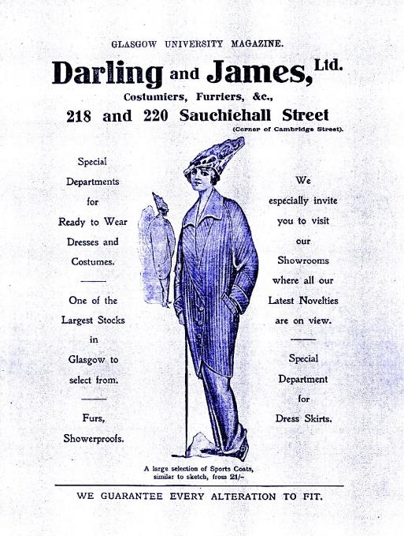
An advert for Darling & James, in the Glasgow University Magazine, was designed to attract the new spending power of female students, admitted since 1892. The grand stores declined with the difficult economic conditions of the inter-war years and competition from chains like Woolworths.
Image: Darling & James advertisement, 1914, University of Glasgow Archive Services, Glasgow University Magazine collection, GB0248 DC198/26.

Nearby are the former Willow Tearooms (2), opened in 1903 by businesswoman and art patron Kate Cranston (1849–1934).
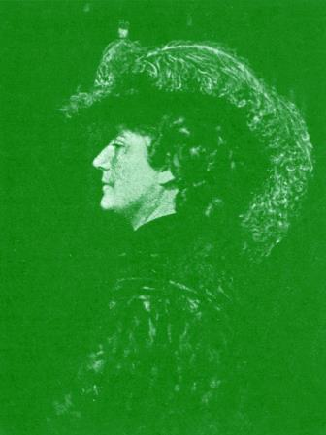
Image: Kate Cranston, Courtesy of the Mitchell Library, Glasgow City Council.

Miss Cranston’s four premises here, and in Argyle, Ingram and Buchanan Streets, made Glasgow “a very Tokio for tearooms” [sic].
Now walk up Rose Street to Garnethill Park (3). Garnethill, originally called Summerhill, is said to have been named after resident Thomas Garnett (1766–1802), an early supporter of female education. He was appointed Professor of Natural Philosophy at the new and progressive Anderson’s Institution in 1796, “the first regular institution in which the fair sex have been admitted to the temple of knowledge on the same footing as men”. Half the students at his popular lectures were female and, in his words, represented “an era in the annals of female education which posterity may contemplate with peculiar pleasure.”

From the 1820s Garnethill developed into a leafy suburb of detached villas, tenements and terraces. Cheaper housing spread as the area became built-up and less desirable. By the 1970s it was in decline and artists including Margaret Watt, Carol Rhodes, Irene Keenan and Jane Sutherland began its regeneration. Most of this environmental art is gone but one mosaic and a gable end survive in the urban oasis of Garnethill Park.
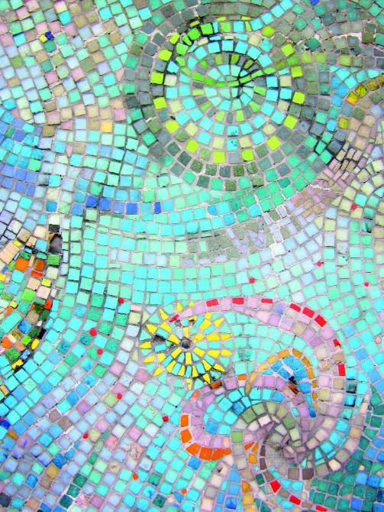
Image: Garnethill Mosaic Mural (1978) by various artists, Photography by Heather Middleton.
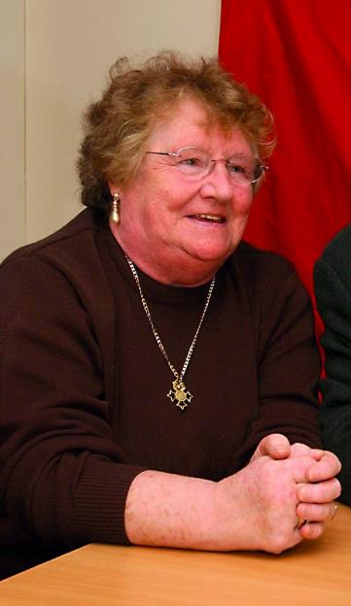
A key player in the site’s development was “Battling” Betty Brown, an STV cleaner and union representative who chaired Garnethill Community Council. She organised groups to recycle masonry from skips and derelict buildings for the park. Designed by Dieter Magnus, it was opened in 1991 by Princess Diana and incorporates mosaic, lighting, metallic globes and waterfalls.
Image: Betty Brown, Newsquest Glasgow Herald & Times.
Cast slabs by architect Ulrike Enslein bear quotations from residents, one of which pays tribute to Betty. Her determination was legendary: “If you don’t harass, then things don’t get done.’’ Honoured with an MBE in 1998, she died in 2006.

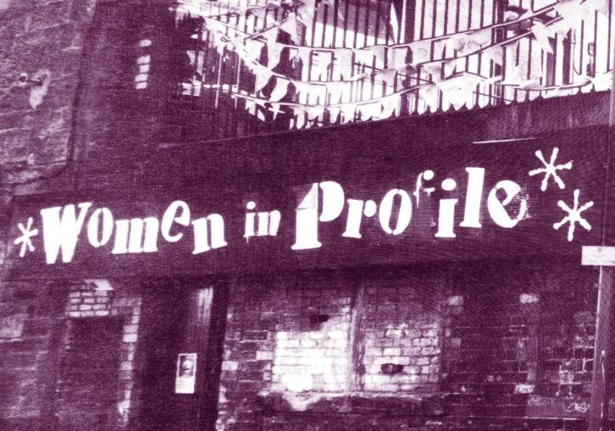
Walk through the park to the corner of Hill and Dalhousie Street. This shop front marks the first home of Glasgow Women’s Library (4), opened in 1991.
Image: Women in Profile, GWL.
GWL grew from a grassroots project, Women in Profile, founded in 1990 (when Glasgow was European City of Culture) to promote the work of women artists. The WiP building, round the corner in Dalhousie Lane, was in poor condition with no windows, but from it emerged an ambitious programme of events. GWL was run by volunteers for its first seven years; it now has paid staff alongside a volunteer programme and resides in permanent award-winning premises in Bridgeton.

Now look up at the lamp-posts to the small plump birds perched on top. These are the much-loved Chookie Burdies by sculptor Shona Kinloch. Around 150 were installed in the surrounding streets in 1993.
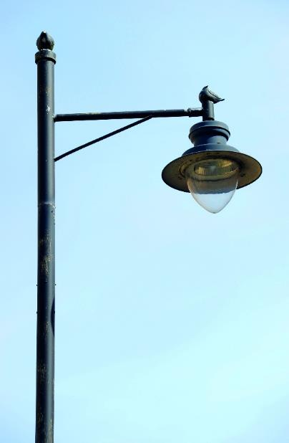
Image: Chookie Burdies by Shona Kinloch, Credit: Glasgow City Council.

Go up Dalhousie Street and left on to Buccleuch Street, to the corner with Scott Street.
The sandstone villa with the roundel showing Charity comforting a child housed Glasgow’s first Hospital for Sick Children (5), opened in 1882 in response to Glasgow’s high infant mortality rate. The authorities prided themselves on recruiting only ‘ladies’ as nurses. It survived entirely on charitable donations, so fortunately its location gave it excellent access to the benevolent ladies of Glasgow’s prosperous West End. It soon outgrew its premises and in 1914 a new purpose-built hospital opened at Yorkhill.

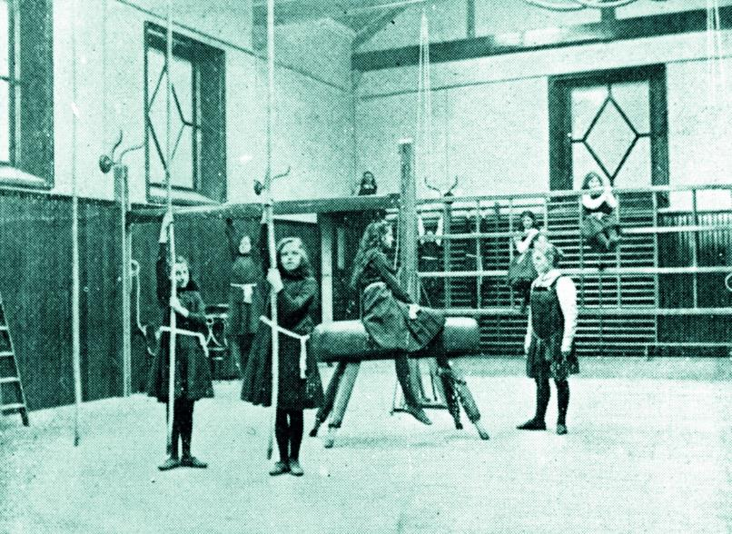
Continue along Buccleuch Street, past Garnethill Street. The grand building marked Garnethill School and its neighbour served as the Glasgow High School for Girls (6) from 1899–1968.
Image: Glasgow High School for Girls Gymnasium, 1901, Courtesy of the Mitchell Library, Glasgow City Council.

Graduates include veteran journalist Katherine Whitehorn; writer and broadcaster Muriel Gray; Lady Hazel Cosgrove, first woman to be appointed to a permanent seat as a judge in the Court of Session; and Alison Sheppard, Olympic and Commonwealth Games swimmer. The school moved in 1969 and began admitting boys in 1976.

Continue to the end of Buccleuch Street, just before it curves left.

This row of seven red sandstone tenements dates from 1892; the last, 145, was the home of Agnes Toward (1886–1975) (7).
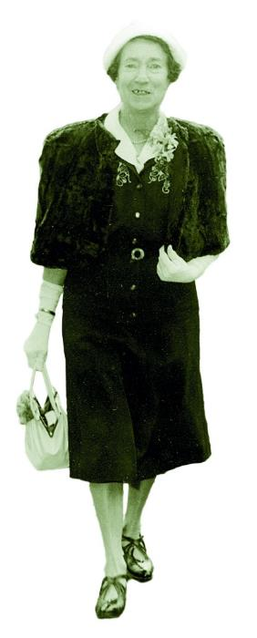
Born in nearby Renfrew Street, she was brought up by her mother, her siblings having died in infancy and her father dying when she was three. They moved here in 1911 and, after her mother’s death in 1939, Agnes stayed another 26 years.
Image: Agnes Toward dressed for a Wedding in the 1960s, The National Trust for Scotland.

A shorthand typist who worked for a shipping company, she never married and worked to the age of 73. She occasionally had the house redecorated and in 1960 had electric lights installed but made no major changes. She spent the last decade of her life in hospital. The flat and her belongings remain a time capsule and their very ordinariness makes them fascinating. Owned by the National Trust for Scotland, The Tenement House is open to the public from March to October.

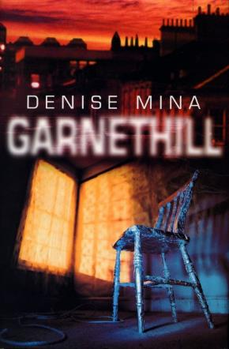
Another woman associated with Garnethill is author Denise Mina (b. 1966). After leaving school at 16 she did a series of lowpaid jobs, then studied law as a mature student. Whilst researching her PHD thesis, she started a novel. Struggling with writer’s block, she attended a writing course at Glasgow Women’s Library and afterwards said, “That’s why I became a crime writer... I finished the book and I owe it all to them.” ‘Garnethill’ (1999) was the start of a hugely successful career.
Image: Garnethill by Denise Mina (Bantam Press) Courtesy of The Random House Group Ltd.
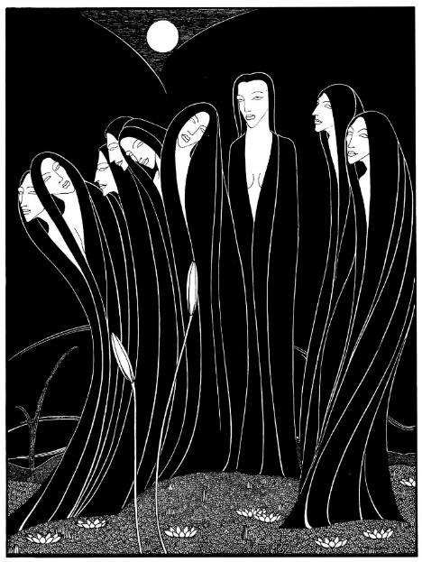
Retrace your steps and bear right up Garnet Street, then right again on to Hill Street. Garnethill Synagogue (8), opened in 1879, has connections with two remarkable artists.
Image: Night Forms (1932) by Hannah Frank, Courtesy of Fiona Frank.

Hannah Frank (1908–2008) was the daughter of Russian Jewish émigrés who fled their homeland to settle in Glasgow.
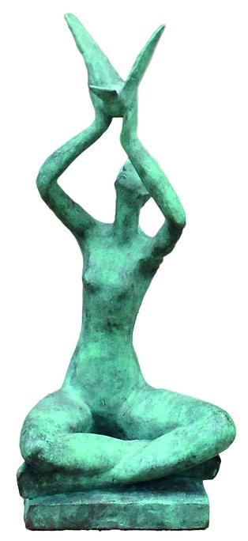
As a schoolteacher, she attended evening classes at Glasgow School of Art, going on to study sculpture and developing distinctive art nouveau pen and ink work. Her work would have disappeared from history had it not been for her niece who, instead of dispersing her drawings and sculptures amongst family and friends, showed them to art curators.
Image: Woman with Bird (1955) by Hannah Frank, Courtesy of Fiona Frank.
Exhibitions around the world were organised, and in 2008, on her 100th birthday, there was a special exhibition of her work at the University of Glasgow. Hilda Goldwag (1912–2008), a long-time resident at 155 Hill Street, was a familiar sight in the area, her shopping trolley piled high with painting materials. She often painted buildings and factories before they were demolished.

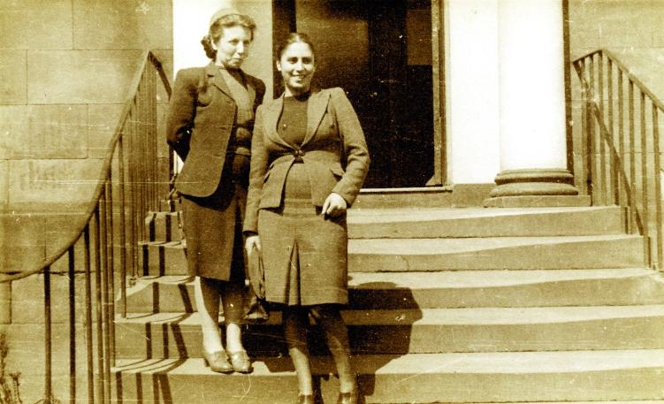
After graduating from Art School in Vienna, Hilda arrived in Scotland in 1939 where she met fellow refugee Cecile Schwarzschild, who became her lifelong companion. Hilda’s family was unable to escape Austria, perishing in the Holocaust. During the war years, she and Cecile worked as turners at engineering works in Glasgow, living in poor hostels. Post-war, Hilda became head designer at Friedlanders designing scarves for Marks and Spencer, and afterwards moved into freelance illustration. A major exhibition at the Collins Gallery in 2005 brought Hilda’s work to the notice of a new generation.
Image: Hilda Goldwag (left) and Cecile Schwarzschild on steps to Refugee Centre, Sauchiehall Street, Scottish Jewish Archives Centre.

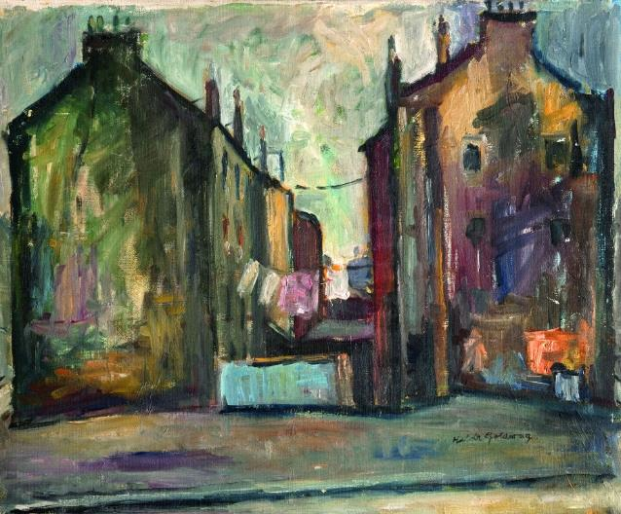
Image: Glasgow Close, Washing Lines, Cowcaddens (1964) by Hilda Goldwag, University of Strathclyde.

The Scottish Jewish Archives Centre holds a collection of the works and papers of both artists. The building opposite the synagogue has significance for many women in Glasgow and beyond (9).
In 1896, following a local appeal, the recently established Glasgow Cancer Hospital moved here. Two existing villas were converted into a modern 30- bed hospital, research facilities and staff accommodation. Director George Beatson was one of the pioneers in the treatment of breast cancer. The current building, rebuilt 1906–12, is now flats but is still associated with his name.

Continue to 101 Hill Street (10). Author and journalist Catherine Carswell (1879–1946) was born here.
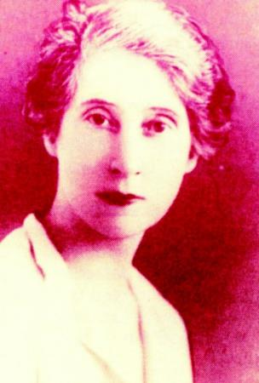
She studied at Glasgow School of Art and Glasgow University before embarking on “a rash and foolish marriage to a man I scarcely knew”, who tried to kill her when she fell pregnant, as he believed that he was sterile. The marriage was annulled in a groundbreaking legal case, on the basis her husband was “insane” when he proposed. Carswell worked as a critic for many years but was fi red from the Glasgow Herald for her favourable review of ‘The Rainbow’ by DH Lawrence.
Image: Catherine Carswell, ‘Mungo’s Bairns’ by Carol Primrose, University of Glasgow, 1990.
‘Open the Door’ (1920), the first of two Glasgow-based novels, dealt with the quest for independence of a heroine who attends the Glasgow School of Art. A lively, unsentimental biography of Burns outraged traditionalists, to the extent she received a bullet in the post. The reissue of her novels by Virago Press in the 1980s re-established her reputation as an important figure in Scottish literature and you can borrow her books from Glasgow Women’s Library.

Continue along Hill Street, turn right on to Scott Street, and to the corner with Renfrew Street.

In 1899, Glasgow Art School (11) moved to this purpose-built home, designed by ex-student Charles Rennie Mackintosh. Sadly the building suffered two major fires in 2014 and 2018.

The Reid building opposite is named after Dame Seona Reid, Director of the School of Art from 1999 to 2013.

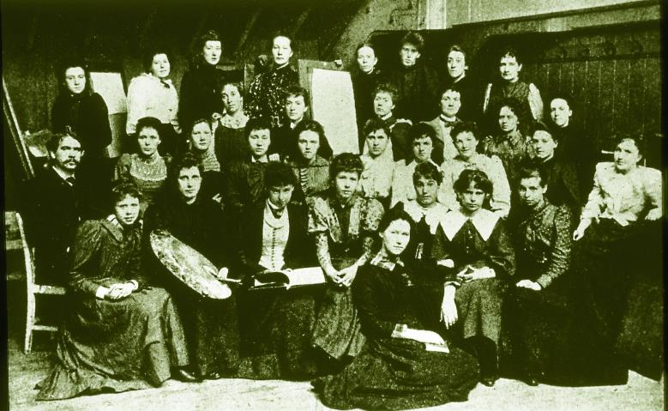
The Glasgow Boys are justly celebrated artists but their female contemporaries have not always received similar recognition. Students including Jessie M. King, Bessie MacNicol, Ann Macbeth, Jessie Newbery and Margaret and Frances Macdonald helped evolve the distinctive Glasgow Style, drawing and designing, working with textiles, ceramics and metals, and even making avant-garde clothes and suffragette banners.
Image: Students and Fra Newbery, 1894, Glasgow School of Art.

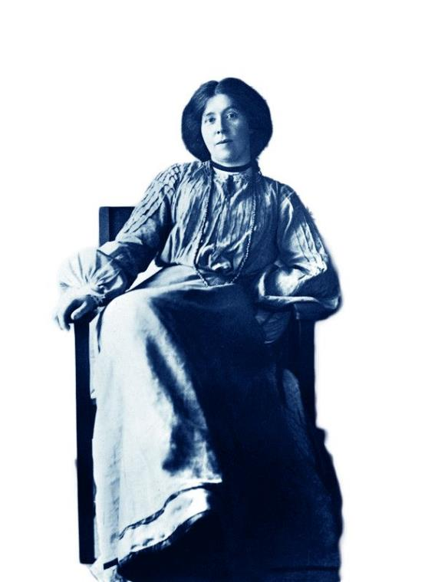
Margaret Macdonald (1865–1933) and her husband worked closely on their elegant art nouveau interiors. Mackintosh appreciated his wife’s contribution where some have not, saying, “Margaret has genius, I only have talent”.
Image: Margaret MacDonald, Courtesy of the Mitchell Library, Glasgow City Council.

Jude Burkhauser (1947–1998) rescued these women from obscurity, creating a Glasgow Girls exhibition at Kelvingrove in 1990. In the accompanying book she wrote, “Young women in the arts have been starved for stories of other women, tales of these maverick sisters whom they might learn from [...] We followed in one another’s footsteps, knocking on doors, asking the same questions, rediscovering fire, the wheel, electricity, because there was no record of our past.”

Continue past the Glasgow School of Art, turning right down Dalhousie Street, then right onto Sauchiehall Street.

Our final stop is an unlikely landmark with no plaque, which played an important role in the women’s suffrage campaign. The Women’s Freedom League opened a Suffrage Centre at 302 Sauchiehall Street (12), with a bookshop and tearoom decorated in their colours of green, white and gold. A banner proclaimed their slogan: “Dare to be free”. As a result of their and others’ efforts, the vote was finally extended to British women on the same terms as men in 1928.

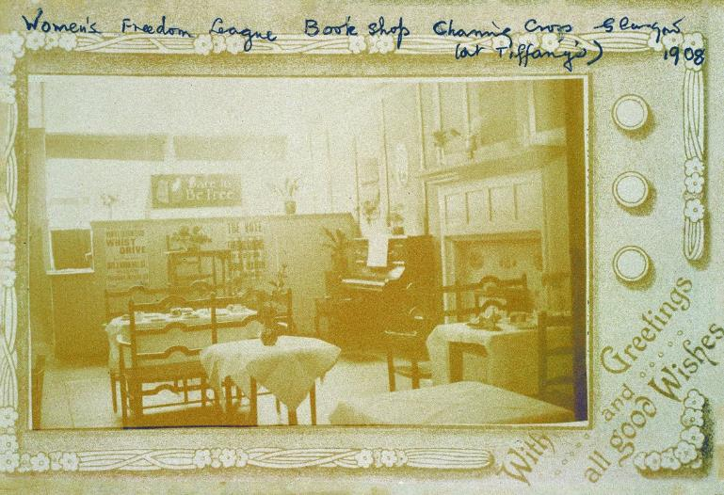
Image: Suffrage Centre, 1908 © CSG CIC Glasgow Museums Collection.

This final stop acts as a reminder of the importance of recognising and paying tribute to remarkable women from Glasgow, whose history is all too often forgotten. We hope you have enjoyed the walk, and have discovered more about the fascinating women associated with Garnethill.

For further reading, visit the Women Make History pages at the website address below. For more insight into women’s history contact Glasgow Women’s Library to find out when our two hour guided walks of Garnethill and other areas of Glasgow take place. You can also download our maps and audio tours from our website.
About Glasgow Women’s Library

Glasgow Women’s Library is no ordinary library. It is the only Accredited Museum dedicated to women’s history in the UK, and also a designated Recognised Collection of National Significance. A place for browsing, borrowing and being inspired, GWL is welcoming, free and open to all, with programmes of events and activities that offer something for everyone: from film screenings to literacy support; from talks to supported volunteering opportunities; and from exhibitions to workshops.

About Women Make History

Women Make History is GWL’s women’s history project. Volunteers research and deliver pioneering Women’s Heritage Walking tours in Glasgow and produce related maps and audio tours. Other activities include talks, workshops, recording the histories of living heroines, exhibition curation, tour guiding, training and ongoing women’s history detective work. For more details contact GWL.

How to get involved

Glasgow’s women’s history is still largely hidden from the general public. There are many ways to get involved to address this. Why not join our women’s history detective or tour guide teams? You may have information you think could be added to this tour or suggestions of how it could be improved. If so, we want to hear from you. You can also support GWL by becoming a Friend. This is an invaluable way of ensuring that our work is sustainable for future generations. Visit friends.womenslibrary.org.uk to become a Friend.

Contact us

To find out more about GWL, Women Make History, our guided tour dates and maps and audio tours of other routes please visit our website: www.womenslibrary.org.uk, or email us at info@womenslibrary.org.uk

Thanks to: Dr Anne Cameron, University of Strathclyde; Deborah Haase; Scottish Jewish Archives Centre; Stephen Hosey, Glasgow City Council; Fiona Frank, hannahfrank.org; Garnethill Multicultural Centre; Fiona Hayes, Glasgow Museums; Gary Nisbet, glasgowsculpture.com; Public Catalogue Foundation; Public Monuments and Sculpture Association. Designed by Kirsty McBride. Edited and compiled by Heather Middleton. © GWL 2019

Glasgow Women’s Library, 23 Landressy Street, Bridgeton, Glasgow G40 1BP, 0141 550 2267 info@womenslibrary.org.uk womenslibrary.org.uk @womenslibrary
Registered Company No: 178507
Glasgow Women’s Library is a Scottish Charity SC029881, regulated by the Scottish Charity Regulator (OSCR)

