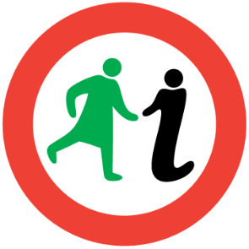
WOMEN’S
EAST END
HERITAGE WALK

3.7km/2.3miles
The terrain is flat and the route follows paths and pavements.

Introduction
The women of Glasgow’s East End have always had to be industrious and resourceful simply to survive. This walk focuses on some of their achievements and struggles, and the radical nature of the area which gave birth to them.

But first let us acknowledge the unrecorded ranks whose destinies were unfairly determined by their gender. Women are invisible in early sources about Glasgow, but the laws passed after the Reformation of 1560 paint a grim picture of female subordination to a misogynist theocracy.

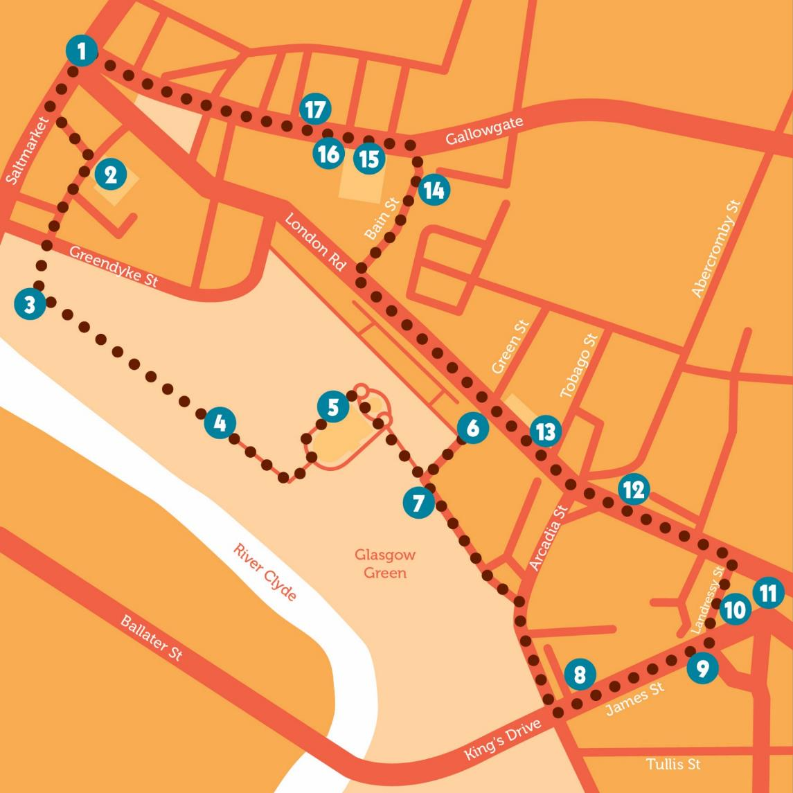

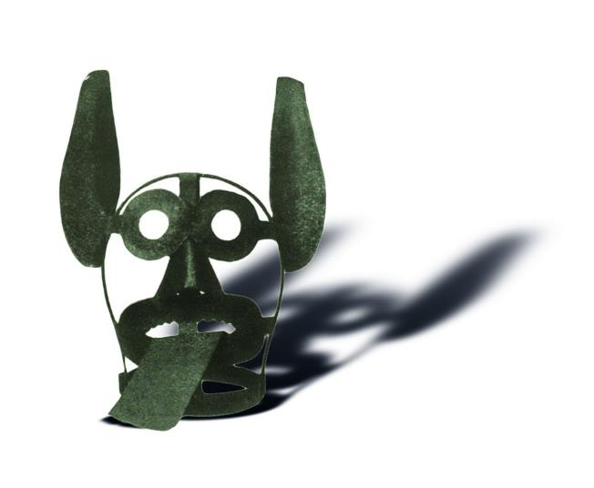
Glasgow Cross (1) was a marketplace from medieval times, but also a site of punishment. Iron head-cages with spiked mouthpieces were excavated nearby; ‘scolds’ were amongst the punished women. A pulley was built over the Clyde to duck adulterers. Witches were likely held, interrogated and tried at the old Tolbooth here, and prostitutes were carted across town, ducked, put in stocks and then banished to drums and chants.
Image: Branks, Reproduced with the permission of Glasgow City Council, Special Collections.
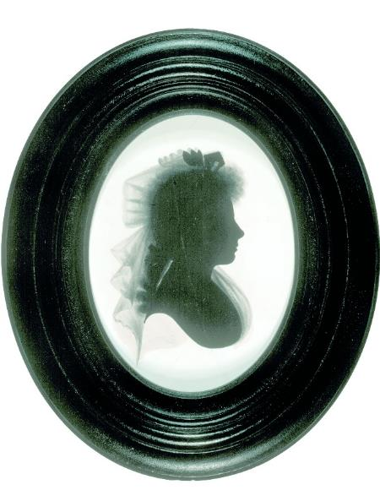
Walk down Saltmarket, then left to approach St Andrews in the Square (2).
Image: Silhouette of Mrs Agnes Maclehose, ‘Clarinda’ by John Miers. © Scottish National Portrait Gallery.

Agnes Craig (1759–1841) was well- educated for a woman of her time, a poet and a renowned conversationalist, who married here in 1776. 11 years on, now separated, she determined to meet Robert Burns.
Their intense correspondence required pseudonyms, Clarinda and Sylvander, because Agnes was still a married woman. She pled their relationship must remain platonic: “Why urge the odious, one request/ You know I must deny!” They met for the last time in 1791 and Burns wrote Ae Fond Kiss as a parting gift.

Turn right down Turnbull Street, passing the Central Police station where Emmeline Pankhurst was arrested in 1914 following a rowdy suffrage meeting, and into Glasgow Green.
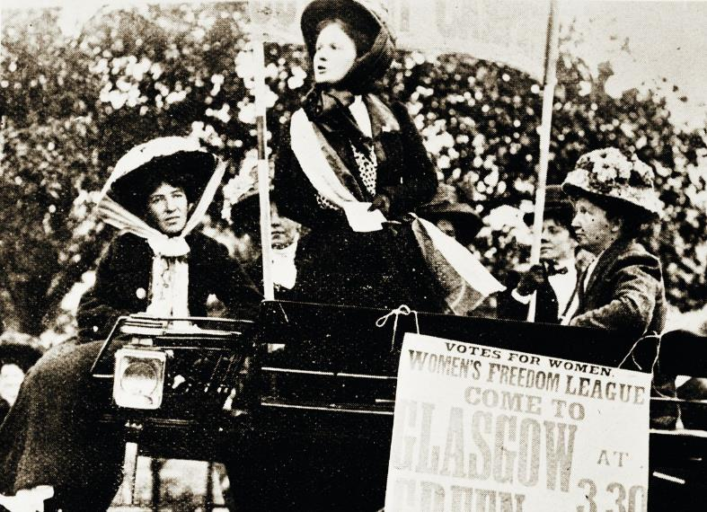
Image: Women’s Freedom League demonstration on Glasgow Green, 1914, Reproduced with the permission of Glasgow City Council, Glasgow Museums.

On your right is the Temperance Fountain (3) commemorating early campaigners who abstained from spirits. The first completely teetotal society in Glasgow was the Radical Temperance Society, founded in 1836.
Five of its founders were women, four of those from one Bridgeton handloom weaving family. Women were active members, having most to gain from temperate households, and this led to involvement in other causes, such as woman’s suffrage.

Walk to Nelson’s Column (4). Suffragettes rallied at this time-honoured place of protest from their first large open-air meeting in 1872 until WWI, which divided the movement. The pacifists turned to other causes, and, with the men off fighting, took up leadership positions.

Suffragettes Agnes Dollan and Helen Crawfurd, along with Mary Barbour, set up the Glasgow Women’s Housing Association, and co-ordinated the successful Rent Strikes of 1915. They launched the Women’s Peace Crusade, and on 8 July 1917 a demonstration of 14,000 converged on the Green.

The Crusade was a housewives’ movement including women with husbands and sons killed in the war, yet still provoked criticism from a jingoistic press.

Walk to the near side entrance of the Winter Gardens, and find the pavement plaque commemorating Sister Smudge, chief rodent operative of the People’s Palace (5) and only cat to be a full member of the GMB Union.

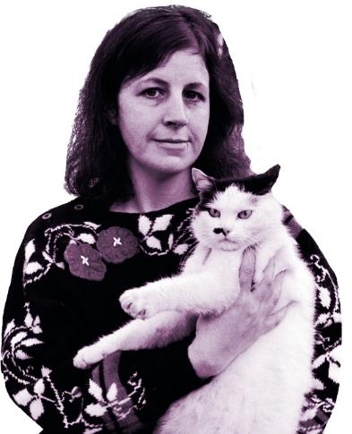
The People’s Palace is a leading museum of social history, containing many items of relevance to the lives of women in Glasgow. Elspeth King was its curator between 1974 and 1991. In 1993, King published her ground - breaking book, The Hidden History of Glasgow’s Women, essential reading for anyone on this tour!
Image: Elspeth King & Smudge, 1988 ©The Scotsman Publications Ltd. Licensor scran.ac.uk

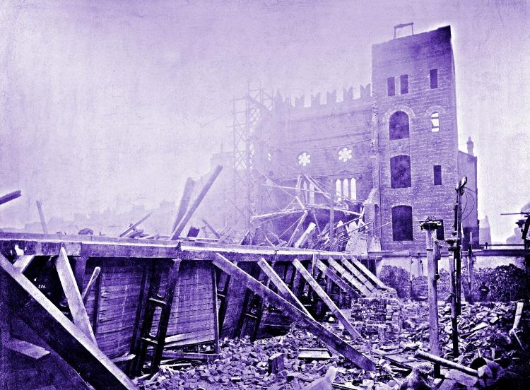
Walk past the former carpet factory, based on the Doge’s Palace, to the Templeton Gate (6) commemorating female workers killed during its construction.
Image: Templeton’s after the disaster. Reproduced with the permission of Glasgow City Archives and Special Collections.

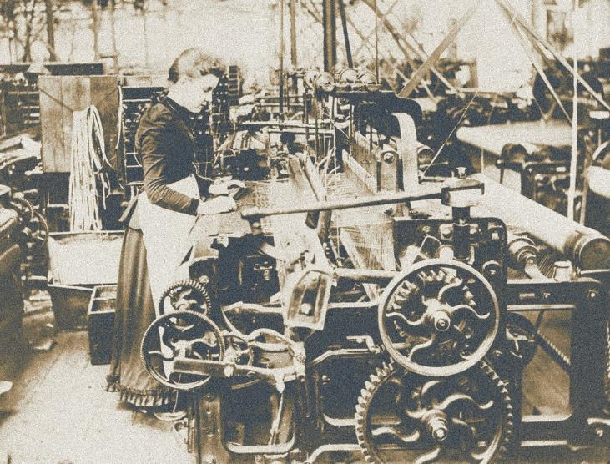
The weaving industry was central to the development of the East End, but its gender profile shifted with the introduction of power looms, which women could cheaply operate. On 1 November 1889, high winds collapsed the brick facade under construction onto the weaving sheds it had been designed to mask. 29 women died in the rubble and are commemorated in stone outside Calton Heritage and Learning Centre (13).
Image: Woman weaving a carpet at Templeton’s Carpet Factory, late 19th century, Reproduced with the permission of Glasgow City Council, Glasgow Museums.

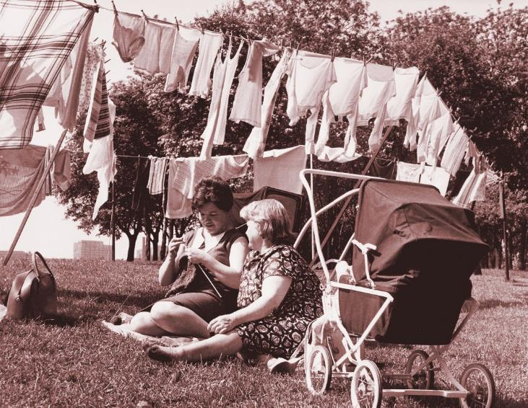
Now walk back down to the drying green (7).
Image: Two Bridgeton women sitting in Glasgow Green ©Newsquest (Herald & Times). Licensor scran.ac.uk

Most of the poles here are Victorian originals, but women have been washing and drying clothes on the Green since it was gifted to the people in 1450. Women tramped washing in tubs with skirts hitched high and English travellers remarked on the brazen women of Glasgow Green.
The Green’s first 18th century washhouse was the model for later “steamies”, the first being Greenhead Washhouse, built in 1878 where you now stand. It included swimming pools and private baths – 27 for men and seven for women. It was demolished in 1960, but the drying green was still in use up to 1977.

Continue east along Templeton Street to leave the Green, then right onto Arcadia Street. Cross at the pedestrian crossing to James Street.

On the corner with Greenhead Street can be seen the former Logan & Johnson School of Domestic Economy (8), which educated girls in cooking, sewing and laundry duties from 1893–1936. It was a condition of Jean Johnston Logan’s bequest that the lady superintendent be a Protestant. The beehive sculpture above the windows represents the industry of the girls within.

Continue up James St to Landressy Street (9). On your right once stood a Singer factory, opened in 1873, 12 years before the more well-known one in Clydebank. The sewing machine revolutionised the lives of working-class women.
March 1911 saw massive demonstrations on Glasgow Green after 12 women walked out of Clydebank’s Singer factory in protest over reorganisation. They were followed by thousands more, then by the men. The strike did not succeed, and 400 were sacked, but it destroyed the myth of the biddable female worker.

Continuing along Landressy Street, we pass Glasgow Women’s Library (10), in the former Bridgeton Library. Times have changed since it was built in the early 20th century, with separate reading rooms for men (large) and women (smaller) and children (upstairs where they could be neither seen nor heard!)
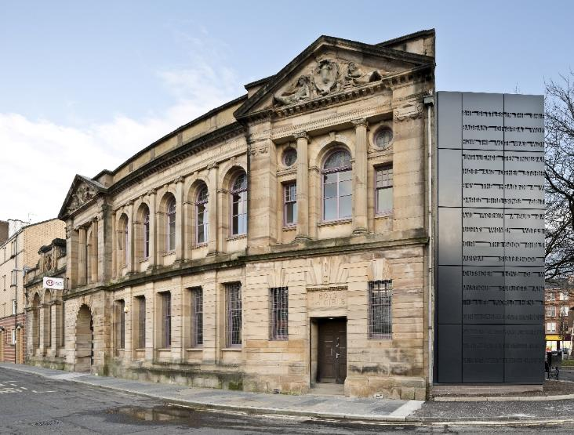
Image: Glasgow Women’s Library. Credit: Keith Hunter.

Glasgow Women’s Library is the only Accredited Museum in the UK dedicated to women’s lives, histories and achievements, with a lending library, archive and museum and innovative programmes of public events and learning opportunities. Pop in for a cup of tea and a browse, you’ll be sure to have a very warm welcome!

Turn right at the top of Landressy Street onto London Road to reach Bridgeton Cross (11).
In the 1830s and 1840s, Bridgeton was an important centre of Chartism, which sought votes for all men over 21. Chartists disagreed about female suffrage, but women still played a vital role, forming 23 Female Chartist Associations across Scotland, including the Bridgeton & Calton and Mile End Associations. They raised funds, organised tea parties, led boycotts of unsympathetic shops and businesses, and marched under home-made banners. Initially spectators, they developed into public speakers, sometimes addressing thousands.
Historian Dorothy Thompson concedes it is, “difficult to conceive Chartism without their participation”.

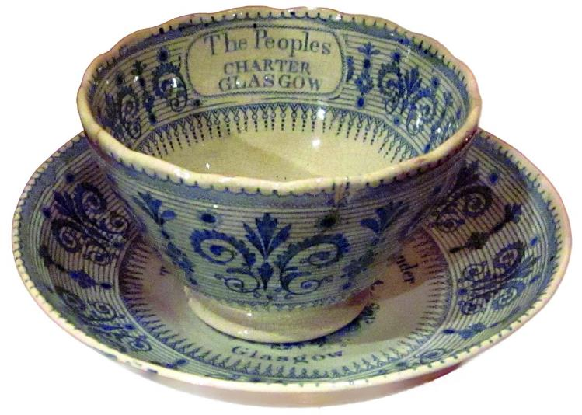
Image: Chartist teacup and saucer, 19th Century, Photograph by Heather Middleton, reproduced with permission of People’s Palace Collection, Glasgow Museums.

Cross at the pedestrian crossing and go west along London Road to Abercromby Street, traditionally known as Witches Loan (12).
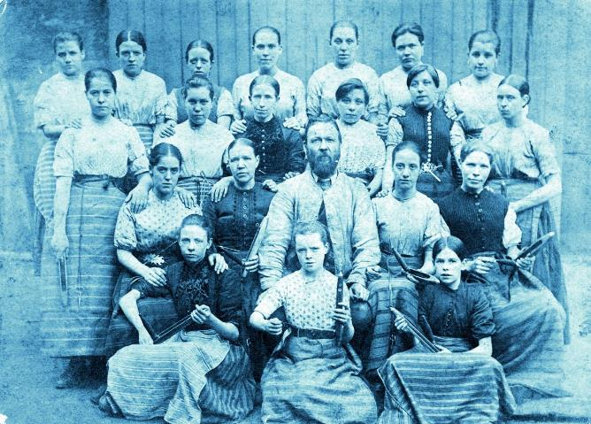
The Old Cattle Market was situated where it met Duke Street and while cattle were moved along here between market and river, they were said to be spellbound. One possible explanation is that cows that were victims of poor pasture recovered when brought to the Clyde to be fed and watered, falling ill again on their return. The burial ground here contains a Martyrs monument commemorating the Calton Weavers massacre of 1787.
Image: Weavers at Camlachie Mill, 1892. Reproduced with the permission of Glasgow City Council, Glasgow Museums – GlasgowStory.
Walk along London Road, taking a moment to pause at the memorial for the women and girls who lost their lives in the Templeton Fire (13).

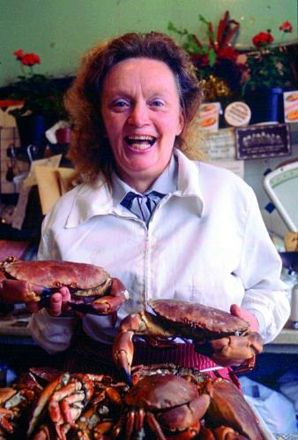
Continue for five minutes before turning right into Bain Street. At no. 9, “Battling” Betty McAllister ran a seafood shop (14) for many years. This was known as “the office” and functioned as HQ for her many campaigns.
Image: Betty McAllister, 1982, © The Scotsman Publications Ltd. Licensor scran.ac.uk

She knew how to grab headlines, and when Margaret Thatcher visited Templeton’s Business Park, Betty organised a protest and informed the PM she could, “stick the poll tax where the sun don’t shine!” Her campaigns and other good works were recognised with a British Empire Medal in 1980 and a Scotswoman of the Year award in 1984. Before her death in 2009, she was rumoured to be plotting a midnight raid on Woodlands Road in the West End to return the statue of Lobey Dosser to his ancestral home in “Calton Creek”.

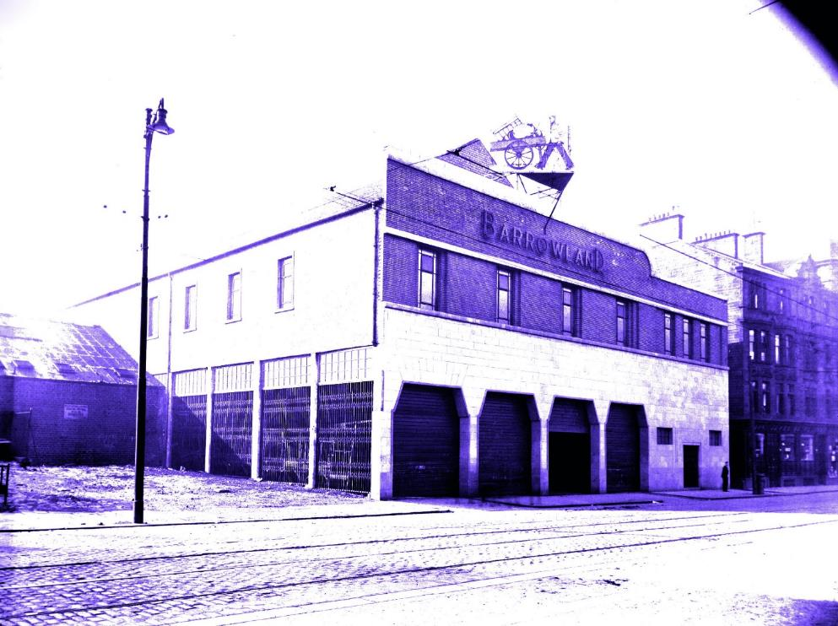
Cross to Gallowgate’s north side and along to East Campbell Street to get a good view of the neon starburst frontage of the Barrowland Ballroom (15), and the archway to the Barras market (16).
Image: The original Barrowland Ballroom, 1935. Reproduced with the permission of Glasgow City Archives and Special Collections.

The rags to riches tale of Maggie McIver,“the Barras Queen”, reads like something from Catherine Cookson. She was born in 1880, and worked as a barrow girl selling fish and fruit. After marriage, she and her husband began renting barrows to other hawkers. In 1920, they opened a market on the site of the present Barras, and by 1928, this was fully enclosed with static stalls. Maggie traditionally put on a Christmas dance and meal for their hawkers, and, legend has it, she found their usual venue booked one year so decided to build her own. Maggie died in 1958, and a few months later Barrowland burned down. It was rebuilt and reopened in 1960 and it is still a hugely popular venue for touring bands. A gate into Glasgow Green commemorates its founder.
Continue to the Saracen Head (17), Glasgow’s first ‘pub-museum’ which takes its name from an older inn, built next door in 1755 on what was once the kirkyard 16th century Little St Mungo church.

The original ‘Sarry Heid’ was Glasgow’s leading hotel for several decades but, facing stiff competition, was converted into shops and dwellings before being demolished in 1904. The present-day pub retains a mysterious skull, allegedly that of Maggie Wall, “last witch to be burned at the stake”, according to the wall plaque. Just outside the village of Dunning in Perthshire stands a stone cross with the painted inscription, “Maggie Wall burned here 1657 as a witch”.
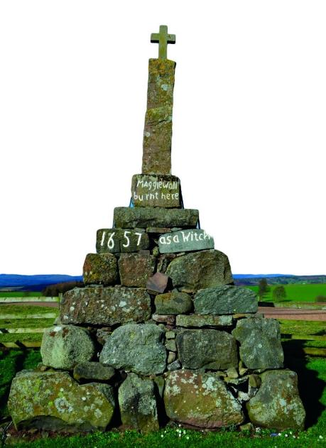
No records confirm her existence, and no-one knows who built the monument. Perhaps Maggie represents all women executed as witches who should be remembered. As for the skull, it was possibly uncovered when the original inn, built on a burial ground, was demolished.
Image: Monument to Maggie Wall, Dunning, Perthshire, Photograph by Sandy Stevenson, www.visitdunkeld.com.

Continue along Gallowgate to return to our starting point (1).
The subtitle to the aforementioned The Hidden History of Glasgow’s Women is The Thenew Factor. Thenew was a 6th century princess and Christian convert who survived banishment, rape and two murder attempts before giving birth to Kentigern, founder of Glasgow. Hers was a popular cult in pre-Reformation Glasgow.

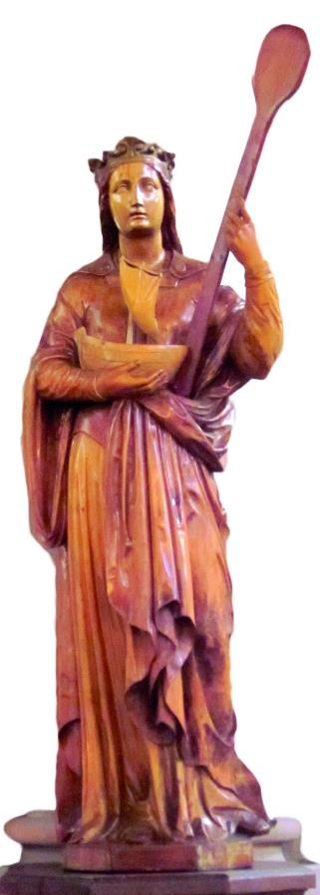
Trongate, leading west from the Cross was originally St Tenu’s Gait, or the way to St Thenew, and St Enoch’s is a corruption of St Tenu’s Croft, now St Enoch’s Square. There her chapel and well stood, the latter reputedly having healing properties. Metal offerings, some in the shape of body parts, appear to have been inserted into a tree beside it – perhaps women sought help with their pregnancies.
Image: St Thenew statue, 1866, Photographed by Heather Middleton, with the kind permission of the Church of St Mungo, Townhead.

After the Reformation, Thenew’s cult died out, as did her name. Today most Glaswegians have no idea that ‘Enoch’ was a woman and the mother of Glasgow. King uses her name as a symbol of how easily women may be written out of history, which is a fitting end to this walk where we have celebrated the lives of the women of Glasgow’s East End. We hope you have enjoyed it.

For further reading, visit the Women Make History pages at the website address below. For more insight into women’s history contact Glasgow Women’s Library to find out when our two hour guided walks of Garnethill and other areas of Glasgow take place. You can also download our maps and audio tours from our website.

About Glasgow Women’s Library

Glasgow Women’s Library is no ordinary library. It is the only Accredited Museum dedicated to women’s history in the UK, and also a designated Recognised Collection of National Significance. A place for browsing, borrowing and being inspired, GWL is welcoming, free and open to all, with programmes of events and activities that offer something for everyone: from film screenings to literacy support; from talks to supported volunteering opportunities; and from exhibitions to workshops.

About Women Make History

Women Make History is GWL’s women’s history project. Volunteers research and deliver pioneering Women’s Heritage Walking tours in Glasgow and produce related maps and audio tours. Other activities include talks, workshops, recording the histories of living heroines, exhibition curation, tour guiding, training and ongoing women’s history detective work. For more details contact GWL.

How to get involved

Glasgow’s women’s history is still largely hidden from the general public. There are many ways to get involved to address this. Why not join our women’s history detective or tour guide teams? You may have information you think could be added to this tour or suggestions of how it could be improved. If so, we want to hear from you. You can also support GWL by becoming a Friend. This is an invaluable way of ensuring that our work is sustainable for future generations. Visit friends.womenslibrary.org.uk to become a Friend.
Contact us

To find out more about GWL, Women Make History, our guided tour dates and maps and audio tours of other routes please visit our website: www.womenslibrary.org.uk, or email us at info@womenslibrary.org.uk

Thanks to: Dr Anne Cameron, University of Strathclyde; Deborah Haase; Scottish Jewish Archives Centre; Stephen Hosey, Glasgow City Council; Fiona Frank, hannahfrank.org; Garnethill Multicultural Centre; Fiona Hayes, Glasgow Museums; Gary Nisbet, glasgowsculpture.com; Public Catalogue Foundation; Public Monuments and Sculpture Association. Designed by Kirsty McBride. Edited and compiled by Heather Middleton. © GWL 2019

Glasgow Women’s Library, 23 Landressy Street, Bridgeton, Glasgow G40 1BP, 0141 550 2267 info@womenslibrary.org.uk womenslibrary.org.uk @womenslibrary
Registered Company No: 178507
Glasgow Women’s Library is a Scottish Charity SC029881, regulated by the Scottish Charity Regulator (OSCR)

