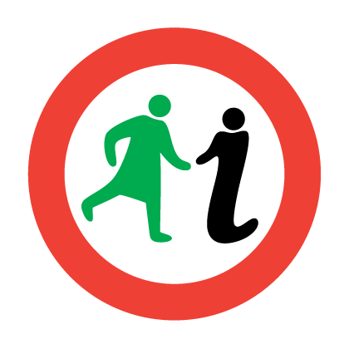
STRIDE WITH PRIDE HERITAGE TRAIL
Large Print Map

4.5km/2.8miles
The trail route is along pavements with some steep hills near Garnethill.

LGBTQ+ people have been a part of Glasgow’s history as long as the city has existed. Although the histories of the LGBTQ+ community are often ignored or not recorded in traditional ways, we can find traces of their lives and experiences. From the court records of male sex workers in the Broomielaw to listings and adverts for club nights in the 2000s, and from memories of the saunas and club scenes of the 1980s to the direct action and activism of LGBTQ+ groups like the Lesbian Avengers.
The terms we use now for LGBTQ+ people are modern definitions for experiences and identities that have always existed; when discussing any LGBTQ+ people in this map all efforts have been made to refer to people with the identities and pronouns they themselves used.
This map highlights just some of the people, places and spaces that have been a part of Glasgow’s LGBTQ+ heritage and history. It’s not exhaustive, but we have tried to make it as representative and inclusive of all LGBTQ+ people and experiences as possible within the limitations of the records available to us. The map has been created with the help of a team of Glasgow Women’s Library’s History Detective volunteers.
We begin our walk at (1) Nelson’s Monument on Glasgow Green. Glasgow Green has been the start and end point of many Pride marches over the years. It also has a history as a location for gay and bisexual men to go cruising and meet. We found stories of police officers in the 19th and early 20th centuries hiding near Nelson’s Monument in the hope of catching couples. Prosecution records serve as a sad but vital reminder of the history of criminalisation in Scotland, and the impact it had on the LGBTQ+ community.
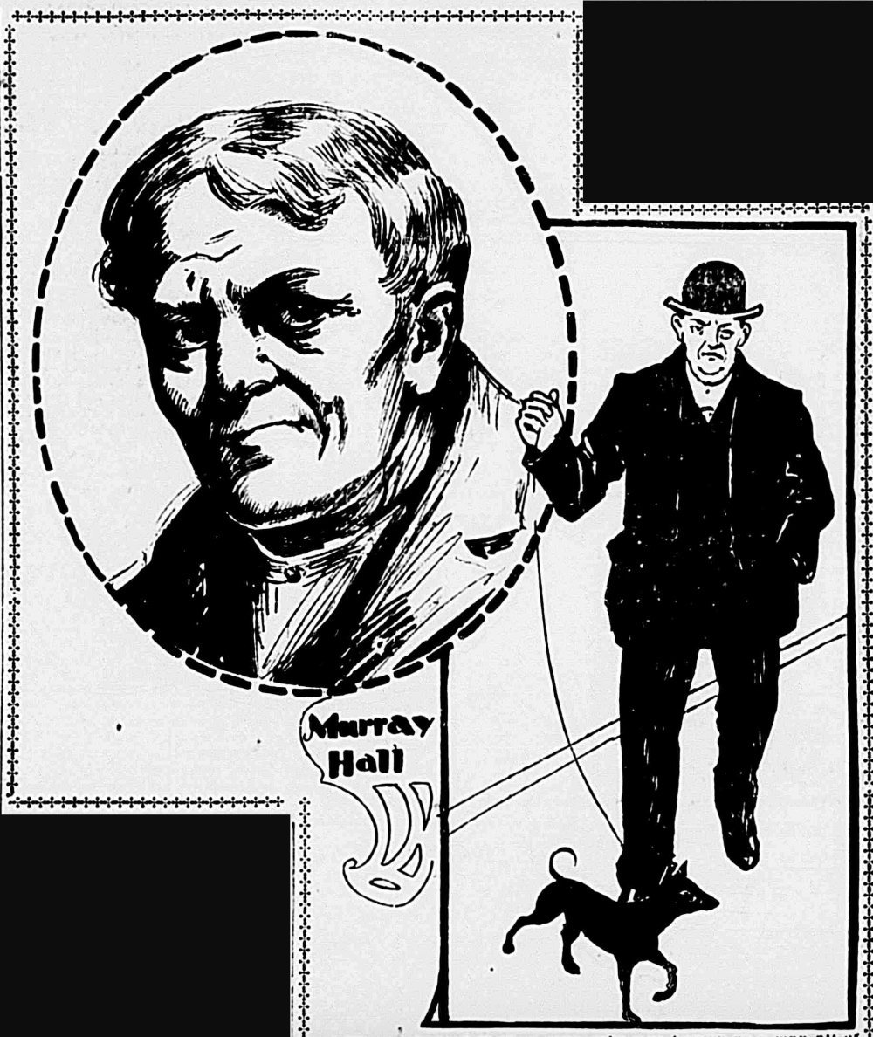
Image: Portrait of Murray Hall in the Evening World (January 18, 1901).
While at Glasgow Green we’re also going to look at the story of New York politician (1) Murray Hall. Murray Hall was born in 1841 in Govan, Glasgow, and died in 1901 in New York. Hall emigrated to America in 1871 and became a New York City bonds man and politician. He married twice and adopted a daughter with his second wife. After his death of breast cancer it was discovered that he had been assigned female at birth. Coverage of his death in newspapers at the time focused on the fact that despite being assigned female at birth, Hall had been able to vote. Hall loved books, amassing a large library.
We will then walk across Glasgow Green towards Glasgow Cross, to join London Road, past Barrowland Park, and on to Trongate. On the left is the building that was used as Pride House.

(2) Pride House 17–19 Trongate (European Championships 2018), 14 Albion Street (Commonwealth Games 2014). Pride House was a space for LGBTQ+ athletes, fans and their allies during large scale sporting events, notably the Commonwealth Games hosted in Glasgow in 2014. The Pride House concept grew out of the hospitality house tradition found in the Olympic and Paralympic Games and the first Pride House took place during the 2010 Winter Olympic and Paralympic Games in Vancouver.
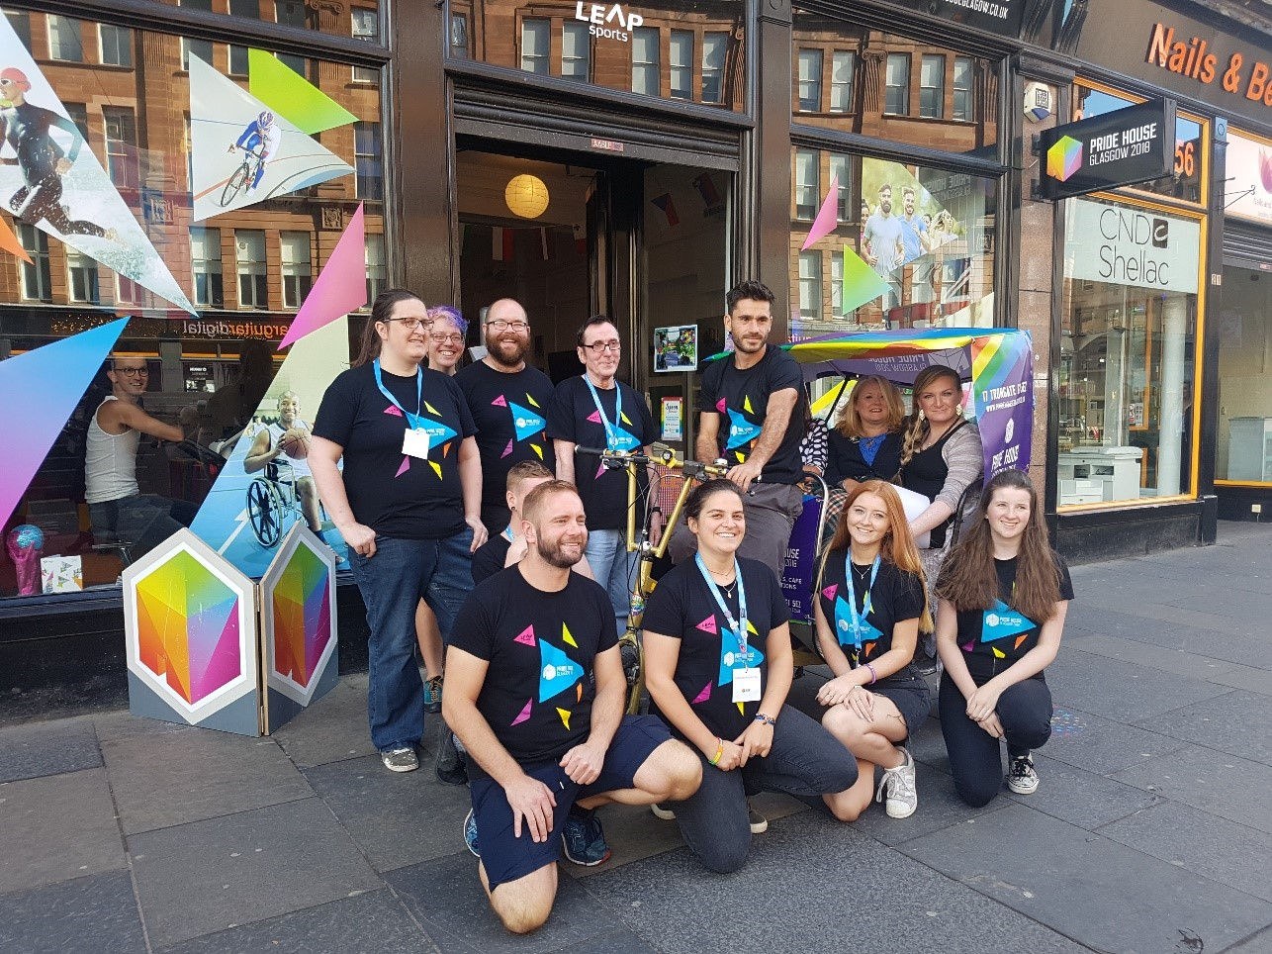
Image: Pride House, LEAP sports.
The Pride House space in Glasgow hosted plays, films, a café, talks, life drawing, story-telling, family crafts, yoga, quizzes, and promotion of sport amongst the LGBTQ+ community. It was a welcoming and inclusive place for people to come together to enjoy the sports, to talk, think and be challenged, and relax and have fun. Pride House champions included singer Horse McDonald, and Olympic Hockey Gold Medallists, Kate and Helen Richardson.
On our left as we head further into the city we can find the Tron Theatre.

(3) Glasgay! Festival The Tron Theatre. The Glasgay! annual festival ran from 1993–2014 in venues across the city. It was a multi-art form festival of work by LGBTQ+ performing artists, including theatre, dance, literature, film, music and comedy. It was founded by performer and writer Cordelia Ditton with arts administrator Dominic D’Angelo in response to Section 28, a law enacted in 1988 that stated that a local authority “shall not intentionally promote homosexuality or publish material with the intention of promoting homosexuality” or “promote the teaching in any maintained school of the acceptability of homosexuality as a pretended family relationship”, which made it difficult for teachers in schools to teach anything about LGBTQ+ people, and impacted other public services, including libraries.
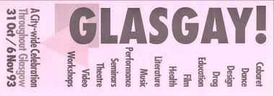
The festival was criticised by sections of the media and some Conservative councillors about the use of public money for LGBTQ+ art. In 2015 the festival failed to secure long-term funding. The producers of Glasgay! now operate as Outspoken Arts Scotland and the Glasgay! archives are held within the Scottish Theatre archive at the University of Glasgow.

Image: Glasgay! Leaflet at GWL
Further along Trongate from the Tron Theatre, we can find the location of Glasgow Women’s Library between 1994 and 2006.

(4) Glasgow Women’s Library Trongate 103. Glasgow Women’s Library was set up in 1991 in Hill Street, Garnethill and moved to this site, then 109 Trongate, in 1994. It occupied three floors of the building, which at the time was accessed via stairs and a semi-automatic lift down this alley.
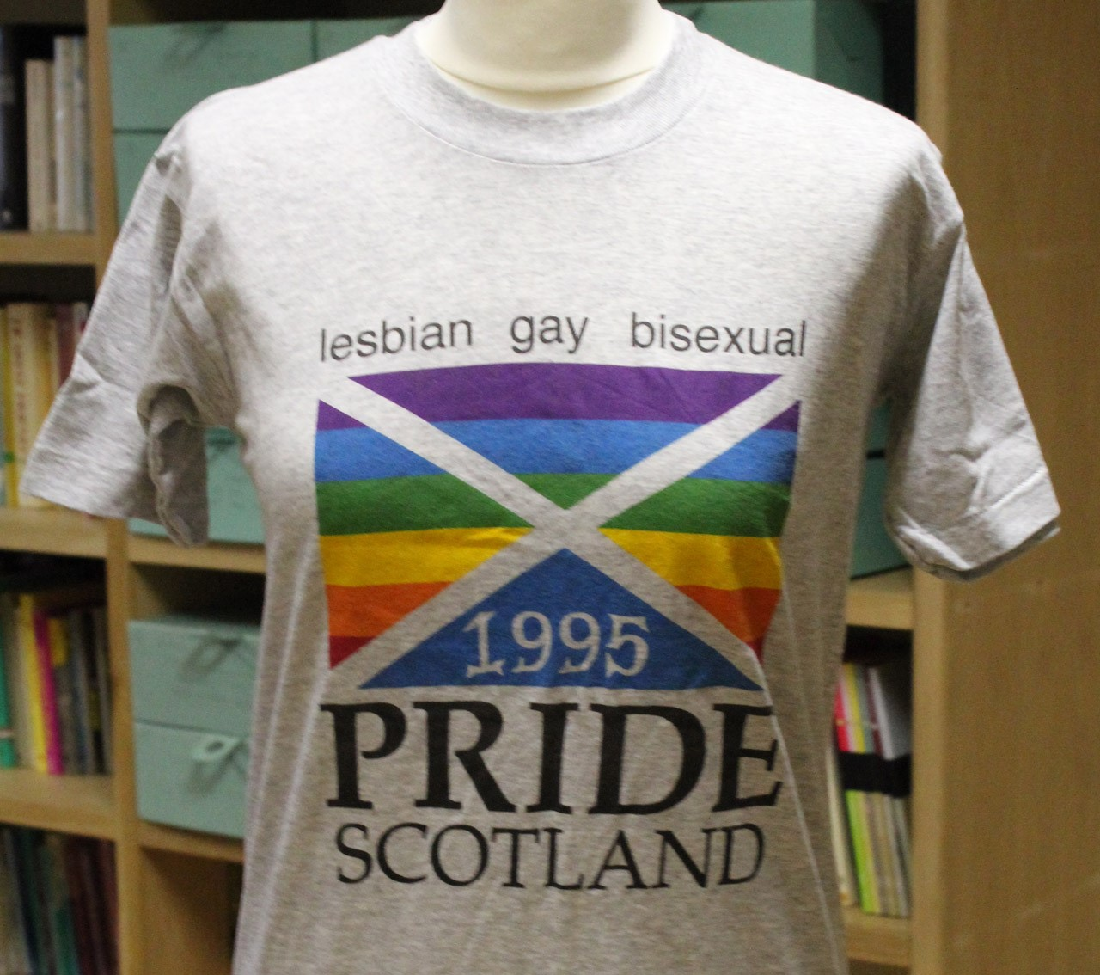
GWL has always played a key role in Glasgow’s LGBTQ+ history and became home to the UK’s Lesbian Archive collection when it relocated from London in 1995 due to funding cuts. GWL was run by volunteers for its first decade, while its first funded project with paid staff was the Lesbians in Peer Support Project (LiPS), a peer support and education project for young lesbian and bi women.

Image: Pride T-shirt in the collection of GWL
GWL has existed in several locations since its inception, including behind Trongate in nearby Parnie Street, and is now permanently based in Bridgeton. It is now the only Accredited Museum dedicated to women’s history in the UK and runs programmes of public events and dedicated projects.
We then cross the road to go up Candleriggs to find the City Halls on the right hand side, where if you look at the ground you’ll see some lines of poetry engraved into the pavement. These are by…

(5) Edwin Morgan (1920–2010) was Scotland’s first official Makar and he published his first book of poetry in 1952. He was born in Glasgow and grew up in Rutherglen. He studied at the University of Glasgow and served as a noncombatant conscientious objector during World War II. He worked as a professor at the University of Glasgow after graduating until he retired in 1980.
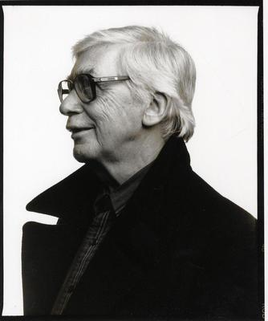
Image: Edwin Morgan, Used by permission of the EM Trust
Although he had written love poems, Morgan was not specific about his sexuality in his writing until the 1990s, and in 1995 he read his specially written poem for the opening of the new Glasgow Gay and Lesbian Centre. Morgan actively supported the repeal of Section 28, and he dedicated his 1982 collection ‘poems of thirty years’ to his partner.
Turn left onto Ingram Street. Many of Glasgow’s LGBTQ+ bars are around this area particularly in Wilson Street, John Street and Virginia Street.
(6) Merchant City LGBTQ+ Bars Glasgow today has several LGBTQ+ focused bars and clubs, most of which are now situated in the same area of Merchant City. In the 1990s, a gay bar called Sadie Frost’s could be found at 10–14 West George Street, next to Queen Street Station. Sadie Frost’s offered a women only night on Sundays in ‘the blue room’, named Sappho’s. In 1996 the bar was in the news for advertising for only gay bar staff (The Herald). The comedian and actor Karen Dunbar hosted karaoke on Thursdays in Sadie Frost’s. It was a popular bar in the city centre, and women only spaces were rare in the clubbing scene. On Sunday May 4th 2014 a reunion event for Sadie Frost’s was held at Katie’s Bar on John Street.
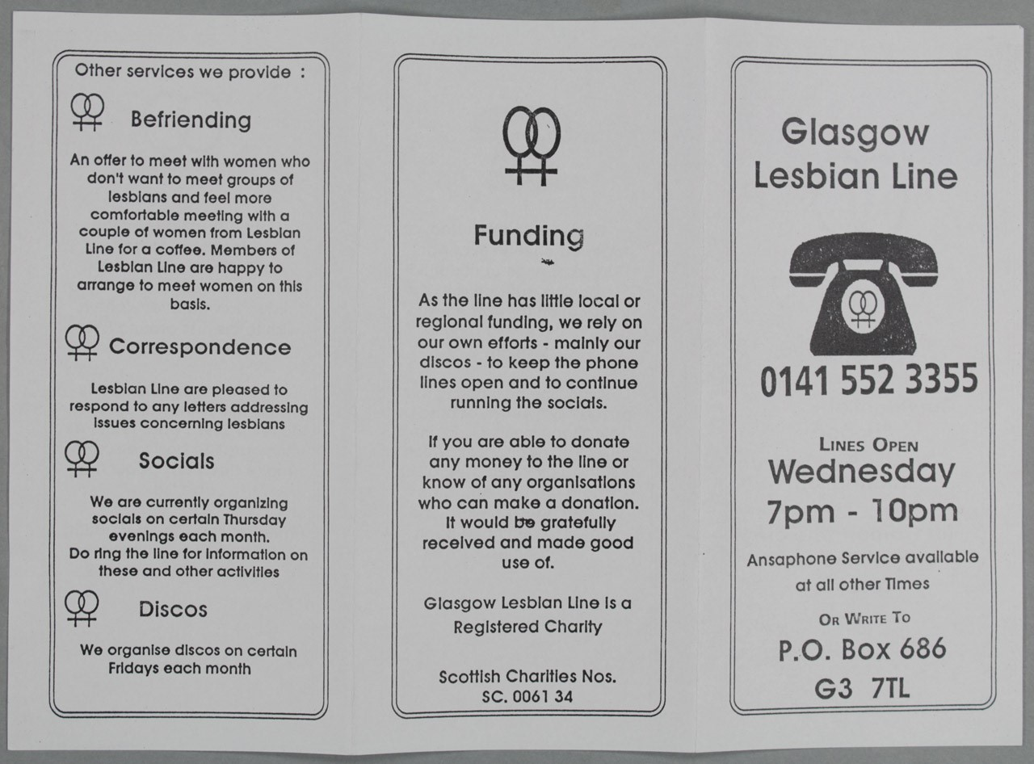
From Ingram Street turn left onto Miller Street and you’ll find the original location of the Glasgow Lesbian Line.
Image: Glasgow Lesbian Line, Information Leaflet, unknown designer, circa 1990, in the collection of Glasgow Women’s Library.

(7) Glasgow Lesbian Line Glasgow Women’s Centre, 57 Miller Street. Glasgow Lesbian Line offered advice and information to lesbians. It was staffed by a lesbian feminist collective of volunteers and provided a telephone helpline – a lifeline for many. Advice and support was given about problems, legal issues, as well as information about social events. GLL also offered a befriending service, correspondence, socials on Thursday evenings, and monthly discos on Fridays. The discos were originally held at The Star Club, (the Communist Party Social Club) in Carlton Place, and then from the early to mid1980s, at the Clyde Halls on the Broomielaw.
Retrace your steps back along Miller Street and turn left until you reach Queen Street, and the Gallery of Modern Art.

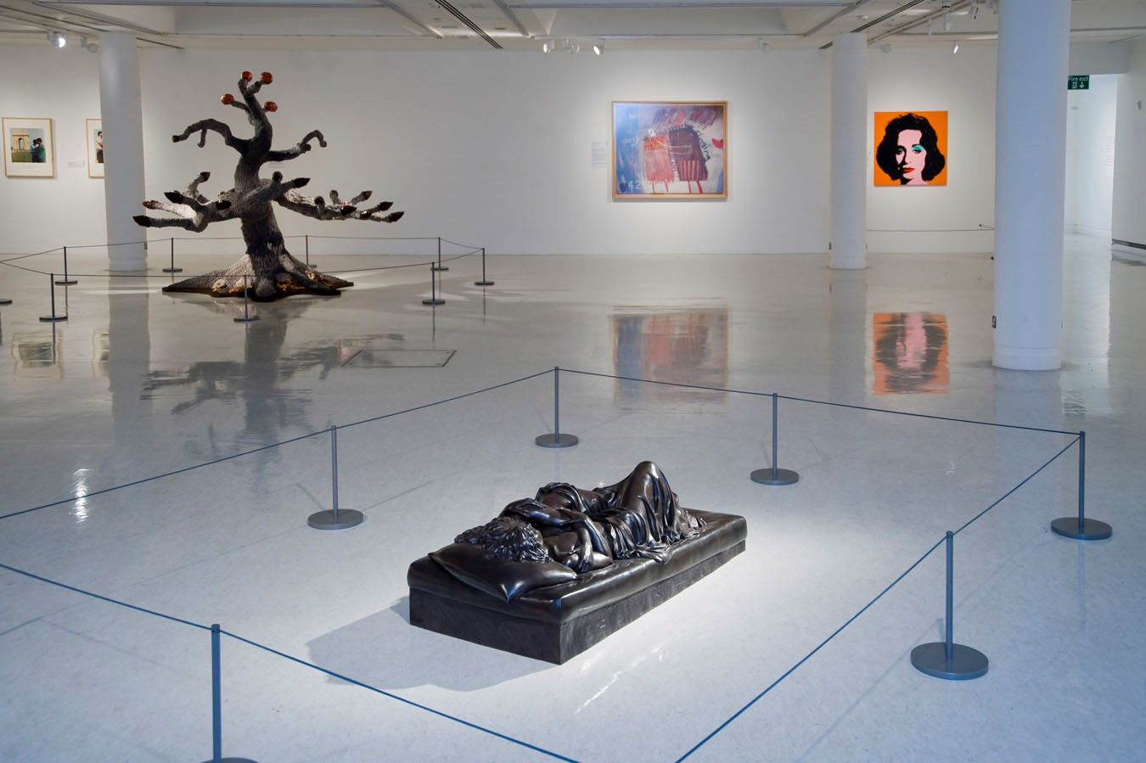
(8) GoMA Royal Exchange Square. The Gallery of Modern Art opened in 1996. The building was built in 1778 as the townhouse of a wealthy Glasgow Tobacco Lord who profited from the labour of enslaved people through the triangular slave trade.

Image: GoMA, Reproduced courtesy of Patricia Cronin, and Glasgow Museums.
As the GoMA it has hosted a wide variety of modern art, including several dedicated LGBTQ+ exhibitions. The SH(out) exhibition in 2009 was part of the contemporary art and human rights series of programmes at GoMA which began in 2001. It included works by Grayson Perry and David Hockney, Patricia Cronin’s Memorial to a Marriage – a funerary sculpture of two embracing lesbian lovers – and Nan Goldin’s photographs of Greer Lankton, as well as a series of films by Scottish LGBTQ+ youth. The exhibition caused a strong reaction amongst critics.
The Queer Times exhibition in 2018/19 was an opportunity for LGBTQ+ people to participate in history-making, by sharing their experiences and the history of the LGBTQ+ community to create an exhibition at GoMA, with artists Ajamu IkweTyehimba and Jason E Bowman as well as other LGBTQ+ organisations.
Past GoMA, turn right onto Buchanan Street and walk to the junction of Bath Street. In front of you is the Royal Concert Hall and behind it is Glasgow Caledonian University, the venue of BiCon Glasgow.

(9) BiCon Glasgow Caledonian University, Cowcaddens Road. BiCon is an annual festival/ Pride celebration for bisexual+ people and allies. Over the 13–17th July 2006, BiCon Glasgow was held at Glasgow Caledonian University. Workshops included topics like bi publicity, intersexuality, juggling, drag kings, and sign language. BiCon started as a political conference and expanded to become the celebration and opportunity for community it continues to be today.
Turn left along Bath Street.

(10) PHACE West, 49 Bath Street. PHACE West was a project for HIV and Aids education in West Scotland. It provided outreach work, health days and events, condom distribution, a buddy service, welfare rights advice service, and a crisis line. It was founded by Ken Cowan, an activist and founding member of the Scottish Homosexual Rights Group. In 2001 Glasgow City Council suspended funding to the agencies providing HIV/AIDS services, including PHACE West, after an organisation called Christian Institution claimed that these services contravened Section 28, but the funding was ultimately restored. PHACE West merged with the Terrence Higgins Trust in 2006, a charity that continues to provide support to people living with HIV to this day.
Continue along Bath Street, turning right onto Blythswood Street and then on to Rose Street to the Glasgow Film Theatre (GFT).

(11) Glasgow Film Theatre 12 Rose Street. The GFT was Scotland’s first arts cinema. As well as putting on an array of LGBTQ+ programming, the GFT held a lot of significance for LGBTG+ young Portrait of Murray Hall in the Evening World (January 18, 1901). Pride House, LEAP sports. people in the 90s. The LGBTQ+ youth group that met before the LGBT Centre opened in 1995 used the GFT as a meeting point. New meetups of the group would be given the instruction to look out for someone holding a blue folder outside the cinema, who would then give out the location of the meeting.

(12) Jackie Kay 14 Rose Street – Millie’s flat. Jackie Kay was born in Edinburgh in 1961 to a Nigerian father and Scottish mother. She was adopted by a white couple at birth and grew up in Bishopbriggs, a town on the outskirts of Glasgow. Kay came out at as a lesbian at 17. Her first novel Trumpet is about a love affair between a cis woman, Millie, and a transgender man, Joss. Although the novel is set mostly in London, Millie’s flat, where she and Joss spend time together, is at 14 Rose Street near the GFT. The novel was inspired by Billy Topton, a white transgender jazz musician. Jackie Kay was appointed Scots Makar in 2016 and is the first black lesbian to receive the honour.
Turn left along Renfrew Street to the Glasgow School of Art.

(13) The Two Roberts Glasgow School of Art. Robert Colquhoun (1914–1962) was a painter, printmaker, theatre and set designer. Born in Kilmarnock, Colquhoun won a scholarship to attend the Glasgow School of Art. Here he met Robert MacBryde who would become his lifelong partner in both his professional and his personal life. They lived and worked together, although collaborating on art pieces rarely. Robert MacBryde (1813–1966) was a modernist, still life painter, and theatre set designer. He was born in Ayrshire and worked in a factory for several years before studying art at GSA, where he met Colquhoun. They were open about their relationship even though at the time homosexuality was illegal. Their work was incredibly successful, both in the UK and internationally, but in the 1950s became less popular. Colquhoun died in 1962 and MacBryde in a car accident in 1966. Their relationship is largely obscured in writing about them and it has taken a long time for people to recognise both their creative legacy and their enduring relationship.
GSA Students’ Association hosts many LGBTQ+ club nights and events and from 2015–17 was the venue for the annual Glasgow Free Pride event, a free alternative to corporate Pride.
Turn left down Scott Street and right onto Sauchiehall Street.

(14) Glasgow LGBT Centres 534 Sauchiehall Street, 11 Dixon Street and 84 Bell Street. The first Gay Centre opened in 1977 at 534 Sauchiehall Street, set up by the Scottish Minorities Group. It closed in 1982. Thirteen years later, in 1995, a new Glasgow Gay and Lesbian Centre opened at 11 Dixon Street, near the Broomielaw by the River Clyde with a café bar, offices and meeting rooms, and OurStory Scotland’s inaugural exhibition ‘Becoming Visible’ was held here. The Centre moved to Bell Street as the LGBT Centre in 2005, before closing in April 2009 after funding was withdrawn. The Metropolitan Community Church, (an LGBTQ+ friendly church) met for its first public worship service at the Bell Street address in 2008.
Crossing carefully, turn left on to North Street, to the Mitchell Library.

(15) The Mitchell Library North Street. The Mitchell Library is a large public library in the Charing Cross area of Glasgow, it contains the Glasgow City Archives, which includes some records of LGBTQ+ people in Glasgow.
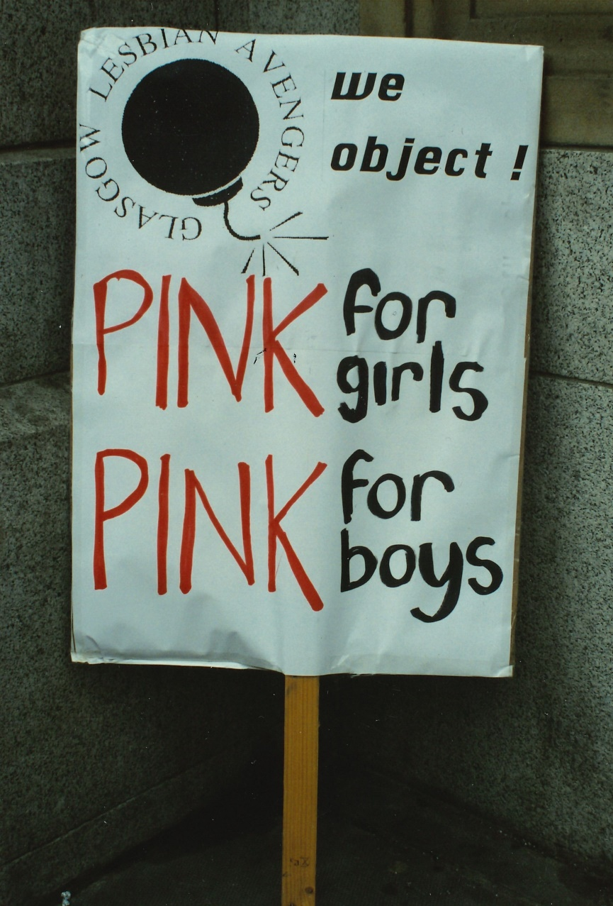
Image: Lesbian Avengers Placard, at the Mitchell Library
It was also the site of a protest in September 1995 by the Glasgow Chapter of the Lesbian Avengers against Section 28 which had a huge impact in schools and on the availability of information for LGBTQ+ people in any local authority context. The Mitchell Library stocked The Pink Paper, a free weekly LGBT paper, but in 1995 decided that it would only make it available on request, citing Section 28 as the reason. The Lesbian Avengers protested every day outside – and on occasion inside – the Mitchell Library until this position changed.
Walk back along North Street towards St. George’s Cross for the final stop at 4 Queens Crescent.

(16) Scottish Homosexual Rights Group 4 Queens Crescent. The SHRG was founded as the Scottish Minorities Group in 1969 by Ian Campbell Dunn in his parents’ home in Glasgow. At this time, the change of law in England and Wales that partially decriminalised sex between men over 21 in private did not apply to Scotland or Northern Ireland. The SMG name was chosen with this in mind, as it did not explicitly mention homosexuality. The SHRG championed the rights of LGBTQ+ people, provided counselling and worked for law reform. It also offered a safe meeting for LGBTQ+ people. It produced a monthly newsletter which started in 1971 and in 1978 changed from being called SMG News to Gay Scotland. There was also an SMG Glasgow Women’s Group, which had its own magazine, Gayzette. In 1980 sex between men over 21 was partially decriminalised in Scotland – by this point the SMG/SHRG had existed for over ten years, and in 1992 the group become Outright Scotland.

You can see where some of our information came from, find out more about the LGBTQ+ history of Glasgow, and see other LGBTQ+ maps of Glasgow at the links below.
Queerscotland.com
Ourstoryscotland.org.uk
http://lgbthistoryscotland.org.uk/
https://www.queeringthemap.com/
https://queerscotland.com/scotland-lgbthistorical-map-1885-1995/
https://www.ourstoryscotland.org.uk/heritage/ mapPast/OurSpaceMap.pdf
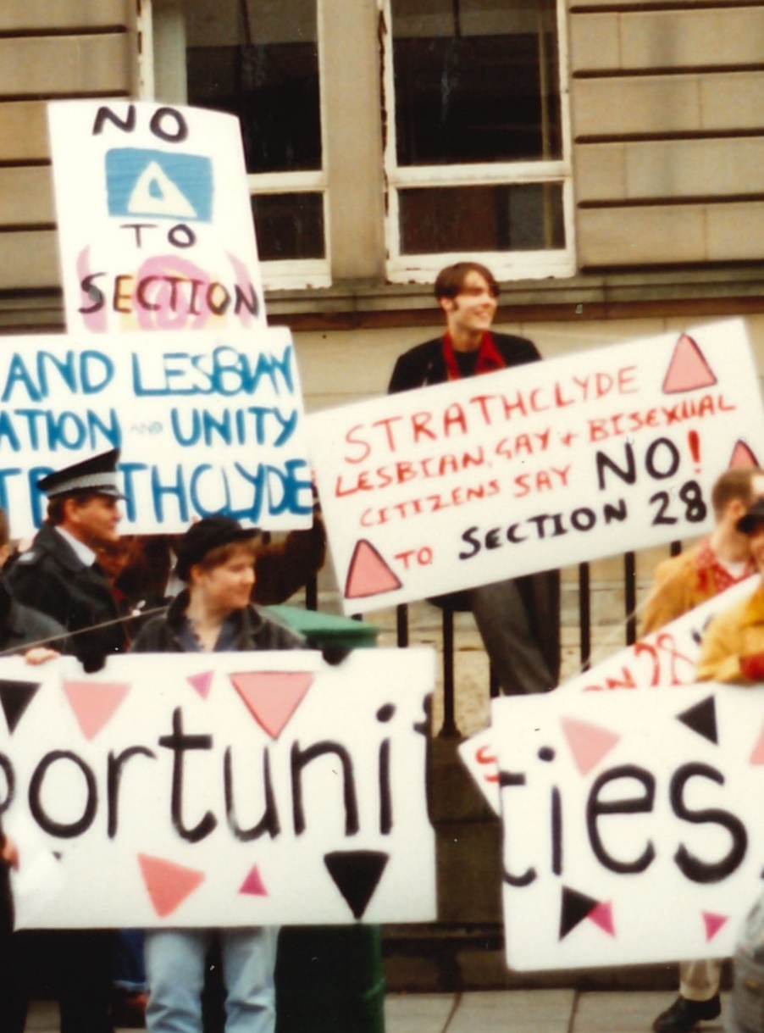

Image: Demonstrators outside the offices of Strathclyde Regional Council, protesting against Section 28, circa 1994. Photo: Sue John, in the collection of Glasgow Women’s Library
For further reading and information on other Glasgow Women’s Library Heritage Walks, visit the Women Make History pages at the website address below. You can also download our maps and audio tours from our website.
About Glasgow Women’s Library
Glasgow Women’s Library is no ordinary library. It is the only Accredited Museum dedicated to women’s history in the UK, and also a designated Recognised Collection of National Significance. A place for browsing, borrowing and being inspired, GWL is welcoming, free and open to all, with programmes of events and activities that offer something for everyone: from film screenings to literacy support; from talks to supported volunteering opportunities; and from exhibitions to workshops.
How to get involved
Glasgow’s women’s and LGBTQ+ history is still largely hidden from the general public. There are many ways to get involved to redress this. Why not join our women’s history detective or tour guide teams? Or come by the Library and use the Lesbian Archive for your own research.
You can also support the Library through volunteering in the Archive, making the Lesbian Archive more visible and accessible. If this heritage map has sparked memories of items or photographs that you’d like to donate to the GWL Archive, we’d love to hear from you.
You can also support GWL by becoming a Friend. This is an invaluable way of ensuring that our work is sustainable for future generations. Visit friends.womenslibrary.org.uk to become a Friend.
Contact us
To find out more about GWL, Women Make History, our guided tour dates, and maps and audio tours of other routes please visit our website: www.womenslibrary.org.uk, or email us at info@womenslibrary.org.uk
This trail was developed by the Glasgow Women’s Library LGBTQ+ History Detectives. Compiled and edited by Mel Reeve. Designed by Kirsty McBride. © GWL 2019. Funded by Tesco Bags of Help Community Grant Scheme.

