Vote 100: the moving story
a secondary school toolkit

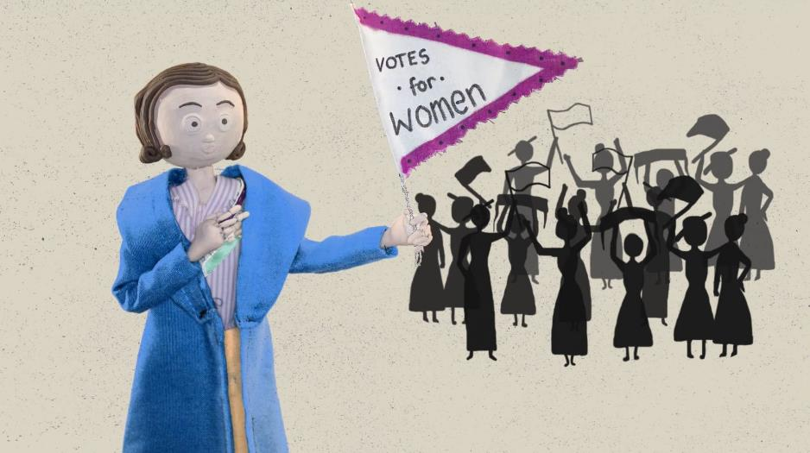
Vote 100: The Moving Story – Ethel Moorhead (still from GWL animation)

table of contents

Introduction .............................................................................. | 3
How suffragettes changed the world ......................................... | 3
Suffragettes & suffragists: Do you know the difference? .................. | 6
Contact Us! ............................................................................... | 7
1. Research! .............................................................................. | 8
2. Debate! ................................................................................ | 9
3. Write! .................................................................................. | 10
4. Create! ................................................................................. | 13
5. Act Out! ................................................................................ | 13
6. Play! .................................................................................... | 14
Panko .............................................................................. | 14
Suffragetto ....................................................................... | 19
Who’s Who: Suffrage Edition .................................................. | 21
Recommended Reading ................................................................. | 23
Useful Resources ......................................................................... | 23
Feedback .................................................................................. | 24
Acknowledgments ....................................................................... | 24

introduction

How Suffragettes Changed the World
Have you heard about the Australian suffragette who scattered handbills from an airship with ‘Votes For Women’ emblazoned on the side? Or the Scottish woman who burned down a stand at Ayr Racecourse? Or the woman who stormed into the Egyptian Parliament demanding equal rights for women? Did you know that the first Suffragette ever to go on hunger strike was a Scot?
In 2018, Glasgow Women’s Library (GWL) launched our Vote 100: The Moving Story project. In the year when we celebrated the 100th Anniversary of the Representation of the People Act, 1918, which allowed some women in the UK to vote for the first time, GWL’s aim was to develop an animated web resource highlighting the forgotten heroines who have campaigned for equal rights and votes for women across the world.
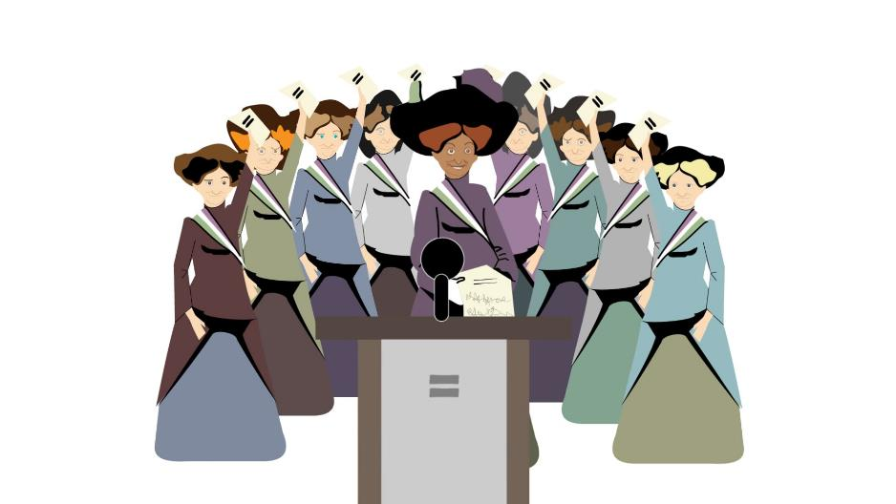
Vote 100: The Moving Story – Lila Clunas (still from GWL animation)
The idea for the project was as a response to Glasgow Women’s Library frequently asking the question at talks to groups of varying sizes and ages: ‘Can you name a Suffragette?’ The usual enthusiastic answer was invariably ‘Emmeline Pankhurst’. Then in answer to the follow-up question, ‘Can you name a Scottish Suffragette?’ we were often met with a puzzled silence. Thousands of women were imprisoned, force-fed, sexually and physically assaulted, verbally abused, vilified. Their physical, emotional and mental health suffered. Some lost their jobs, their children, their families; and a few lost their lives. But so few of us can name even one of them.
We wanted to change this; we wanted the names of the women in Scotland who gave so much to the cause of women gaining the right to vote to roll off the tongue. Some of these women were born in Scotland, others were born elsewhere but were instrumental in the Scottish suffrage campaign. We also wanted to honour forgotten heroines in other contexts who fought for the vote and for women’s rights in other countries, particularly Women of Colour.
We started out with a list of nearly 400 inspirational women and, since September 2018, we have been working with Glasgow Women’s Library learners, volunteers and visitors to:
- Research 101 of these neglected activists
- Write two or three snippets about the amazing things they did
- Record audio versions of the resulting scripts
Students from colleges across Scotland (Glasgow School of Art, City of Glasgow College, Duncan of Jordanstone College of Art and Design in Dundee, Edinburgh College of Art, University of the West of Scotland and Grays School of Art in Aberdeen), as well as individual animators, then worked to produce 101 short animations of each of the scripts and recordings.
Each animation is around 30 seconds in length and we hope you will find them interesting, entertaining, educational and inspirational.
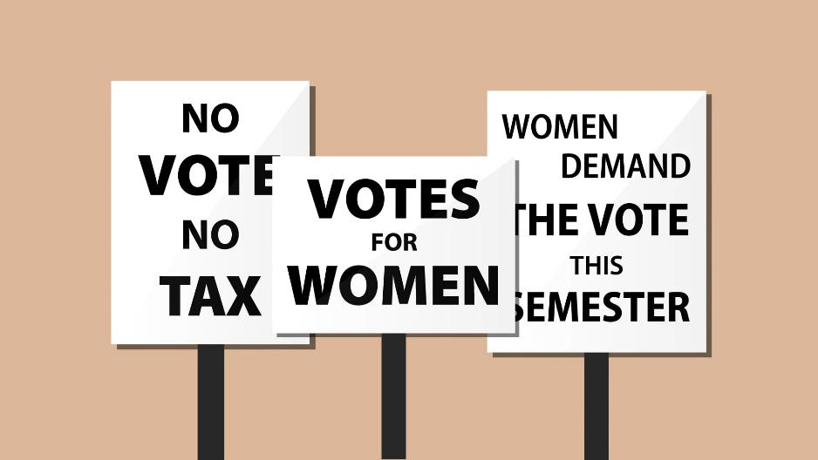
Vote 100: The Moving Story - Margaret Fraser Smith (still from GWL animation)
This project would not have been possible without the 100 women who researched, wrote or recorded the scripts, or the animators who brought those audio recordings to life. And it definitely wouldn’t have been possible without the 101 amazing women who fought for the rights of women across the world and the many, many others whose contributions remain mostly unrecorded. If you would like to help redress that omission, take a look at the names of the 270 other women from our initial list (including 111 further Scottish women!) And that 270 is still only a small selection. Research them, talk about them, write about them, give them a page on Wikipedia, tell us about them!

suffragettes & suffragists: do you know the difference?
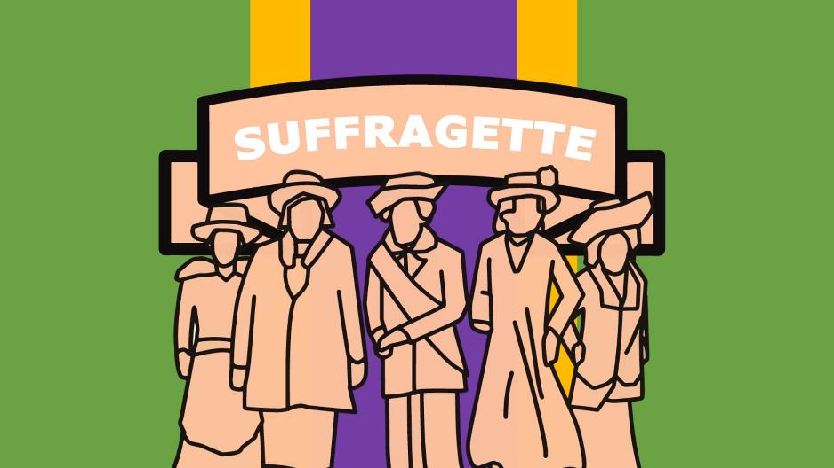
Vote 100: The Moving Story – Agnes Husband (still from GWL animation)
Suffragists adopted a peaceful and non-confrontational approach to campaigning. Members believed that success could be gained by argument and education.
Suffragettes adopted a more militant approach to campaigning. They chained themselves to railings, disrupted public meetings and damaged public property, and many were arrested and imprisoned for their actions.
Women have been involved in campaigns for equality and the right to vote in countries across the world, and have been championing many other issues as well.
Find out more about these female activists on the GWL website!

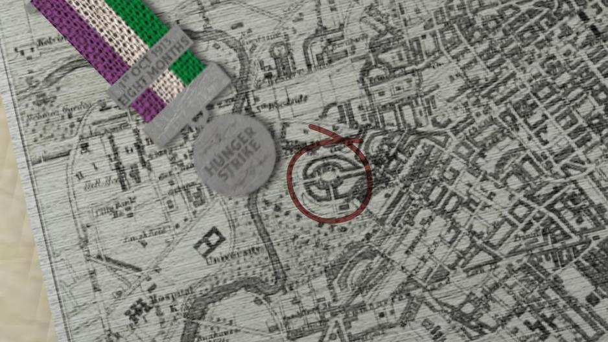
Vote 100: The Moving Story – Dr. Elizabeth Dorothea Chalmers-Smith (still from GWL animation)

contact US!

Website: womenslibrary.org.uk

Email: info@womenslibrary.org.uk

Facebook and Twitter: @womenslibrary

let us know how you feel about this project by using the hashtags #Vote100 and #TheMovingStory!

Research!

curriculum areas: social studies; literacy and english
experiences & OUTCOMES: lit 4-01a; lit 4-04a; soc 4-01a; soc 4-04a; soc 4-16b

CATEGORY: HISTORICAL RESEARCH

type: Case study. estimated time: 2/3 hours (home assignment)

THE PEOPLE:
- Choose a suffragette, suffragist, or activist from the animations: what else can you find out about their life?
- Choose a suffragette, suffragist, or activist who was not portrayed in the animations, and try to find out information about them: where did they live, and when? What did they fight for, and how?
- Were there any suffragettes or suffragists in your own family tree? What about in your neighbourhood or town? Dig into the past!
  - Tip 1: Visit a Genealogy Centre in to find out more about your family history!
  - Tip 2: Use the Interactive Map on the GWL website to discover suffragettes and suffragists in your area!
Suggested animations: Agnes Husband/Agnes Stephen/Annot Wilkie/Ann Shanks/Lila Clunas (Dundee), Anna Munro (Edinburgh), Eunice Guthrie Murray/Frances McPhun/Dr. Elizabeth Dorothea Chalmers-Smith (Glasgow), Jane Arthur (Paisley)

THE ISSUES:
- Focus on one issue (girls’ education, job equality, right to vote, etc.) from the animations, and try to find out how many suffragists or suffragettes fought for that issue.
- Is there a social or political issue that is particularly dear to you in the present day? Did it exist in the past as well? Did any of the activists from the animations fight for it?

Suggested animations: Agnes Husband (suffrage/education), Doria Shafik (suffrage/education), Draga Ljočić (equal professional rights), Elizabeth Cady Stanton (slavery abolition/reproductive rights/custody rights, among others), Hatoon Ajwad al-Fassi (suffrage), Nellie Letitia McClung (political participation)

debate!

curriculum areas: social studies; literacy and english
experiences & outcomes: soc 4-18a/b/c; lit 4-02a; lit 4-10a; lit 4-29a

CATEGORY: TALKING AND LISTENING

type: classroom activity. estimated time: 30 minutes

The right to vote
Nowadays, we take the right to vote almost for granted, and some people even think voting is not fundamental; yet many women fought for it passionately.
- Do you consider voting to be important? If yes/no, why?
- Imagine being a woman in the early 1900s. Should you have the right to vote? Why?
- Imagine being a man in the early 1900s. Should women be refused the right to vote? Why?

the end justifies the means…?
Suffragettes sometimes committed violent acts in protest, like smashing shop windows, or even setting fires.
- Do you think this was an acceptable way of calling attention to their cause?
- What about today? What is the modern response to violent acts?
- Do you think violent protests are more or less effective than peaceful ones?
Suggested animations: Annot Wilkie (suffragette, later suffragist), Ethel Moorhead (suffragette), Flora MacDonald Denison (suffragist), Frances McPhun (suffragette), Jane Taylour (suffragist), Dr. Elizabeth Dorothea Chalmers-Smith (suffragette)

men and feminism
Many suffragettes were married, but not all received the same response by the men in their lives. Some of them, like Dr Elizabeth Dorothea Chalmers Smith, were divorced by their husbands for their activism; others, like Anna Munro, were supported by their spouses… even through unconventional means (watch the animation to find out more!).
- How important do you think the support of a husband was for a suffragette?
- What about today? Do you think the role of male allies is still meaningful?
- What are some ways that male allies can contribute to achieving equality?

WRITE!

curriculum areaS: LITERACY AND ENGLISH
experiences & outcomes: eng 4-03a; lit 4-20a; lit 4-26a; eng 4-30a; eng 4-31a

CATEGORY: CREATIVE WRITING

type: CLASSROOM ACTIVITY; CASE STUDY. estimated time: 1 hour
- If you could write a letter to one of the suffragettes or suffragists in the video, what would you say?
- A lot of suffragettes were imprisoned for their activism. What do you think their experience was like? Imagine being an imprisoned suffragette or suffragist, and try writing a journal entry about your life in prison.
- Postcards were a very popular means of communication in the early 1900s.
Imagine you are a suffragette or suffragist, and you are writing a postcard to someone back home – your parents, your husband, your children, or a friend – about your activities in the fight for suffrage.
- Imagine you are a suffragette or suffragist from the early 20th century, and you have just been transported to our current time. Write a journal entry about your point of view: why did you fight for suffrage? What would you fight for today?
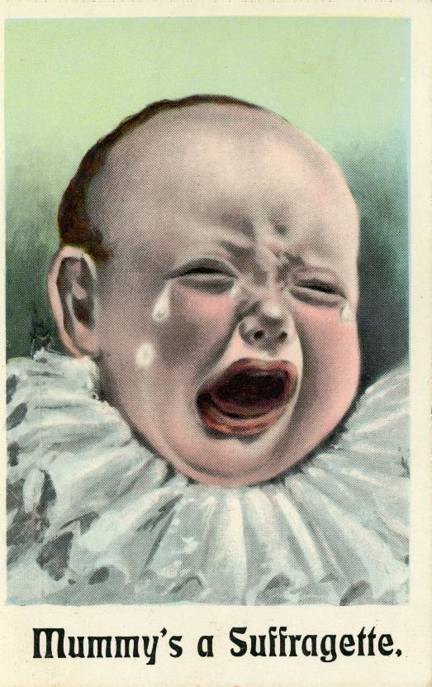
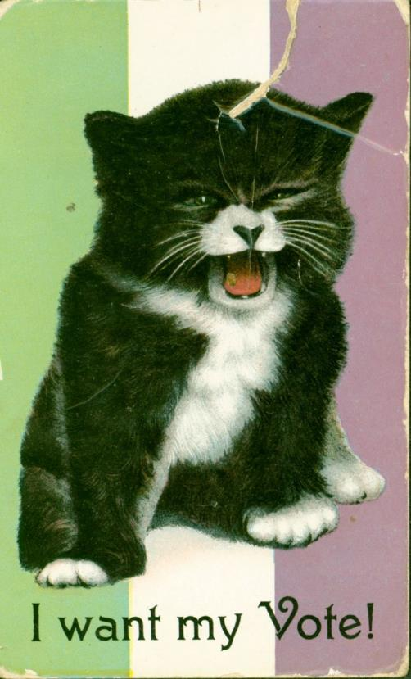
- After researching one suffragette or suffragist, write your own version of a script like the ones from the animations.

Suffrage-themed postcards, early 20th century.

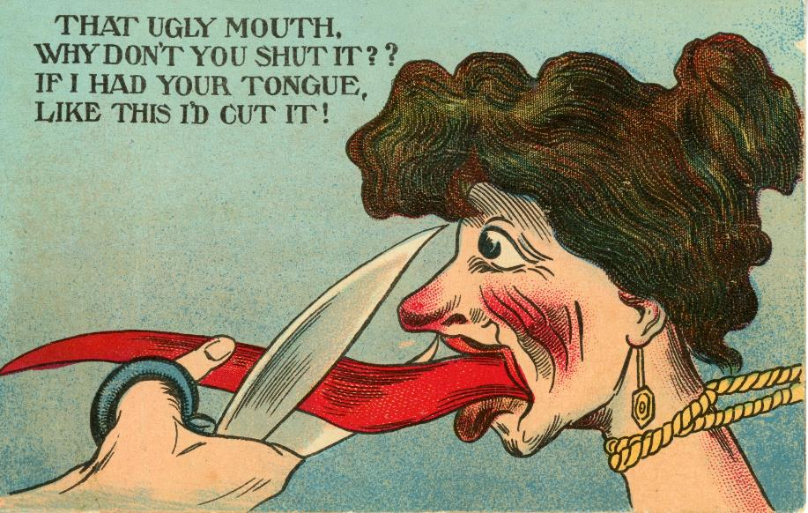
Although most suffrage-themed postcards were dismissive or sarcastic towards suffragettes and suffragists, they were not all equal: there were cutesy postcards, like the one with the kitten pictured on the previous page, and ones that were viciously hateful and violent, like the one above. Strikingly, the messages on the back are often calm and mundane.
What do you think of this kind of media? Did you know about it? Were you surprised? Come discover the collection at Glasgow Women’s Library!

CREATE!

curriculum areaS: EXPRESSIVE ARTS
experiences & outcomes: exa 4-03a; exa 4-05a; exa 4-06a;

category: GRAPHIC AND ILLUSTRATION

type: CLASSROOM ACTIVITY. estimated time: 1 hour
- Choose one of the suffragettes or suffragists from the animations and make a poster about them, coming up with a one-sentence slogan that sums up what they fought for.
- Suffragettes often wore rosettes and badges. Taking inspiration from the animations, design and create a badge that supports women’s fights for equality.

ACT OUT!

curriculum areaS: EXPRESSIVE ARTS
experiences & outcomes: exa 4-12a; exa 4-13a; exa 4-14a

category: drama and screenwriting; DIGITAL AND MULTIMEDIA

type: CLASSROOM ACTIVITY; CASE STUDY. estimated time: 30 minutes
- Choose one of the animations and have a go at reading the script “in character”
- Team up with others to record an audio or video clip of your reading
- If you speak another language besides English, try translating the script and reading it in another language
- Choose one of the suffragettes or suffragists that did not make it into the animations and, after researching a few facts about their life, record or film your own version of the script
- Take turns in the “hot seat”, imagining you are one of the protagonists in the videos. Your classmates will ask you questions about your life, your activism, and your motivations: try to answer them in character!

play!

Panko
“PANKO, or Votes for Women” is a suffrage-themed game that was invented way back in 1910. It was marketed as “The Great Card Game”, pitching “Suffragists v. Anti-Suffragists”. The illustrations on the cards were drawn by Edward Tennyson Reed, a cartoonist who worked for the humour and satire magazine “Punch”.
Print out a set of cards according to the instructions, and then challenge your friends. Who will win: suffragists or anti-suffragists?

game rules
- Panko may be played by 4, 6, or 8 persons, but they must be divided into two equal parties of Suffragists and Anti-Suffragists.
- There are four Suffragist suits and four Anti-Suffragist suits, each consisiting of six cards.
- The suits:
  - Suffragist suits — Colours: mauve and green.
    - Toot, toot, toot = 10 points
    - Pank, pank, pank = 20 points
    - Law, law, law = 30 points
    - Votes for Women = 40 points
  - Anti-Suffragist suits — Colours: red and black.
    - Help, help, help = 10 points
    - Turn ‘em out = 20 points
    - Fourteen days = 30 points
    - Gaol, gaol, gaol = 40 points
- Object of the game:
As soon as the cards are dealt, begin to collect a compete suit of six cards. You can only score for a complete suit in your own colour; i.e., Suffragists can only score for a complete Suffragist suit and Anti-Suffragists only for a complete Anti-Suffragist suit.
- Who starts the game:
Any player may begin by calling out for cards to make a complete suit.
- How to get a complete suit:
Call out for as many cards as you require, and get as many in exchange either from partners or opponents.
- How to score:
As soon as you have got a complete suit of six cards, call out the words that belong to your particular suit, e.g.: “Pank, pank, pank!”, “Gaol, gaol, gaol!”, etc. The player who calls out first will score for his of her party the number of points stated in Rule 3.
- Fines:
  - The winners of each deal shall claim one point for every wrong-coloured card held by their opponents.
  - If any player make a wrong declaration his or her party shall lose 20 points.
- Each deal is finished as soon as a proper declaration has been made.
- The game is won by the party which first scores 100 points.
N.B. — All the cards are dealt except when there are only four players; in that case one Suffragist suit and one Anti-Suffragist suit should be taken out of the pack.

how many cards to print:
- Card backs x 48
- Toot! Toot! Toot! x 6
- Pank! Pank! Pank! x 6
- Law! Law! Law! x 6
- Votes for women x 6
- Help! Help! Help! x 6
- Turn ‘em Out! (Economist/Budget) x 1
- Turn ‘em Out! (Military man 1) x 1
- Turn ‘em Out! (Military man 2) x 1
- Turn ‘em Out! (Man with kilt) x 1
- Turn ‘em Out! (Man with monocle) x 1
- Turn ‘em Out! (Farmer) x 1
- Fourteen Days! x 6
- Gaol! Gaol! Gaol! x! 6

suffragetto
Text adapted from http://pwp.gatech.edu/suffragetto/historiography/
Emmeline Pankhurst (1858-1928), and her daughters Christabel and Sylvia, formed the WSPU because they were frustrated with slow moving pacifist methods. The WSPU disrupted public events and government meetings, destroyed public property through window-breaking, and committed arson in (unoccupied) government buildings, elected leaders’ homes, and high-end retail shops. […]
The confrontational approach of the WSPU often led to members’ arrest; WSPU members always choose incarceration over fines, and protested with hunger strikes. In response to violent police, the WSPU formed a female bodyguard trained in jiu jitsu and armed with clubs to protect suffragettes. […] The suffragettes’ emphasis on self-defense was an attempt to combat and alleviate differential corporeal and political power experienced in public spaces, and enhance the movement’s durability in activist conflict.
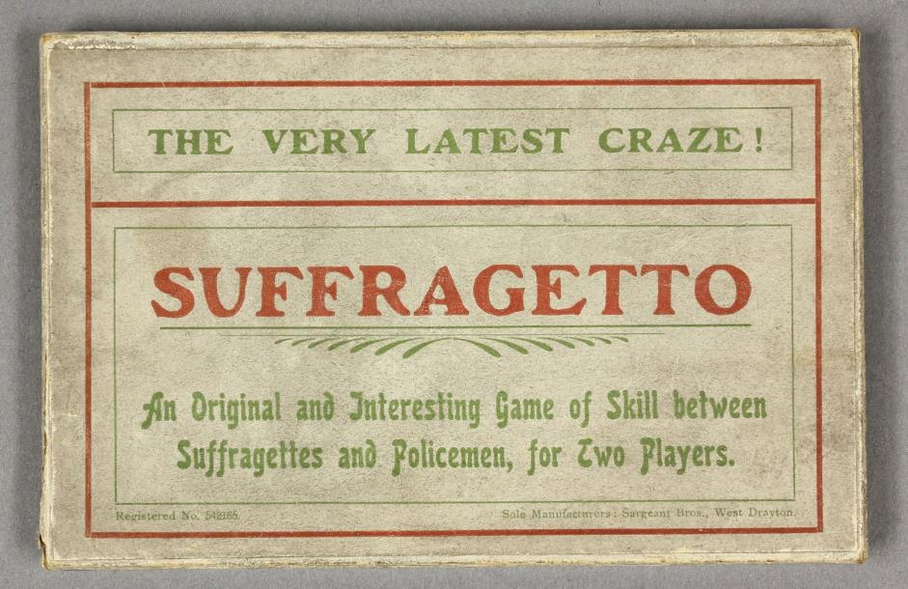
As bodies were important to the British Suffragette movement, bodies are also important in the play of Suffragetto creating a setting where players can perform the corporeal equality enacted by the WSPU through jiu jitsu. In the original game rules, suffragettes “disable” their opponents, a term used in martial arts for when an opponent is neutralized.
Within the game both police and suffragette players move in the same way. In doing so, the game collapses or flattens gender and corporeal differences present in real life—but alleviated through self-defense techniques suffragettes would have been knowledgeable in. However, Suffragetto is set in the actual socio-politico-historical realities of the time. This is most readily seen when players are injured; when police pawns are injured they are taken to the hospital, while suffragette pawns are taken to jail. This reflected actual practices of the time.
Why not have a go at playing Suffragetto with a friend?
You can find the rules, as well as downloadable versions of the game board and game pieces, at this link: http://pwp.gatech.edu/suffragetto/print-and-play/

Who’s who: suffrage edition!
So you’ve watched the animations… but how well do you know your suffragettes and suffragists now?
Give out this list of facts from the animations, and a separate list with the names (scrambled, of course!): how many can you correctly pair up?
N.B.: The hints below are based only on the animations already available on GWL’s website. More will be added as we go along, and of course you are very welcome to create your own!
- This suffragette was awarded freedom of the city of Dundee at the age of 74 (Agnes Husband)
- This suffragette celebrated her 100th birthday in 1993 (Agnes Stephen)
- This suffragette organised the Scottish suffrage summer school (Alice Crompton)
- This suffragette, while imprisoned, received a message from her husband... sewn into a banana! (Anna Munro)
- This suffragist was a part of the notorious Trojan horse raid on the Houses of Parliament (Annot Wilkie
- This woman gave a safe haven to suffragettes by hiding from the police (Ann Shanks)
- This suffragette founded the Scottish Women’s Rural Institute in 1917 (Catherine Hogg Blair)
- This woman founded an Egyptian feminist organisation called "The Daughters of the Nile" (Doria Shafik)
- This suffragette raised her three daughters to be doctors (Dr Elizabeth Dorothea Chalmers Smith)
- This woman was the first female doctor in Serbia (Draga Ljočić)
- This activist helped organise the first women’s rights convention in the United States (Elizabeth Cady Stanton)
- This suffragette once threw an egg at Winston Churchill (Ethel Moorhead)
- This Glasgow suffragist was the first woman to stand in a parliamentary election in Scotland in 1918 (Eunice Guthrie Murray)
- This Pakistani stateswoman was known as "the Mother of the Nation" (Fatima Jinnah)
- This suffragette from the isle of Arran was known as "the General" (Flora Drummond)
- This Canadian businesswoman was president of the Canadian suffrage association from 1910 to 1914 (Flora MacDonald Dennison)
- This Scottish suffragette was involved in organising the pageant of famous women, held in Edinburgh in 1909 (Frances McPhun)
- This associate professor from Saudi Arabia was arrested in 2018 as part of the crackdown on women's rights activists (Hatoon Ajwad al-Fassi)
- This suffragist from Paisley was the first woman to be elected to a Scottish school board, in 1873 (Jane Arthur)
- This suffragist travelled all over Scotland and Northern England giving suffrage lectures which were widely covered by the press (Jane Taylour)
- This suffragette, known as an "excellent heckler", served as a Labour party councillor until the age of 88 (Lila Clunas)
- This suffragette from Dundee delivered a toffee hammer with purple, white and green ribbons to the post office (Margaret Fraser Smith)
- This Australian actress, singer, and suffragist sailed over London in an airship with Votes For Women written on the side, dropping leaflets (Muriel Matters)
- This Canadian suffragette was one of the "Famous Five" who in 1927 launched a case contending women were qualified and eligible to sit on the Senate (Nellie Letitia McClung)
- This feminist revolutionary was known as China's Joan of Arc, and was beheaded under the accusation of "conspiring against the government" (Qiu Jin)
- This women's rights activist was a slave until 1828, and a space rover was named after her (Sojourner Truth)
- This suffragist from Finland founded the Finnish Women's Union in 1907, and was elected as an MP in 1908. (Tekla Hultin)

recommended reading
Forthcoming

USeful resources
Forthcoming

tell us about your experience!
Are you an educator? Did you try any of these activities? Let us know how it went!
This is our first version of the “Vote 100: The Moving Story” toolkit for schools, and feedback is invaluable to us. We are looking for case studies to draw on, not only so we can keep improving our outreach material, but also so that other educators might be able to read about your experience and decide if this toolkit is a good fit for them! So whether you’ve used all of the activities or just a couple, whether you’re a teacher or a librarian or a youth worker, please let us know what you and your students thought of it by writing us at info@womenslibrary.org.uk.
We really appreciate your help!

acknowledgments
This toolkit was developed by Ambra Allison Ghiringhelli for the “Widening Access to Digital Resources” project, a six-month internship (January 2019 — July 2019) offered by Glasgow Women’s Library through the generous support of the Scottish Graduate School of Arts and Humanities. Ambra is currently a PhD candidate in Classics at the University of Edinburgh, as well as collaborating on public engagement and community outreach with an archaeological site in Italy as part of the Apolline Project.
You can reach her at ambra.ghiringhelli@gmail.com or on Twitter @AmbraAllison!

