Women, Media, Politics
21st June, Glasgow Women’s Library
Programme

945-10 Arrival & refreshments

10-1015 Welcome (Karen Boyle)

1015-1145 Roundtable 1: Being a Feminist in Pubic
Speakers: Lee Chalmers, Talat Yaqoob, Emma Ritch, Liz Ely

1145-12 Refreshments

12-1 Academic panel 1: Women, Politics, Twitter & the Press
Fiona McKay: Women, politics media – good, bad, indifferent
Karen Ross: Twitter and the gendered election – women, men and tweets
in the 2015 general election

1-145 Lunch

145-245 Academic panel 2: Women, Politics, Television
Marina Dekavalla & Alenka Jelen: Women in television coverage of the Scottish & EU referenda
Laura Castillo Mateu: Institutionalized feminism in Spanish popular culture: The case of Isabel

245-3 Break

3-430 Roundtable 2: Writing & Speaking as a Feminist
Speakers: Kirsty Strickland, Claire Heuchan, Kirstein Rummery.

This event is organised by the Centre for Gender & Feminist Studies (University of Stirling), and sponsored by The Scottish Graduate School for Arts & Humanities and the MeCCSA Women’s Media Studies Network.

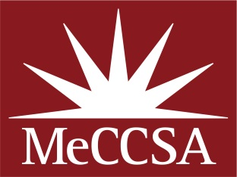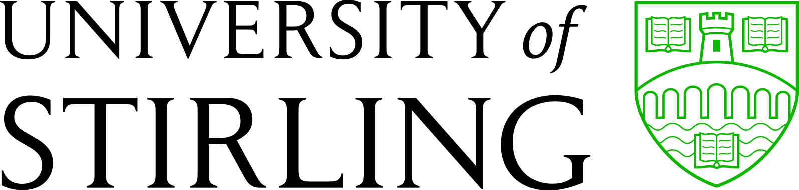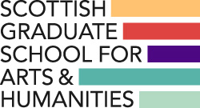

Speaker Biographies

Karen Boyle is Co-Director of the Centre for Gender & Feminist Studies and Programme Director for the MLitt/MSc in Gender Studies (Applied), both at the University of Stirling. Her research is mainly in relation to gendered violence and representation (she is author of Media & Violence: Gendering the Debate from 2005, and editor of Everyday Pornography, 2015) although she is interested in questions of gender and representation more broadly and has recently coordinated the Scottish research for the Global Media Monitoring Project (2015). She has been a member of the Board of Directors of the Women’s Support Project since 2002.

Lee Chalmers Lee Chalmers is a feminist, academic, business owner and new politician. She recently stood as a candidate for the Women’s Equality party in the Scottish parliament elections, was Vice-Chair of the board of The Fawcett Society, is on the board of Engender and is doing a part time PhD at Edinburgh University on trolling and women’s engagement in public life/feminist activism. Soon she is launching The Parliament Project, an initiative to encourage and support women to run for political office in the UK.

Talat Yaqoob Talat Yaqoob is Co-Founder and Chair of the Women 5050 campaign and is Director of Equate Scotland, the national expert on Women in STEM. Talat has a background in campaigning and public affairs, having worked on a range of issues including; mental health, tackling violence against women, international development, and educational inequality.

Emma Ritch: Emma is Executive Director of Engender, which is a feminist policy and advocacy organisation working on women’s social, economic, and political equality in Scotland. Her particular areas of feminist interest are women and the economy, men’s violence against women, and women’s human rights. She is the vice-chair of the board of Rape Crisis Scotland. She is a member of the Scottish Women’s Rights Centre’s advisory committee, the Scottish Women’s Budget Group, and is acting chair of the Scottish Human Rights Consortium management committee. She is a member of the board of the Rape Crisis Centre in Glasgow, the Scotland Committee of the Equality and Human Rights Commission, and the board of the Women 50:50 campaign. Ten years ago she co-owned feminist blog Gendergeek, and tweets at @emmaritch. She was Lying Feminist of the Month in May 2015.

Liz Ely: Liz Ely is the Campaigns and Engagement Officer at Zero Tolerance, where she has worked in a development officer role for the last 4 years. During this time, Liz has overseen Zero Tolerance’s work on improving standards of reporting in the media, which has included founding the Write to End Violence Against Women Awards for excellence in journalism (writetoendvaw.com). Liz and Zero Tolerance have a particular interest in ways to constructively challenge the media around their violence against women coverage, and sexism more generally.

Fiona McKay: Fiona McKay was awarded a PhD scholarship from the Carnegie Trust for the Universities of Scotland and joined the University of Strathclyde’s School of Humanities and Social Science in October 2013 to begin an PhD in Journalism Studies. Her research explore the media representations of gender in the Scottish public sphere within the context of the 2014 independence referendum in Scotland. She holds an MLitt in Journalism from the University of Strathclyde and an undergraduate MA (Hons) in English Literature from the University of Glasgow. She has worked as a reporter for the Herald and Times Group as well as projects for the BBC and continues to work intermittently on a freelance basis for the Herald newspaper.﻿

Karen Ross is Professor of Media at the University of Northumbria at Newcastle, UK. Her teaching and research are focused on issues of gender, media and society including aspects of social media, public and political communication, and the wider diversity and inclusion agenda. She is the UK and European Coordinator of the Global Media Monitoring Project. She is currently writing up a research project focused on the use of Twitter by MPs during the British General Election 2015 and her latest monograph Gender, Politics and Media will be published in summer 2016 with Wiley. She is the Managing Editor of a new Wiley-Blackwell Encyclopaedia on Gender, Media and Communication which is in development. Recent books include: A Handbook of Gender, Sex and Media (2012, Wiley), The Media and the Public: Them and Us in Media Discourse (2010, Wiley-Blackwell) and Gendered Media (2009, Rowman and Littlefield). She was the Lead Researcher and Project Coordinator on a pan-European project, funded by the European Institute for Gender Equality (EU NGO), focused on identifying issues in relation to both the promotion and representation of women across the European media sector She has previously carried out projects for the BBC and the independent TV sector on aspects of diversity in programming including ethnicity, disability and age and on niche audience responses to audiovisual content. For further information about Karen, please visit her website.

Marina Dekavalla Dr Marina Dekavalla is lecturer in Journalism Studies at Stirling University, specializing in research on the relationship between the media and politics. Her current ESRC project (2015-16), looks at the framing of the 2014 Scottish independence referendum on television (http://scottishreferendumcoverage.org.uk ). She is convener of the Scottish Media and Communication Association (SMCA), Scotland’s higher education subject association in the media and communication fields.

Alenka Jelen-Sanchez is a Lecturer in Public Relations at the University of Stirling and General Secretary of ECREA (European Communication Research and Education Association). Her research interest is in public relations and political communication with a focus on interactions between media and politics; gender in public relations, media and politics; public and media manifestations of death and dying; and public relations as an academic discipline. She has experience in media as a journalist, radio news director, anchor, and is currently a British Correspondent for Slovenian Kanal A TV channel and Večer newspaper.

Laura Castillo Mateu Laura Castillo Mateu is a PhD candidate in International Peace, Conflict and Development Studies (line of research: Communication and Education for Peace –from a Gender perspective) at the Universitat Jaume I (Castelló, Spain) under the supervision of María José Gámez Fuentes. The Ministry of Education has awarded her with a four-year Research Assistantship in the Department of Communication Science of the same university. Her thesis research is being developed within the frame of two research projects (funded by Jaume I University and the Ministry of Economy and Competitiveness of Spain), both focused in the re-signification of the (female) victims through witness in popular culture.

Kirsty Strickland: Kirsty is a feminist campaigner and writer with an interest in women's representation in politics and the media. She writes for the #WFImediawatch blog about gender balance in current affairs programmes, and is the bursary winner for the Write To End Violence Against Women Awards.

Claire Heuchan: is a Black radical feminist and student of Gender Studies at the University of Stirling.She is an active user of social media for activist debate (@claireshrugged) and blogs at https://sisteroutrider.wordpress.com/.

Kirstein Rummery: Kirstein is Co-Director of the Centre for Gender & Feminist Studies at the Unviersity of Stirling and researches on gender and disability equality, and care policy. She is an active user of social media to discuss research findings (@kirsteinrummery) and also regularly appears on television (in particular, Scotland 2016) to discuss related issues. Her book What Works in Gender Equality will be published by Policy Press later this year.

