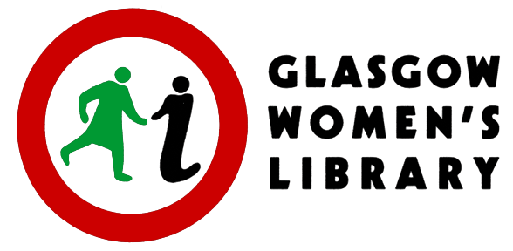

Sessional Worker opportunity:

Discussion Group Facilitator
What Women Talk About When They Talk About Sex

Context:

Glasgow Women’s Library is hosting a programme of events as part of a partnership with the Wellcome Collection. These discussion groups will form one of the core activities in the programme.

Brief:

We are looking for an experienced facilitator who can lead a lively, open, judgement-free discussion group aimed at a diverse group of women who want to share, in a safe space, honest insights into how sex, sexual identity or sexuality figures in their lives.

WORKSHOP PROMO BLURB
What Women Talk About When They Talk About Sex
Thursdays 7th and 21st May and 4th June, 13.00-14.30 and 18.00-19.30 (6 workshops)
Share honest insights into how sex, identity or sexuality figure in women’s lives. What do women feel about their bodies, relationships, passions and pleasures? What are our desires and the costs of naming and claiming them? Using the historical model of feminist consciousness-raising groups, discussions will explore the personal and political dimensions of sex.

We are aiming to discover what a small group of women feel about their bodies, their relationships, their passions and pleasures in Scotland in 2015 Who are the subjects of our desires and what are the costs for women today of naming and claiming them? These discussion groups will use the historical model of feminist Consciousness Raising groups to explore the personal and political dimensions of sex in our lives.

These sessions will be recorded and, whilst acknowledging the ownership of the content by the participants will be looking to share elements of the contents of the discussion (anonymously or otherwise dependent on the wishes of the participants) online, and in creative workshops so skilled negotiation around confidentiality as well as a confidence in working with diverse groups with sensitivity and positivity is important to us.

Dates:
Thursdays 7th and 21st May and 4th June, 13.00-14.30 and 18.00-19.30 (6 workshops)
Saturday 30th May, 3pm to 5pm
Friday 18th September 2015, 6pm to 7.30pm

Payment: £450

Please email your expression of interest to adele.patrick@womenslibrary.org.uk
Closing Date for expressions of interest: 12 noon on Wednesday 25th March 2015

Expression of Interest:

Name:

Address:

Email:

Tel: Mobile:

Please use only this side of A4 paper to summarize your interest and qualification for this post. Please attach a cv (no more than 2 pages). We will select and invite potential sessional workers to meet with us to discuss this opportunity further. You must be available to meet on Tuesday 31st March or Wednesday 1st April 2015.

Sessional work fee: £450

Dates of workshops: Thursdays, 7th & 21st May and 4th June 2015, 1pm to 2.30pm and 6pm to 7.30pm
and launch event on Friday 18th September

Expressions of interest must be sent to adele.patrick@womenslibrary.org.uk by 12 noon on Wednesday 25th March 2015.

What experience have you had of working with equalities and diverse groups and especially working with individuals and groups on sensitive or challenging topics?

What is your experience of working with women?

How would your describe your approach to working with groups?

Why does this specific work interest you?

